CAPSTONE PROJECT

Test 2:

5G Core Network

SMF PDU Session Establishment (5G Core (SMF))

Group 1:

58620_Harsh Prasad

58618_Vinayak Majhi

58633_Diptendra Maity

58625_Keshav Janghala

58621_Diyanisha Dey

Table of Contents
1. Introduction to SMF & PDU Sessions
2. 5G Core Architecture (Diagram)
3. PDU Session Establishment Signaling Flow (Diagram)
4. SMF State Machine (Diagram)
5. C++ Implementation
6. Output
7. Key Concepts & 3GPP References
8. Compilation Guide

1. Introduction to SMF & PDU Sessions
The Session Management Function (SMF) is one of the most critical control plane network functions in the 5G Core (5GC) architecture. It serves as the brain behind establishing, managing, and terminating data connectivity sessions for mobile devices. Understanding the SMF and PDU Sessions is fundamental to comprehending how 5G networks deliver high-speed, low-latency connectivity to billions of devices worldwide.

1.1 What is the Session Management Function (SMF)?
The SMF is responsible for the complete lifecycle management of PDU (Protocol Data Unit) Sessions. Think of the SMF as a traffic controller at an airport – it coordinates multiple systems to ensure passengers (data packets) reach their destinations safely and efficiently. Just as an air traffic controller manages flight paths, runway assignments, and coordination with ground services, the SMF manages data session establishment, IP address allocation, routing rules, and quality of service parameters.
Real-World Analogy: Imagine you're checking into a hotel (establishing a PDU session). The hotel manager (SMF) performs several critical tasks:
• Verifies your reservation and identity (subscription data from UDM)
• Assigns you a room number (allocates UE IP address)
• Provides access level and amenities based on your membership tier (applies policy rules from PCF)
• Coordinates with housekeeping, maintenance, and concierge services (manages UPF, ensures QoS)
• Ensures your stay meets quality standards (enforces Session AMBR and QoS flows)

1.2 Understanding PDU Sessions
A PDU Session represents an end-to-end data connectivity tunnel between the User Equipment (UE) and a Data Network (DN), such as the Internet, IMS (IP Multimedia Subsystem), or a private enterprise network. Each PDU Session is uniquely identified by:
• PDU Session ID: A unique identifier (1-255) assigned by the AMF
• DNN (Data Network Name): Specifies which network to connect to (e.g., "internet", "ims", "enterprise.vpn")
• S-NSSAI (Single Network Slice Selection Assistance Information): Identifies the network slice (e.g., eMBB, URLLC, mMTC)

1.2.1 Real-World PDU Session Scenarios
Example 1: Smartphone User Browsing the Internet
When Sarah opens her web browser on her 5G smartphone, the following PDU Session is established:
• DNN: "internet" (connects to the public Internet)
• S-NSSAI: SST=1, SD=0x000001 (Enhanced Mobile Broadband slice)
• PDU Session Type: IPv4 or IPv4v6 dual-stack
• UE IP Address: 10.45.0.10 (dynamically allocated by SMF)
• Session AMBR: DL=500 Mbps, UL=100 Mbps
• Default QoS: 5QI=9 (Non-GBR, best-effort for web browsing)
Example 2: VoLTE Call Over 5G
When John makes a voice call using Voice over New Radio (VoNR), a dedicated PDU Session is established for IMS signaling and media:
• DNN: "ims" (connects to IMS core network)
• S-NSSAI: SST=1, SD=0x000002 (IMS-dedicated slice)
• PDU Session Type: IPv6
• UE IP Address: 2001:db8:ims::123 (IPv6 for IMS)
• QoS Flows:
- QFI=1, 5QI=5 (IMS signaling, Non-GBR, priority 10)
- QFI=2, 5QI=1 (Voice media, GBR, priority 20, PDB=100ms)
Example 3: Industrial IoT Factory Automation
A smart factory uses 5G for ultra-reliable low-latency communication (URLLC) between robotic arms and control systems:
• DNN: "factory.private" (private enterprise network)
• S-NSSAI: SST=2, SD=0x000005 (URLLC slice)
• PDU Session Type: IPv4
• UE IP Address: 172.16.10.50 (static IP from factory subnet)
• Session AMBR: DL=50 Mbps, UL=50 Mbps
• QoS: 5QI=85 (URLLC, PDB=5ms, PER=10^-5)

1.3 SMF Key Responsibilities in Detail
The SMF performs numerous critical functions throughout the lifecycle of a PDU Session. Let's explore each responsibility with practical examples:

1.3.1 Session Establishment, Modification, and Release
The SMF orchestrates the entire PDU Session lifecycle from cradle to grave.
Establishment Process:
1. Receives session creation request from AMF (triggered by UE's NAS PDU Session Establishment Request)
2. Validates subscriber authorization (checks UDM for allowed DNNs and slices)
3. Selects appropriate UPF based on UE location, DNN, and load balancing
4. Allocates UE IP address from the DN's address pool
5. Retrieves PCC rules from PCF for QoS and charging control
6. Installs PFCP rules in UPF (PDRs, FARs, QERs, URRs)
7. Sends session establishment accept to UE via AMF
Modification Scenarios:
• UE mobility: When the device moves to a new gNB, SMF updates the N3 tunnel endpoint
• New QoS flow: Starting a video call requires adding a dedicated QoS flow with stricter latency requirements
• Policy change: Network congestion may trigger PCF to reduce Session AMBR temporarily
Release Triggers:
• UE-initiated: User turns off data or disconnects from network
• Network-initiated: Policy enforcement, roaming restrictions, or session timeout
• Error conditions: UPF failure, authentication revocation, or resource exhaustion

1.3.2 UE IP Address Allocation and Management
The SMF acts as a DHCP server for 5G devices, allocating IP addresses from preconfigured pools.
Allocation Method | Description | Use Case Example
Dynamic IPv4 | SMF allocates IP from pool, typically 10.x.x.x or 100.64.x.x range | Consumer smartphones browsing internet
Dynamic IPv6 | SMF assigns /64 prefix from DN pool, UE generates interface ID using SLAAC | IoT devices requiring unique global addresses
Static IP | Preconfigured IP address stored in UDM subscription data | Industrial equipment needing consistent addressing for firewall rules
IPv4v6 Dual-Stack | SMF allocates both IPv4 and IPv6 addresses simultaneously | Devices accessing both legacy IPv4 and modern IPv6 services

Real-World Scenario:
A mobile operator has 10 million subscribers. The SMF manages several IP pools:
• 10.0.0.0/8: General internet access (16.7 million addresses)
• 100.64.0.0/10: CGNAT pool for IPv4-only subscribers (4 million addresses)
• 2001:db8:5g::/32: IPv6 global unicast addresses (virtually unlimited)
• 172.16.0.0/12: Private enterprise APNs (1 million addresses)

1.3.3 UPF Selection Strategy
Selecting the optimal User Plane Function (UPF) is critical for performance and efficiency. The SMF considers multiple factors:
Selection Criteria | Considerations | Impact
Geographic Proximity | Choose UPF closest to UE's current serving gNB to minimize latency | Reduces N3 tunnel RTT by 10-50ms in typical deployments
DNN/Slice Support | Not all UPFs support all DNNs; enterprise APNs may route through specific UPFs | Ensures correct routing to corporate networks or IMS
Load Balancing | Distribute sessions across multiple UPFs to prevent hotspots | Improves throughput and prevents single UPF bottlenecks
Latency Requirements | URLLC slices need UPF with minimal processing delay | Enables <5ms end-to-end latency for factory automation
Roaming Scenarios | V-UPF in visited network, H-UPF in home network for LBO/HR | Optimizes data path and billing in international roaming
Deployment Example:
Tier-1 mobile operator in USA with nationwide 5G coverage:
• 50 regional UPFs distributed across major cities (New York, LA, Chicago, Dallas, etc.)
• 5 central UPFs for enterprise and IMS traffic
• 10 edge UPFs co-located with MEC (Multi-access Edge Computing) for AR/VR and gaming
When a UE in Manhattan requests internet access, SMF selects the New York regional UPF. If the UE roams to San Francisco, SMF can either maintain the NYC UPF (session continuity) or relocate to SF UPF (optimize latency).

1.3.4 PFCP Session Management (N4 Interface)
The Packet Forwarding Control Protocol (PFCP) is the SMF's language for instructing the UPF on how to handle user plane traffic. Think of PFCP as a recipe that the SMF (chef) gives to the UPF (line cook) describing exactly how to process each packet.
PFCP Rules Overview:
PFCP Rule | Full Name | Purpose | Example
PDR | Packet Detection Rule | Defines which packets to detect and how to classify them | Match all packets from UE IP 10.45.0.10 → apply QoS Flow ID 1
FAR | Forwarding Action Rule | Specifies what action to take with detected packets | Forward packets with GTP-U encapsulation to gNB TEID 0x2001
QER | QoS Enforcement Rule | Enforces QoS parameters like bitrate limits and priority | Limit downlink bitrate to 500 Mbps (Session AMBR)
URR | Usage Reporting Rule | Tracks data volume for billing and policy enforcement | Report when UE consumes 1 GB of data for charging
Real-World PFCP Configuration Example:
When Sarah starts a video streaming session, SMF configures the following PFCP rules in the UPF:
PDR #1 (Uplink Traffic Detection):
• Source: UE IP 10.45.0.10
• Match: GTP-U tunnel from gNB TEID 0x2001
• QFI: 1 (default internet)
• Action: Apply FAR #1
FAR #1 (Uplink Forwarding):
• Action: FORWARD
• Destination: Internet via N6 interface
• Remove GTP-U header, perform NAT, route to DN
PDR #2 (Downlink Traffic Detection):
• Source: Internet (N6 interface)
• Match: Destination IP 10.45.0.10
• QFI: 1
• Action: Apply FAR #2
FAR #2 (Downlink Forwarding):
• Action: FORWARD
• Outer Header Creation: GTP-U tunnel to gNB
• Destination: gNB N3 TEID 0x2001, IP 192.168.1.50
QER #1 (QoS Enforcement):
• 5QI: 9 (Non-GBR, best-effort)
• Session AMBR DL: 500 Mbps
• Session AMBR UL: 100 Mbps
• Priority: 90 (low priority, can be delayed during congestion)
URR #1 (Usage Reporting):
• Measurement Method: Volume-based
• Reporting Triggers: Every 100 MB or every 15 minutes
• Quota Management: Alert SMF when 80% of monthly data cap reached

1.4 3GPP Technical Specifications
The SMF and PDU Session management are defined across multiple 3GPP technical specifications. Understanding these specifications is crucial for implementing and troubleshooting 5G networks.
Specification | Title | Key Content | Relevance to SMF
TS 23.501 | System architecture for the 5G System (5GS) | Overall 5GC architecture, NF descriptions, service-based interfaces | Defines SMF role, interactions, and architectural principles
TS 23.502 | Procedures for the 5G System (5GS) | PDU Session establishment, modification, release procedures | Complete signaling flows for SMF operations - CRITICAL REFERENCE
TS 29.502 | Session Management Services | Nsmf service APIs (HTTP/2 RESTful) | SMF northbound APIs for AMF and other NFs to invoke
TS 29.244 | Interface between Control Plane and User Plane nodes | PFCP protocol specification | SMF-UPF N4 interface - defines all PFCP messages and rules
TS 24.501 | Non-Access-Stratum (NAS) protocol for 5GS | NAS SM messages between UE and SMF | PDU Session Establishment Request/Accept message formats
TS 29.512 | Session Management Policy Control Service | Npcf_SMPolicyControl API | SMF-PCF N7 interface for policy retrieval
Practical Tip for Engineers:
When debugging PDU Session establishment issues, always refer to TS 23.502 Section 4.3.2 first. It contains the complete 12-step signaling flow with detailed descriptions of each message, parameters, and error handling procedures. This specification is your bible for understanding SMF behavior.

1.3.5 QoS Flow Creation and Management
Unlike 4G LTE where QoS was bearer-based, 5G uses a more flexible QoS Flow model within PDU Sessions. Each PDU Session can contain multiple QoS Flows, each with distinct quality characteristics.
QoS Flow Hierarchy:
1. PDU Session (e.g., internet connection)
└─ QoS Flow 1 (default, 5QI=9, best-effort web browsing)
└─ QoS Flow 2 (dedicated, 5QI=2, GBR video call)
└─ QoS Flow 3 (dedicated, 5QI=7, streaming video)
Real-World Multi-Flow Scenario:
Emma is using her smartphone for multiple applications simultaneously:
• Background email sync: QFI=1, 5QI=9 (Non-GBR, low priority)
• WhatsApp video call: QFI=2, 5QI=2 (GBR, 2 Mbps guaranteed, 150ms PDB)
• YouTube streaming in background: QFI=3, 5QI=7 (Non-GBR, higher priority than email)
The SMF:
1. Creates the PDU Session when Emma enables mobile data
2. Establishes QFI=1 immediately as the default QoS Flow
3. Adds QFI=2 when Emma starts the video call (triggered by PCC rule from PCF)
4. Adds QFI=3 for streaming video
5. Updates PFCP session in UPF to create separate PDRs and FARs for each QFI
6. Signals RAN to map QoS Flows to appropriate radio bearers (QFI=2 gets dedicated DRB)

1.3.6 Session AMBR Enforcement
Session AMBR (Aggregate Maximum Bit Rate) is the total bandwidth limit for all Non-GBR QoS Flows within a PDU Session. Think of it as a speed limit for the entire highway, where GBR flows get dedicated lanes and Non-GBR flows share the remaining capacity.
How SMF Enforces AMBR:
• Retrieves Session AMBR from UDM subscription data (e.g., DL=500 Mbps, UL=100 Mbps)
• PCF may modify AMBR based on network congestion, time-of-day policies, or user tier
• SMF configures QER in UPF with AMBR values
• UPF performs traffic shaping and policing to enforce limits
• RAN also enforces AMBR on radio interface to prevent uplink congestion
Real-World Policy Scenario:
Mobile operator 'FastNet 5G' has three subscription tiers:
Subscription Tier | Session AMBR DL | Session AMBR UL | Price/Month
Basic | 100 Mbps | 50 Mbps | $30
Premium | 500 Mbps | 100 Mbps | $60
Ultra | 2 Gbps | 500 Mbps | $100
When a Basic subscriber tries to download a large file, the UPF enforces the 100 Mbps limit even if the network and UE support gigabit speeds. If the subscriber upgrades to Ultra, SMF immediately modifies the PFCP session to update the AMBR, providing instant speed boost without reconnecting.

1.3.7 Downlink Data Notification Handling
When a UE is in RRC_IDLE state (radio inactive to save battery), the SMF must coordinate with UPF and AMF to deliver incoming data efficiently.
Downlink Data Notification (DDN) Flow:
1. Downlink IP packet arrives at UPF from Internet
2. UPF detects no active N3 tunnel (gNB not connected)
3. UPF buffers the packet and sends PFCP Session Report to SMF
4. SMF forwards DDN to AMF via Namf_Communication_N1N2MessageTransfer
5. AMF initiates network-triggered Service Request to wake up UE
6. UE establishes RRC connection with gNB
7. SMF updates UPF with new gNB N3 tunnel info
8. UPF forwards buffered packet to UE via gNB
Practical Example:
Tom's phone is in his pocket with screen off. WhatsApp sends a message notification from the server. The packet reaches the UPF, which buffers it and notifies SMF. SMF triggers AMF to page Tom's phone. The phone wakes up, re-establishes radio connection, and receives the message—all within 200-500 milliseconds.

1.3.8 Roaming Support (V-SMF and H-SMF)
When a subscriber roams to a foreign network, the SMF architecture splits into two entities to handle local and home network responsibilities.
SMF Type | Location | Responsibilities | Example
V-SMF (Visited) | Visited PLMN | UPF selection in visited network, local breakout control, N4 session with V-UPF | American tourist in Paris uses Orange France's V-SMF
H-SMF (Home) | Home PLMN | Policy control, charging, subscription verification, home routing | Verizon's H-SMF in USA maintains control over roaming session
Roaming Scenarios:
Local Breakout (LBO):
• User data exits to Internet directly from visited network
• V-SMF controls V-UPF for efficient routing
• Best for general internet browsing, reduces latency
• Example: Streaming Netflix while on vacation
Home Routed (HR):
• User data tunnels back to home network through IPX/GRX
• H-SMF controls H-UPF in home network
• Required for services needing home IP address (corporate VPN, banking)
• Example: Accessing corporate intranet from abroad

1.5 Summary and Key Takeaways
The Session Management Function is the cornerstone of 5G data connectivity, orchestrating a complex dance between network functions to deliver seamless, high-performance user experiences.
Critical Concepts to Remember:
✓ SMF manages PDU Sessions from establishment through release
✓ Each PDU Session connects UE to a specific Data Network (DNN + S-NSSAI)
✓ SMF selects optimal UPF based on location, DNN, slice, and load
✓ PFCP (N4) carries control instructions from SMF to UPF
✓ QoS Flows within a PDU Session enable differentiated service quality
✓ Session AMBR limits total bandwidth for Non-GBR flows
✓ SMF coordinates with UDM, PCF, AMF, and UPF for complete session lifecycle
✓ Roaming scenarios use V-SMF/H-SMF split architecture
This enhanced introduction provides the foundation for understanding the detailed signaling flows, C++ implementation, and advanced scenarios covered in subsequent topics of this document.

2. 5G Core Architecture - SMF Role
The 5G Core (5GC) represents a revolutionary shift from the rigid, hardware-centric architectures of previous mobile generations to a cloud-native, service-based architecture (SBA). At the heart of this transformation lies the Session Management Function (SMF), which orchestrates data connectivity between user devices and data networks. Understanding the 5GC architecture and the SMF's role within it is fundamental to comprehending modern 5G network operations.

2.1 5G Core Service-Based Architecture Overview
The 5G Core architecture is built on two fundamental design principles:
1. Control and User Plane Separation (CUPS): The control plane (signaling) and user plane (actual data) are completely decoupled, allowing independent scaling and deployment. This means network operators can add more UPF capacity for data traffic without touching the control plane, and vice versa.
2. Service-Based Architecture (SBA): Network Functions (NFs) expose their capabilities as services through standardized APIs, typically using HTTP/2 RESTful interfaces. This microservices-based approach enables:
• Dynamic service discovery via NRF (NF Repository Function)
• Independent scaling of individual network functions
• Vendor interoperability through standardized interfaces
• Cloud-native deployment using containers and Kubernetes

2.2 5G Core Architecture Diagram
The diagram below illustrates the complete 5G Core architecture with the SMF positioned as the central session management controller. The architecture is divided into two distinct planes:
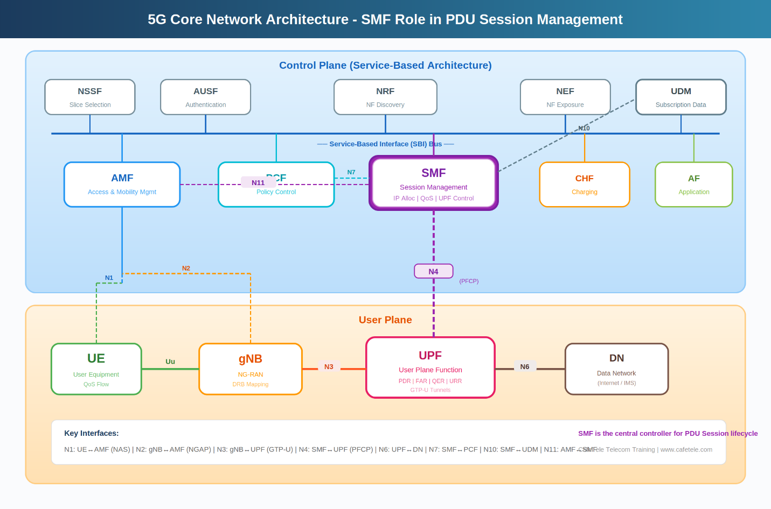
Figure 2.1: 5G Core Network Architecture showing SMF's central role in PDU Session Management

2.3 Control Plane - Service-Based Architecture
The control plane contains all the intelligence and decision-making functions of the 5G Core. These Network Functions communicate via the Service-Based Interface (SBI) bus, which acts like a communication highway where NFs can discover and invoke each other's services.

2.3.1 Network Functions in Detail
AMF - Access and Mobility Management Function
Role: The AMF is the first point of contact for all UE signaling. It acts as the gateway between the radio access network (RAN) and the core network.
Key Responsibilities:
• Registration Management: Handles UE attach, detach, and periodic registration updates
• Connection Management: Establishes and releases NAS (Non-Access Stratum) connections
• Mobility Management: Tracks UE location, manages handovers, and updates tracking areas
• Authentication: Coordinates with AUSF for UE authentication and security
• NAS Security: Encrypts and protects NAS messages between UE and core
• SMF Selection: Chooses appropriate SMF for PDU Session establishment based on DNN, S-NSSAI, and UE location

Real-World Example:
When you power on your 5G smartphone, the AMF receives your registration request, verifies your identity with AUSF, retrieves your subscription profile from UDM, and assigns a 5G-GUTI (Globally Unique Temporary Identifier) to protect your privacy. If you're roaming, the AMF in the visited network coordinates with your home AMF to validate your credentials.
SMF - Session Management Function ★
Role: The SMF is the central orchestrator for all PDU Sessions, managing the complete lifecycle from establishment through modification to release.
Key Responsibilities:
• Session Lifecycle: Creates, modifies, and releases PDU Sessions
• IP Address Management: Allocates and manages UE IP addresses (IPv4, IPv6, or dual-stack)
• UPF Selection & Control: Selects optimal UPF and manages N4 PFCP sessions
• QoS Management: Creates and enforces QoS flows based on PCC rules from PCF
• Traffic Steering: Programs packet routing rules (PDR/FAR) in UPF
• Charging Coordination: Works with CHF for session-based charging
• Policy Enforcement: Retrieves and applies policies from PCF (Session AMBR, traffic filters)
• Downlink Data Notification: Coordinates with AMF to wake up idle UEs

SMF's Position in Architecture:
The SMF sits at a critical junction in the architecture, connecting control plane functions (AMF, PCF, UDM, CHF) with the user plane (UPF). This unique position makes it the only NF that directly controls data path establishment and traffic flow.
PCF - Policy Control Function
Role: The PCF is the policy brain of the 5G Core, providing dynamic policy rules that govern QoS, charging, and network behaviour.
Key Responsibilities:
• PCC Rules: Generates Packet Detection Rules (SDF filters) and QoS parameters
• QoS Control: Defines 5QI, GFBR, MFBR, and priority for each QoS flow
• Session AMBR: Sets aggregate bandwidth limits per PDU Session
• Traffic Gating: Controls when traffic flows are allowed (gate open/closed)
• Charging Rules: Provides rating groups and charging methods (online/offline)
• Application Detection: Identifies applications via DPI (Deep Packet Inspection) for granular control
Real-World Policy Scenario:
During network congestion, the PCF might reduce Session AMBR for video streaming from 100 Mbps to 50 Mbps while maintaining VoIP call quality at guaranteed bitrates. It could also implement time-based policies, offering unlimited data speeds during off-peak hours (2 AM - 6 AM) to incentivize usage patterns.
UDM - Unified Data Management
Role: The UDM is the central repository for all subscriber data, acting as the database of record for user profiles and credentials.
Key Responsibilities:
• Subscription Management: Stores allowed DNNs, S-NSSAIs, PDU Session types, and service limits
• Authentication Credentials: Manages K (subscriber key), OPc, and authentication vectors
• Session Management Data: Provides default Session AMBR, 5QI, SSC mode, and DNN configurations
• Access Authorization: Controls which network slices and services the subscriber can use
• UE Context: Stores UE capability information, serving AMF/SMF, and current location
Database Structure Example:
For SUPI (imsi-001010123456789), the UDM stores:
• Allowed DNNs: ["internet", "ims", "enterprise.vpn"]
• Default Session AMBR: DL=500 Mbps, UL=100 Mbps
• Subscribed Slices: [{SST=1, SD=0x000001}, {SST=1, SD=0x000002}, {SST=2, SD=0x000005}]
• Default 5QI: 9 (best-effort internet)
• PDU Session Types: ["IPv4", "IPv6", "IPv4v6"]
AUSF - Authentication Server Function
The AUSF handles UE authentication using 5G AKA (Authentication and Key Agreement) or EAP-AKA' protocols. It receives authentication requests from AMF, retrieves credentials from UDM, and generates authentication vectors (RAND, AUTN, XRES*, Kausf) used to verify the UE's identity.
NSSF - Network Slice Selection Function
The NSSF assists the AMF in selecting the appropriate network slice instance for a UE based on subscription data, requested S-NSSAI, location, and slice availability. In multi-slice deployments, the NSSF ensures UEs are directed to the correct slice (e.g., eMBB for smartphones, URLLC for industrial devices).
NRF - NF Repository Function
The NRF acts as the service registry and discovery mechanism. Each NF registers its services (name, version, endpoint, capacity) with the NRF. When a NF needs to invoke another NF's service, it queries the NRF to discover available instances and their network addresses. The NRF enables load balancing and failover by providing multiple service endpoints.
NEF - Network Exposure Function
The NEF provides secure exposure of 5GC capabilities to external applications and third parties. For example, an enterprise application can request QoS on-demand for a specific data flow, or a video streaming service can request bandwidth guarantees. The NEF translates external API calls into internal 5GC operations while maintaining security and isolation.
CHF - Charging Function
The CHF handles both online charging (pre-paid, quota management) and offline charging (post-paid, CDR generation). For each PDU Session, the SMF provides usage reports to CHF, which tracks data volume, session duration, QoS levels, and generates charging records for billing systems.
AF - Application Function
The AF represents external application servers (IMS, video platforms, enterprise apps) that interact with the 5G Core. For instance, an IMS server (acting as AF) can request dedicated QoS flows for voice calls, or a video streaming platform can signal the start/end of a streaming session to optimize network resources.

2.4 User Plane Architecture
The user plane is where actual user data flows. It is completely separated from the control plane, allowing independent scaling and optimization.

2.4.1 UPF - User Plane Function
Role: The UPF is the data plane workhorse, handling packet forwarding, filtering, QoS enforcement, and traffic measurement.
Key Responsibilities:
• Packet Forwarding: Routes packets between gNB (N3) and Data Network (N6)
• GTP-U Tunneling: Encapsulates/decapsulates GTP-U headers for N3 interface
• Traffic Filtering: Applies SDF filters from PCC rules (e.g., match IP 5-tuple)
• QoS Enforcement: Implements traffic shaping, policing, and prioritization per QER
• Buffering: Stores downlink packets when UE is in RRC_IDLE state
• Usage Reporting: Measures data volume, session duration for charging (URR)
• Lawful Intercept: Duplicates packets to mediation devices when authorized

UPF Deployment Models:
Deployment Type | Location | Use Case | Latency
Central UPF | Centralized data center | General internet access, cost-optimized | 20-50ms
Regional UPF | Regional Points of Presence | Distributed traffic load, improved latency | 10-20ms
Edge UPF | Edge locations (cell sites, MEC) | Ultra-low latency apps (AR/VR, gaming, Industry 4.0) | 1-5ms
Roaming UPF | Visited/Home network | V-UPF (local breakout), H-UPF (home routing) | Varies

UPF Data Path Example:
Uplink (UE → Internet):
1. UE sends IP packet (src: 10.45.0.10, dst: 8.8.8.8)
2. gNB encapsulates in GTP-U (N3 tunnel TEID 0x1000)
3. UPF receives on N3, matches PDR #1 (uplink rule)
4. UPF removes GTP-U header, applies QoS shaping per QER
5. UPF performs NAT (if needed), forwards to Internet via N6
Downlink (Internet → UE):
1. Internet packet arrives at UPF (dst: 10.45.0.10)
2. UPF matches PDR #2 (downlink rule for this UE IP)
3. UPF applies FAR: add GTP-U header with gNB TEID 0x2001
4. UPF forwards to gNB IP 192.168.1.50 via N3
5. gNB decapsulates, delivers to UE over radio

2.4.2 gNB - Next Generation NodeB
The gNB is the 5G radio base station that provides wireless connectivity to UEs. While technically part of the RAN (Radio Access Network), it plays a critical role in user plane data delivery.
Key Functions:
• Radio Resource Management: Allocates radio bearers (DRBs) for QoS flows
• QoS Flow Mapping: Maps each QFI to appropriate Data Radio Bearer with matching QoS
• N3 GTP-U Tunneling: Maintains GTP-U tunnels with UPF for each PDU Session
• Mobility: Handles handovers between cells and neighboring gNBs (Xn interface)
• Scheduling: Assigns time-frequency resources to UEs based on channel conditions and QoS requirements

2.4.3 DN - Data Network
The DN represents the external networks that UEs connect to:
• Public Internet: For web browsing, social media, general data services
• IMS (IP Multimedia Subsystem): For VoNR, video calls, RCS messaging
• Enterprise Networks: Corporate intranets, private APNs, IoT platforms
• Content Delivery Networks (CDNs): Video streaming, software updates

2.5 5G Core Interfaces - Complete Reference
The 5G Core uses reference point interfaces (N1, N2, N3, etc.) for point-to-point connections and Service-Based Interfaces (Namf, Nsmf, Npcf, etc.) for service invocations. Understanding these interfaces is crucial for troubleshooting and network design.
Interface | Between | Protocol | Purpose | Key Messages/Services
N1 | UE ↔ AMF | NAS (Non-Access Stratum) | UE-Core signaling for registration and session management | Registration Request/Accept, PDU Session Est Request/Accept
N2 | gNB ↔ AMF | NGAP (NG Application Protocol) | Radio access network control signaling | Initial Context Setup, Handover Request, Paging, PDU Session Resource Setup
N3 | gNB ↔ UPF | GTP-U (User Plane Tunneling) | User plane data tunnel between RAN and core | Encapsulated user IP packets in GTP-U with TEID routing
N4 | SMF ↔ UPF | PFCP (Packet Forwarding Control Protocol) | Control plane management of user plane functions | Session Establishment/Modification/Deletion, PDR/FAR/QER/URR rules
N6 | UPF ↔ DN | IP (varies by DN) | Connection to external data networks | Native IP routing, NAT, firewall integration
N7 | SMF ↔ PCF | HTTP/2 (Npcf_SMPolicyControl) | Session policy retrieval and updates | SM Policy Create/Update/Delete, Event Notifications
N10 | SMF ↔ UDM | HTTP/2 (Nudm_SubscriberDataManagement) | SM subscription data retrieval | Get SM Data (DNN, AMBR, 5QI, SSC mode)
N11 | AMF ↔ SMF | HTTP/2 (Nsmf_PDUSession) | PDU Session management procedures | CreateSMContext, UpdateSMContext, ReleaseSMContext
N15 | AMF ↔ PCF | HTTP/2 (Npcf_AMPolicyControl) | Access and mobility policy | AM Policy Create, UE Policy Association
N8 | AMF ↔ UDM | HTTP/2 (Nudm_UECM, Nudm_SDM) | UE context and subscription management | Registration, UE Context Retrieval, Subscription Data
N12 | AMF ↔ AUSF | HTTP/2 (Nausf_UEAuthentication) | UE authentication | Authentication Request/Response, 5G AKA
N22 | AMF ↔ NSSF | HTTP/2 (Nnssf_NSSelection) | Network slice selection | Slice Selection Request, Available Slices

2.6 Service-Based Interfaces (SBI) - Deep Dive
Unlike traditional 3G/4G networks with hardwired point-to-point interfaces, 5G uses Service-Based Interfaces built on HTTP/2 RESTful APIs. Each Network Function exposes services that other NFs can discover and invoke.

2.6.1 How SBI Works
Service Registration:
1. When an SMF instance starts, it registers with NRF
2. Registration includes: NF Instance ID, service name (Nsmf_PDUSession), endpoint URL, capacity, supported S-NSSAIs
3. NRF stores this information in its service registry
Service Discovery:
1. AMF needs to create a PDU Session for a UE
2. AMF queries NRF: "Find SMF instances supporting DNN='internet' and S-NSSAI={SST=1, SD=0x000001}"
3. NRF returns list of matching SMF instances with endpoint URLs and current load
4. AMF selects SMF based on load balancing algorithm
Service Invocation:
1. AMF sends HTTP POST to https://smf1.operator.com/nsmf-pdusession/v1/sm-contexts
2. Request body contains JSON: {supi, dnn, s-nssai, pduSessionId, n1SmInfo}
3. SMF processes request, creates session context
4. SMF responds with HTTP 201 Created, includes smContextRef for future operations

2.6.2 Real-World SBI Example - PDU Session Establishment
Let's trace the actual HTTP messages when Sarah's phone establishes an internet PDU Session:
Step 1: AMF → SMF (Nsmf_PDUSession_CreateSMContext)
POST /nsmf-pdusession/v1/sm-contexts HTTP/2 Host: smf1.operator5g.com Content-Type: application/json { "supi": "imsi-001010123456789", "pduSessionId": 5, "dnn": "internet", "sNssai": {"sst": 1, "sd": "000001"}, "servingNfId": "amf1.operator5g.com", "servingNetwork": {"mcc": "001", "mnc": "01"}, "n1SmMsg": {"contentId": "n1-pdu-session-est-req"}, "requestType": "INITIAL_REQUEST" }
Step 2: SMF → UDM (Nudm_SDM_Get)
GET /nudm-sdm/v2/imsi-001010123456789/sm-data?dnn=internet HTTP/2 Host: udm1.operator5g.com
UDM Response:
HTTP/2 200 OK Content-Type: application/json { "dnnConfigurations": { "internet": { "pduSessionTypes": {"defaultSessionType": "IPV4"}, "sscModes": {"defaultSscMode": "SSC_MODE_1"}, "5gQosProfile": {"5qi": 9}, "sessionAmbr": {"downlink": "500 Mbps", "uplink": "100 Mbps"} } } }
Step 3: SMF → PCF (Npcf_SMPolicyControl_Create)
POST /npcf-smpolicycontrol/v1/sm-policies HTTP/2 Host: pcf1.operator5g.com Content-Type: application/json { "supi": "imsi-001010123456789", "pduSessionId": 5, "dnn": "internet", "pduSessionType": "IPV4", "ipv4Address": "10.45.0.10", "ratType": "NR", "servingNetwork": {"mcc": "001", "mnc": "01"} }
Benefits of SBI Architecture:
✓ Vendor Interoperability: Different vendors' NFs can communicate via standard HTTP/JSON APIs
✓ Dynamic Scaling: Add/remove NF instances without reconfiguring entire network
✓ Load Balancing: NRF provides multiple endpoints, enabling automatic load distribution
✓ Service Versioning: Multiple API versions can coexist (v1, v2) for gradual upgrades
✓ Cloud-Native: Easy deployment in Kubernetes, containerized environments

2.7 SMF's Strategic Position in 5G Architecture
The SMF occupies a unique and critical position in the 5G Core architecture, acting as the bridge between control plane intelligence and user plane data forwarding.

2.7.1 Why SMF is Central
1. Control-User Plane Integration: SMF is the ONLY control plane NF that directly programs the user plane (via N4 PFCP). All other control NFs interact solely with other control NFs. This makes SMF the critical translation layer that converts policy decisions into actual traffic forwarding rules.
2. Multi-NF Orchestration: During PDU Session establishment, SMF coordinates with at least 5 other NFs:
• AMF: Receives session requests, sends responses
• UDM: Retrieves subscription data
• PCF: Gets policy rules
• UPF: Installs forwarding rules
• CHF: Coordinates charging
3. Session State Management: SMF maintains the authoritative state for each PDU Session including UE IP, QoS flows, tunnel endpoints, PFCP rules, and session status. If SMF fails, all associated PDU Sessions are lost.
4. End-to-End Accountability: From UE request to DN connectivity, SMF tracks the entire lifecycle. It's responsible for ensuring QoS, enforcing policies, reporting usage, and handling failures.

2.7.2 Evolution from 4G to 5G Architecture
Aspect | 4G LTE (EPC) | 5G Core (5GC)
Architecture Style | Point-to-point interfaces | Service-based architecture with HTTP/2 APIs
Session Management | MME + S-GW + P-GW (3 separate entities) | SMF + UPF (control/user plane separated)
Scalability | Coupled control/data planes, limited scaling | Independent scaling of SMF and UPF instances
Protocol | GTP-C (binary protocol) | HTTP/2 with JSON (human-readable, debuggable)
Service Discovery | Static configuration, DNS-based | Dynamic via NRF with load info
Network Slicing | Limited via APNs | Native support with S-NSSAI throughout stack
QoS Model | Bearer-based (default + dedicated bearers) | Flow-based (QoS flows within PDU Session)
Cloud Readiness | Hardware-centric, vendor-locked | Cloud-native, containerized, multi-vendor

Key Architectural Advancement:
In 4G, establishing a data session required the MME to sequentially communicate with S-GW, P-GW, HSS, and PCRF using different protocols. In 5G, the SMF orchestrates parallel service invocations using uniform HTTP/2 APIs, reducing latency from 500ms to under 100ms for session setup.

2.8 Summary - Key Architectural Concepts
The 5G Core architecture represents a paradigm shift in mobile network design:
✓ Service-Based Architecture enables modularity and flexibility
✓ Control/User Plane Separation allows independent scaling and optimization
✓ SMF acts as the central orchestrator for all PDU Session operations
✓ HTTP/2 RESTful APIs replace proprietary protocols, improving interoperability
✓ NRF enables dynamic service discovery and load balancing
✓ Each Network Function has clear, well-defined responsibilities
✓ Reference point interfaces (N1-N22) provide standardized communication
✓ The architecture supports network slicing natively at all layers
Understanding this architecture is essential for:
• Designing 5G network deployments
• Troubleshooting session establishment failures
• Optimizing network performance and resource utilization
• Implementing network automation and orchestration
• Planning capacity and scaling strategies
With this architectural foundation, the subsequent topics will explore detailed signaling flows, state machines, and C++ implementation of SMF-centric PDU Session management.

3. PDU Session Establishment Signaling Flow
The PDU Session Establishment procedure is the most fundamental signaling flow in 5G networks. It represents the moment when a user device transitions from being merely registered with the network to having an active data connection capable of sending and receiving packets to the Internet or other data networks.
This procedure, standardized in 3GPP TS 23.502 Section 4.3.2, involves a carefully orchestrated sequence of 12 steps across 7 network entities: UE, gNB, AMF, SMF, UPF, PCF, and UDM. Each step serves a specific purpose, and understanding this flow is essential for:
• Troubleshooting session establishment failures
• Optimizing network performance and reducing latency
• Implementing 5G core network functions
• Analyzing protocol traces and logs
• Planning capacity and dimensioning network resources

3.1 Overview of the Establishment Flow
The PDU Session Establishment can be conceptually divided into four distinct phases:
Phase | Steps | Primary Action | Key Outcome
Phase A: Request & Context Creation | 1-2 | UE requests session, AMF creates SM context at SMF | SMF becomes aware of session request
Phase B: Policy & Resources | 3-5 | SMF retrieves subscription data, policies, and programs UPF | User plane resources allocated, UE IP assigned
Phase C: Radio Setup | 6-9 | SMF coordinates with AMF/gNB to establish radio bearers | Radio connection configured, UE receives session acceptance
Phase D: Downlink Activation | 10-12 | gNB tunnel info sent to SMF, which activates DL path in UPF | Bidirectional data flow activated, session ACTIVE

Timeline Perspective:
In a well-optimized 5G network, the entire 12-step PDU Session Establishment typically completes in 50-150 milliseconds. Legacy 4G LTE bearer establishment could take 200-500ms, making 5G significantly faster.

3.2 Complete Signaling Flow Diagram
The diagram below illustrates the complete message exchange sequence for PDU Session Establishment. Each numbered step represents a specific message or action, with solid lines indicating requests and dashed lines indicating responses.
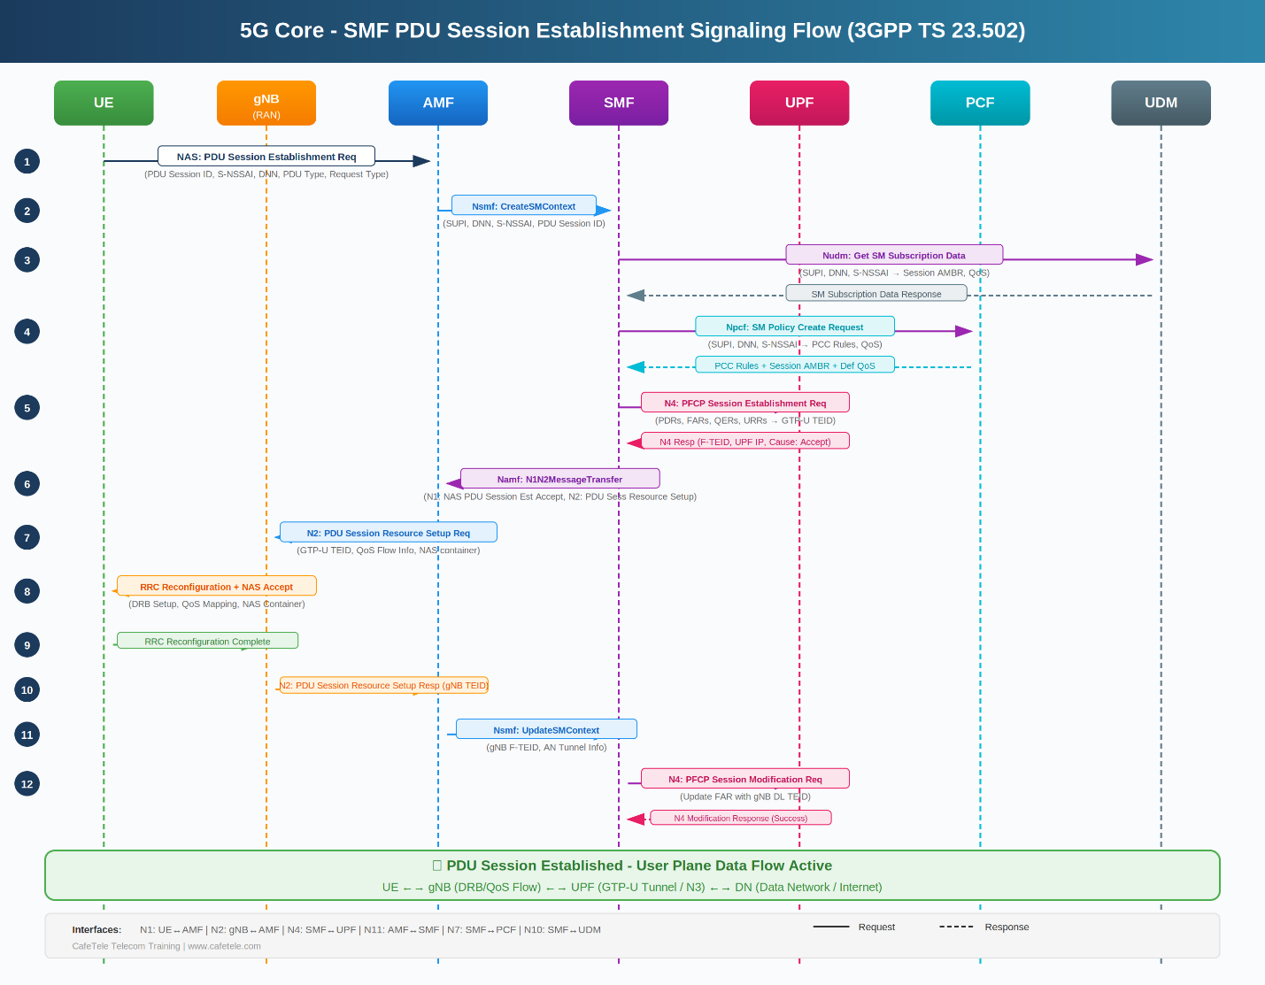
Figure 3.1: PDU Session Establishment Signaling Flow (3GPP TS 23.502 Section 4.3.2)

3.3 Detailed Step-by-Step Explanation
Let's examine each step in detail, including the messages, parameters, protocol details, and real-world implications.
Step 1: UE → AMF - NAS PDU Session Establishment Request
Protocol: NAS (Non-Access Stratum) Session Management
Trigger: This step is triggered when the user initiates any action requiring data connectivity, such as opening a web browser, launching an app, or the operating system performing background synchronization.
Message Contents:
• PDU Session ID: Unique identifier (1-255) for this session, assigned by UE
• S-NSSAI: Network slice identifier (e.g., {SST=1, SD=0x000001} for eMBB)
• DNN (Data Network Name): Requested network (e.g., "internet", "ims")
• PDU Session Type: IPv4, IPv6, IPv4v6, Ethernet, or Unstructured
• Request Type: INITIAL_REQUEST, EXISTING_PDU_SESSION, or EMERGENCY
• SM PDU DN Request Container: Optional application-specific data
Real-World Example:
When Maria opens Chrome on her 5G smartphone, Android detects no active PDU Session for internet access. The modem sends a NAS PDU Session Establishment Request with:
• PDU Session ID: 5
• DNN: "internet"
• S-NSSAI: {SST=1, SD=0x000001}
• PDU Session Type: IPv4
• Request Type: INITIAL_REQUEST
Technical Note: The NAS message is encrypted using NAS security keys established during initial registration. The AMF is the only network function that can decrypt and process this message.
Step 2: AMF → SMF - Nsmf_PDUSession_CreateSMContext
Protocol: HTTP/2 POST (Service-Based Interface)
Purpose: The AMF creates a new SM (Session Management) context at the SMF, delegating all session management responsibilities to the SMF.
Message Contents:
• SUPI (Subscription Permanent Identifier): e.g., imsi-001010123456789
• DNN, S-NSSAI, PDU Session ID: Forwarded from UE's request
• Serving PLMN ID: Mobile Country Code (MCC) + Mobile Network Code (MNC)
• AMF ID: Identifies this AMF instance for future communication
• GUAMI: Globally Unique AMF Identifier
• N1 SM Container: The encrypted NAS PDU Session Establishment Request
• Request Type: INITIAL_REQUEST
SMF Selection Logic:
Before sending this message, the AMF must select an appropriate SMF. The selection criteria include:
1. DNN Support: SMF must support the requested DNN ("internet", "ims", etc.)
2. S-NSSAI Support: SMF must be part of the requested network slice
3. Geographic Location: Prefer SMF instances close to UE's location
4. Load Balancing: Distribute sessions across multiple SMF instances
5. NRF Query: AMF queries NRF to discover available SMF instances
HTTP/2 Request Example:
POST /nsmf-pdusession/v1/sm-contexts HTTP/2 Host: smf1.operator.com:443 Content-Type: application/json { "supi": "imsi-001010123456789", "pduSessionId": 5, "dnn": "internet", "sNssai": {"sst": 1, "sd": "000001"}, "servingNfId": "amf-guid-12345", "servingNetwork": {"mcc": "001", "mnc": "01"}, "requestType": "INITIAL_REQUEST", "n1SmMsg": { "contentId": "n1-msg" } }
Step 3: SMF → UDM - Nudm_SDM_Get (SM Subscription Data)
Protocol: HTTP/2 GET
Purpose: The SMF retrieves the subscriber's session management subscription data from UDM to verify authorization and obtain default parameters.
Retrieved Data Includes:
• Allowed DNNs: List of DNNs the subscriber can access
• PDU Session Types: Supported types (IPv4, IPv6, IPv4v6)
• Session AMBR: Default Aggregate Maximum Bit Rate (DL and UL)
• Default 5QI: Quality of Service Identifier for default flow
• SSC Mode: Session and Service Continuity mode (1, 2, or 3)
• Static IP Address: If configured for this subscriber/DNN
Subscription Data Example:
{ "dnnConfigurations": { "internet": { "pduSessionTypes": { "defaultSessionType": "IPV4", "allowedSessionTypes": ["IPV4", "IPV6", "IPV4V6"] }, "sscModes": { "defaultSscMode": "SSC_MODE_1" }, "5gQosProfile": { "5qi": 9, "priorityLevel": 90 }, "sessionAmbr": { "downlink": "500 Mbps", "uplink": "100 Mbps" }, "staticIpAddress": null } } }
Authorization Check:
If the requested DNN is not in the subscriber's allowed list, the SMF will reject the PDU Session request with cause "DNN_NOT_SUPPORTED" or "INSUFFICIENT_RESOURCES".
Step 4: SMF → PCF - Npcf_SMPolicyControl_Create
Protocol: HTTP/2 POST
Purpose: The SMF requests policy and charging control (PCC) rules from the PCF. These rules govern QoS, traffic filtering, charging, and other policies for the PDU Session.
Policy Rules Retrieved:
• Session AMBR: May override or confirm UDM's default AMBR
• PCC Rules: Traffic detection and QoS enforcement rules
• SDF (Service Data Flow) Filters: IP 5-tuple filters to identify application traffic
• QoS Flows: Default and dedicated QoS flow parameters
• Charging Rules: Online/offline charging, rating groups
• Gate Status: Whether traffic flows are initially OPEN or CLOSED
Example PCC Rule:
Rule Name: "default-internet" Rule ID: 1 Precedence: 100 SDF Filter: permit out from any to any 5QI: 9 ARP Priority: 15 Gate Status: OPEN Charging Key: 1000 Measurement Method: VOLUME
Dynamic Policy Scenario:
During peak hours (12 PM - 2 PM), the PCF might return a reduced Session AMBR of 300 Mbps DL instead of the subscribed 500 Mbps to manage network congestion. The PCF can also create dedicated PCC rules for specific applications (e.g., video streaming gets 5QI=7 with higher priority).
Step 5: SMF → UPF - N4 PFCP Session Establishment
Protocol: PFCP (Packet Forwarding Control Protocol) over UDP
Purpose: This is the moment when the SMF programs the UPF with packet forwarding rules. The SMF translates high-level policies into concrete forwarding actions that the UPF will execute.

PFCP Rules Created:
Rule Type | Direction | Purpose | Configuration
PDR #1 (Uplink) | gNB → UPF | Detect uplink packets from UE | Match: GTP-U TEID from gNB QFI: 1 Action: Apply FAR #1
FAR #1 (Uplink) | UPF → DN | Forward uplink packets to Internet | Action: FORWARD Destination: N6 interface NAT: Apply if needed
PDR #2 (Downlink) | DN → UPF | Detect downlink packets for UE | Match: Destination IP = 10.45.0.10 QFI: 1 Action: Apply FAR #2
FAR #2 (Downlink) | UPF → gNB | Forward downlink packets to gNB | Action: BUFFER (initially) Outer Header: None (gNB TEID unknown) Later updated to FORWARD
QER #1 | Bidirectional | Enforce QoS limits | 5QI: 9 Session AMBR DL: 500 Mbps Session AMBR UL: 100 Mbps Priority: 90
URR #1 | Bidirectional | Measure data usage | Volume Measurement: Both directions Reporting: Every 100 MB Quota: Monitor for monthly cap

Critical Detail - Downlink FAR Buffering:
At this stage, the SMF does NOT yet know the gNB's N3 tunnel endpoint (F-TEID). Therefore, the downlink FAR is configured with action=BUFFER. Any downlink packets arriving at the UPF will be buffered in memory until Step 12, when the SMF updates the FAR to FORWARD with the gNB's TEID.
UPF Response:
The UPF responds with PFCP Session Establishment Response, including:
• UPF N3 F-TEID: GTP-U tunnel endpoint for uplink (e.g., TEID=0x1000, IP=10.200.1.100)
• PFCP Session ID: Unique identifier for this PFCP session
• Cause: SUCCESS or error code
• UE IP Address Allocation: If SMF requested UPF to allocate IP
Step 6: SMF → AMF - Namf_Communication_N1N2MessageTransfer
Protocol: HTTP/2 POST
Purpose: The SMF sends TWO critical containers to the AMF: N1 (for UE) and N2 (for gNB). This is the response to the session establishment request.
N1 Container (for UE via AMF):
• Message: NAS PDU Session Establishment Accept
• UE IP Address: 10.45.0.10
• PDU Session Type: IPv4
• Session AMBR: DL=500 Mbps, UL=100 Mbps
• QoS Rules: Default QoS flow with 5QI=9
• DNN: "internet"
• S-NSSAI: {SST=1, SD=0x000001}
N2 Container (for gNB via AMF):
• Message: PDU Session Resource Setup Request
• UPF N3 TEID: 0x1000
• UPF N3 IP: 10.200.1.100
• QoS Flow List: [QFI=1, 5QI=9, Priority=90]
• Session AMBR: For radio resource allocation
• NAS Container: Encapsulates the PDU Session Accept for UE
Why Two Containers?
The N1 container informs the UE of session acceptance and provides IP addressing. The N2 container instructs the gNB to set up radio bearers with specific QoS parameters and establish a GTP-U tunnel to the UPF. Both must be coordinated because the UE needs radio resources to actually use the IP address.
Step 7: AMF → gNB - N2 PDU Session Resource Setup Request
Protocol: NGAP (NG Application Protocol) over SCTP
Purpose: The AMF forwards the N2 container to the gNB, instructing it to allocate radio resources for the PDU Session.
gNB Actions Upon Receipt:
1. Analyzes QoS requirements for each QoS Flow
2. Maps QoS Flows to Data Radio Bearers (DRBs)
3. Allocates radio resources (frequency, time slots) based on 5QI parameters
4. Creates GTP-U tunnel endpoint (allocates TEID) for downlink from UPF
5. Prepares RRC Reconfiguration message for UE
QoS Flow to DRB Mapping Example:
QoS Flow | 5QI | Priority | PDB | DRB Type | Radio Config
QFI=1 (default) | 9 | 90 | 300ms | Non-GBR DRB | Shared radio resources, best-effort scheduling
QFI=2 (voice) | 1 | 20 | 100ms | GBR DRB | Dedicated resources, strict latency guarantee

Radio Resource Allocation:
For a default internet session (5QI=9), the gNB typically allocates a shared DRB with dynamic scheduling. If the user starts a voice call (5QI=1), the gNB establishes a dedicated DRB with Semi-Persistent Scheduling (SPS) to guarantee low latency and jitter.

Step 8: gNB → UE - RRC Reconfiguration + NAS Accept
Protocol: RRC (Radio Resource Control) + embedded NAS
Purpose: The gNB reconfigures the UE's radio parameters and delivers the NAS PDU Session Establishment Accept message.
RRC Reconfiguration Contents:
• DRB Configuration: PDCP, RLC, MAC layer parameters
• SDAP Configuration: Maps QoS Flows (QFI) to DRBs
• Security: PDCP encryption and integrity protection keys
• QoS Flow Parameters: Reflective QoS configuration
• NAS Container: PDU Session Establishment Accept from SMF
UE Actions Upon Receipt:
1. Processes RRC Reconfiguration, configures DRBs
2. Extracts and decrypts NAS PDU Session Establishment Accept
3. Learns its assigned UE IP address (10.45.0.10)
4. Configures IP stack with the new address
5. Updates PDU Session state to ACTIVE in NAS SM layer
6. Sends RRC Reconfiguration Complete to gNB
What the User Sees:
At this moment, the 5G icon on the smartphone changes from showing only signal bars to displaying "5G" with data connection indicator. The operating system's network status changes from "Mobile Data Off" to "Connected". Applications can now send and receive IP packets.
Step 9: UE → gNB - RRC Reconfiguration Complete
Protocol: RRC (Radio Resource Control)
Purpose: The UE confirms successful DRB setup and activation. This acknowledgment is critical for the gNB to know the radio configuration succeeded.
Message Contents:
• Transaction Identifier: Matches the RRC Reconfiguration request
• Status: SUCCESS (or specific failure cause if any)
• DRB IDs: List of successfully configured bearers
Significance:
At this point, the UE can START transmitting uplink user data. The uplink path is complete: UE → gNB (DRB) → UPF (GTP-U N3) → Internet (N6). However, the downlink path is NOT yet active because the UPF is still buffering packets (waiting for gNB TEID).
Step 10: gNB → AMF - N2 PDU Session Resource Setup Response
Protocol: NGAP (NG Application Protocol)
Purpose: The gNB reports successful radio bearer setup and provides its N3 tunnel endpoint (F-TEID) for downlink data.
Critical Information in Response:
• gNB N3 TEID: e.g., 0x2001 (assigned by gNB)
• gNB N3 IP Address: e.g., 192.168.1.50
• QoS Flow Status: Which QoS flows were successfully mapped to DRBs
• PDU Session ID: 5
• Cause: SUCCESS or partial success/failure
This TEID is the Missing Piece:
Remember in Step 5, the SMF configured the downlink FAR with action=BUFFER because it didn't know the gNB's TEID. Now, with this information, the SMF can complete the puzzle and activate the downlink data path.
Step 11: AMF → SMF - Nsmf_PDUSession_UpdateSMContext
Protocol: HTTP/2 POST
Purpose: The AMF forwards the gNB's N3 tunnel information to the SMF so it can update the UPF.
Message Contents:
• N2 SM Info: Contains gNB N3 F-TEID (TEID + IP)
• AN Tunnel Info: Access Network tunnel details
• QoS Flow Status: Indicates radio setup success
• Context Reference: Points to existing SM context
HTTP Request Example:
POST /nsmf-pdusession/v1/sm-contexts/smf-context-12345 HTTP/2 Host: smf1.operator.com:443 Content-Type: application/json { "n2SmInfo": { "contentId": "n2-info", "ngapData": { "pduSessionResourceSetupResponseTransfer": { "dlQosFlowPerTnlInformation": { "upTransportLayerInformation": { "gtpTunnel": { "transportLayerAddress": "192.168.1.50", "gtpTeid": "0x2001" } } } } } } }
Step 12: SMF → UPF - N4 PFCP Session Modification
Protocol: PFCP (Packet Forwarding Control Protocol)
Purpose: The FINAL STEP! The SMF updates the downlink FAR in the UPF from BUFFER to FORWARD, providing the gNB's TEID. This activates bidirectional data flow.
FAR Update Details:
• FAR ID: #2 (downlink forwarding rule)
• Previous Action: BUFFER
• New Action: FORWARD
• Outer Header Creation:
- GTP-U TEID: 0x2001
- Destination IP: 192.168.1.50 (gNB)
- Destination Port: 2152 (GTP-U)
UPF Actions Upon Receipt:
1. Updates FAR #2 in its forwarding tables
2. Flushes any buffered downlink packets
3. Encapsulates buffered packets with GTP-U header
4. Forwards buffered and new packets to gNB
5. Sends PFCP Session Modification Response to SMF
🎉 PDU Session Fully Established! 🎉
At this moment:
✓ UE has an active IP address (10.45.0.10)
✓ Uplink data path is operational: UE → gNB → UPF → Internet
✓ Downlink data path is operational: Internet → UPF → gNB → UE
✓ QoS enforcement is active (Session AMBR, 5QI)
✓ Charging/billing has started (URR reporting)
✓ User can browse websites, stream videos, use apps

3.4 Timeline and Performance Analysis
Understanding the timing of each step helps in performance optimization and troubleshooting.
Step(s) | Typical Duration | Factors Affecting Timing | Optimization Tips
1-2 | 5-10ms | NAS encryption/decryption, AMF processing, SMF selection via NRF | Cache NRF queries, pre-select SMF pools
3 | 10-20ms | UDM database query latency, network RTT | Use UDM caching, deploy UDM replicas regionally
4 | 10-25ms | PCF policy engine processing, rule generation | Precompute common policies, use policy templates
5 | 15-30ms | PFCP encoding, UPF processing, rule installation | Optimize UPF hardware, use DPDK for packet processing
6-7 | 5-10ms | HTTP/2 latency, NGAP processing | Minimize hops between AMF and gNB
8-9 | 20-50ms | Radio conditions, RRC message size, UE processing | Optimize RRC configuration, reduce message size
10-12 | 10-20ms | N2/N11 latency, PFCP modification | Co-locate SMF and UPF to reduce N4 RTT

Total PDU Session Establishment Time:
• Best Case (optimal network): 50-80ms
• Typical Case (commercial 5G): 80-150ms
• Worst Case (congested/distant NFs): 200-400ms
Comparison with 4G LTE:
4G LTE default bearer establishment typically takes 200-500ms due to sequential processing across MME, S-GW, and P-GW. 5G's service-based architecture enables parallel processing (SMF can query UDM and PCF simultaneously), reducing overall latency by 50-70%.

3.5 Common Failure Scenarios and Troubleshooting
PDU Session establishment can fail at various stages. Understanding failure points helps in rapid troubleshooting.
Failure Point | Cause | Error Message | Troubleshooting
Step 1-2 | UE not registered | NAS reject: NOT_REGISTERED | Verify UE registration state, check AMF logs
Step 3 | DNN not allowed | SM reject: DNN_NOT_SUPPORTED | Check UDM subscription data for allowed DNNs
Step 3 | Subscription expired | SM reject: INSUFFICIENT_RESOURCES | Verify subscriber account status in HSS/UDM
Step 4 | PCF unreachable | Internal SMF error | Check PCF availability, network connectivity
Step 5 | No UPF available | SM reject: UPF_NOT_AVAILABLE | Check UPF pool status, capacity, S-NSSAI support
Step 5 | IP address pool exhausted | SM reject: INSUFFICIENT_RESOURCES | Expand IP pool, check for IP leaks
Step 8-9 | Radio bearer setup failed | RRC failure, no response | Check radio conditions, UE capability, gNB resources
Step 12 | PFCP modification timeout | SMF timeout error | Check N4 connectivity, UPF processing capacity

Debugging with Protocol Traces:
When troubleshooting, capture traces at multiple interfaces:
• N1 (UE-AMF): NAS signaling, check PDU Session request parameters
• N11 (AMF-SMF): Verify CreateSMContext and UpdateSMContext messages
• N4 (SMF-UPF): Validate PFCP session establishment and modification
• N2 (AMF-gNB): Check PDU Session Resource Setup messages
• N3 (gNB-UPF): Confirm GTP-U tunnel establishment

3.6 Key Takeaways
The PDU Session Establishment procedure represents the culmination of 5G's revolutionary architecture:
✓ 12 carefully orchestrated steps across 7 network entities
✓ Completes in 50-150ms (2-5x faster than 4G LTE)
✓ SMF acts as central orchestrator, coordinating UDM, PCF, and UPF
✓ PFCP enables precise control of user plane packet forwarding
✓ Downlink path activation (Step 12) is the final critical piece
✓ Understanding each step is essential for implementation and troubleshooting
This signaling flow forms the foundation for all 5G data connectivity. Mastering it enables engineers to:
• Design and optimize 5G core networks
• Troubleshoot session establishment failures rapidly
• Implement network functions (SMF, AMF, UPF)
• Analyze performance bottlenecks
• Plan capacity and dimensioning
With this comprehensive understanding of the PDU Session Establishment signaling flow, we can now proceed to examine the SMF state machine and C++ implementation in subsequent topics.

4. SMF PDU Session State Machine
The SMF (Session Management Function) State Machine is the core behavioral engine that governs how a PDU Session transitions through its complete lifecycle — from the moment a user device requests connectivity until data flows freely or the session is terminated. It is defined in 3GPP TS 23.502 and represents one of the most important control plane mechanisms in the 5G Core network.

Every PDU Session that exists in a live 5G network is backed by an SMF state machine instance. When you stream a YouTube video on a 5G phone, make a VoNR call, or control a robot on a factory floor over 5G, the SMF's state machine is silently orchestrating the entire setup, management, and eventual teardown of your data session.

3GPP Specification References
• TS 23.502 Section 4.3.2 — PDU Session Establishment Procedure
• TS 29.502 Section 5 — SMF PDU Session Service Operations (Nsmf_PDUSession)
• TS 29.244 — PFCP (Packet Forwarding Control Protocol) for N4 Interface
• TS 24.501 — NAS (Non-Access Stratum) Session Management messages
• TS 23.501 Section 5.7 — QoS Framework and 5QI Table

4.1 What is a State Machine in the Context of 5G SMF?
A state machine is a mathematical model that describes the behavior of a system as it moves through a finite set of well-defined states in response to events or inputs. In the 5G SMF context, each PDU Session has its own state machine that tracks exactly where in the establishment (or teardown) process that session currently is.

Think of the SMF state machine like a hotel check-in process:

- IDLE = No reservation exists — the guest (UE) has not yet requested a room
- SM_CONTEXT_CREATING = The front desk (SMF) has received the booking request and is verifying membership (UDM) and determining room amenities/pricing (PCF)
- N4_SESSION_SETUP = Housekeeping (UPF) is being briefed on which room to prepare and how to handle deliveries (PFCP rules)
- WAITING_AN_TUNNEL = The room is ready, the key has been sent to the guest (NAS Accept), but the guest has not yet arrived at the door (gNB tunnel not yet known)
- N4_SESSION_MODIFYING = The guest has arrived; housekeeping (UPF) is now directed to start delivering items directly to the room (DL FAR activated)
- ACTIVE = Guest is in the room, all services are flowing — minibar, WiFi, room service (full data flow)
- RELEASED = Guest has checked out, room is cleaned up and returned to inventory
- ERROR = Booking failed — room unavailable, authentication failed, or a system error occurred

4.2 Original State Machine Overview (from the Base Document)
The following diagram is the original state machine illustration from the base training document. It provides a high-level overview of the primary states and transitions during PDU Session Establishment.

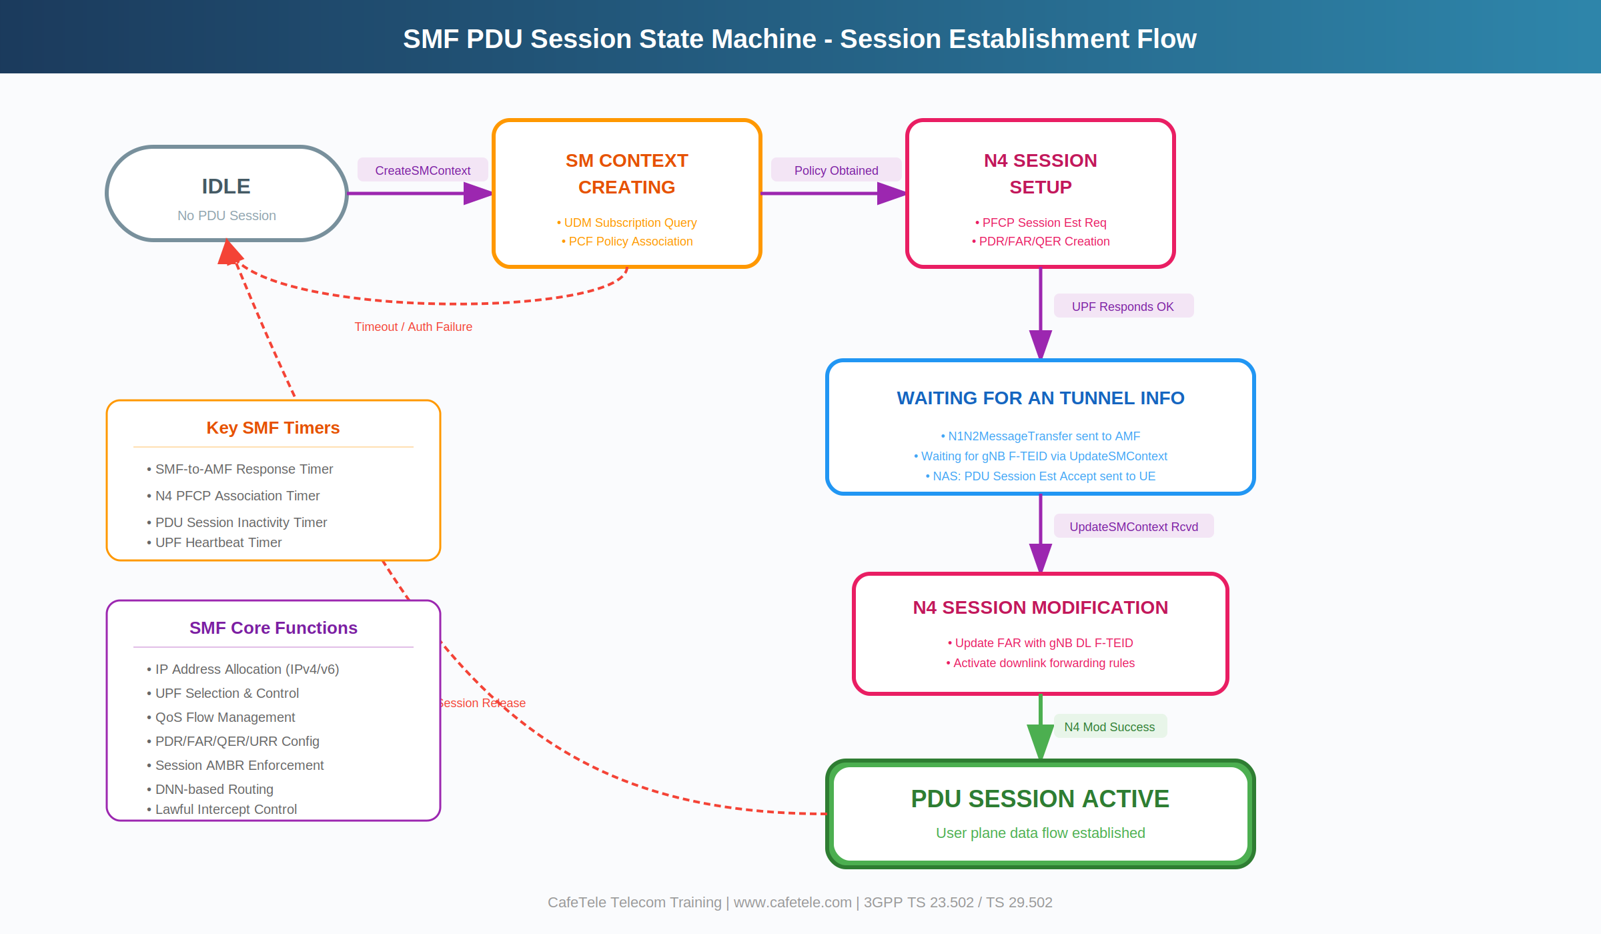
Figure 4.1: Original SMF PDU Session State Machine

4.2.1 State Descriptions (Summary Table)
State | Description & Key Actions
IDLE | No PDU session exists. SMF is waiting for a CreateSMContext request from AMF.
SM_CONTEXT_CREATING | SMF queries UDM for subscription data (N10). Requests PCC rules from PCF (N7). Allocates UE IP address. Creates default QoS flow.
N4_SESSION_SETUP | Creates PFCP session on UPF via N4 interface. Installs PDRs, FARs (DL initially BUFFER), QERs, URRs. UPF returns N3 F-TEID.
WAITING_AN_TUNNEL | SMF sent N1N2MessageTransfer to AMF. Waiting for gNB tunnel info via UpdateSMContext. NAS PDU Session Accept forwarded to UE.
N4_SESSION_MODIFYING | gNB F-TEID received via UpdateSMContext. SMF updates DL FAR from BUFFER to FORWARD with gNB endpoint via N4 PFCP Session Modification.
ACTIVE | PDU Session fully established. Bidirectional user plane data flows: UE <-> gNB (DRB) <-> UPF (GTP-U/N3) <-> DN (N6). Charging URRs running.
RELEASED | Session creation failed or session released by UE/network. All resources freed: IP released, UPF PFCP session deleted, PCF/UDM subscriptions terminated.
ERROR | Authentication failure, PCF/UDM error, UPF PFCP failure, or T3580 timer expiry. AMF notified with appropriate 5GSM cause code.

4.3 Enhanced Complete State Machine Diagram
The enhanced diagram below extends the original by including all states, error paths, the session modification loop (for QoS changes and UE mobility), and the key SMF timers. This represents the full behavioral model as implemented in production 5G cores.

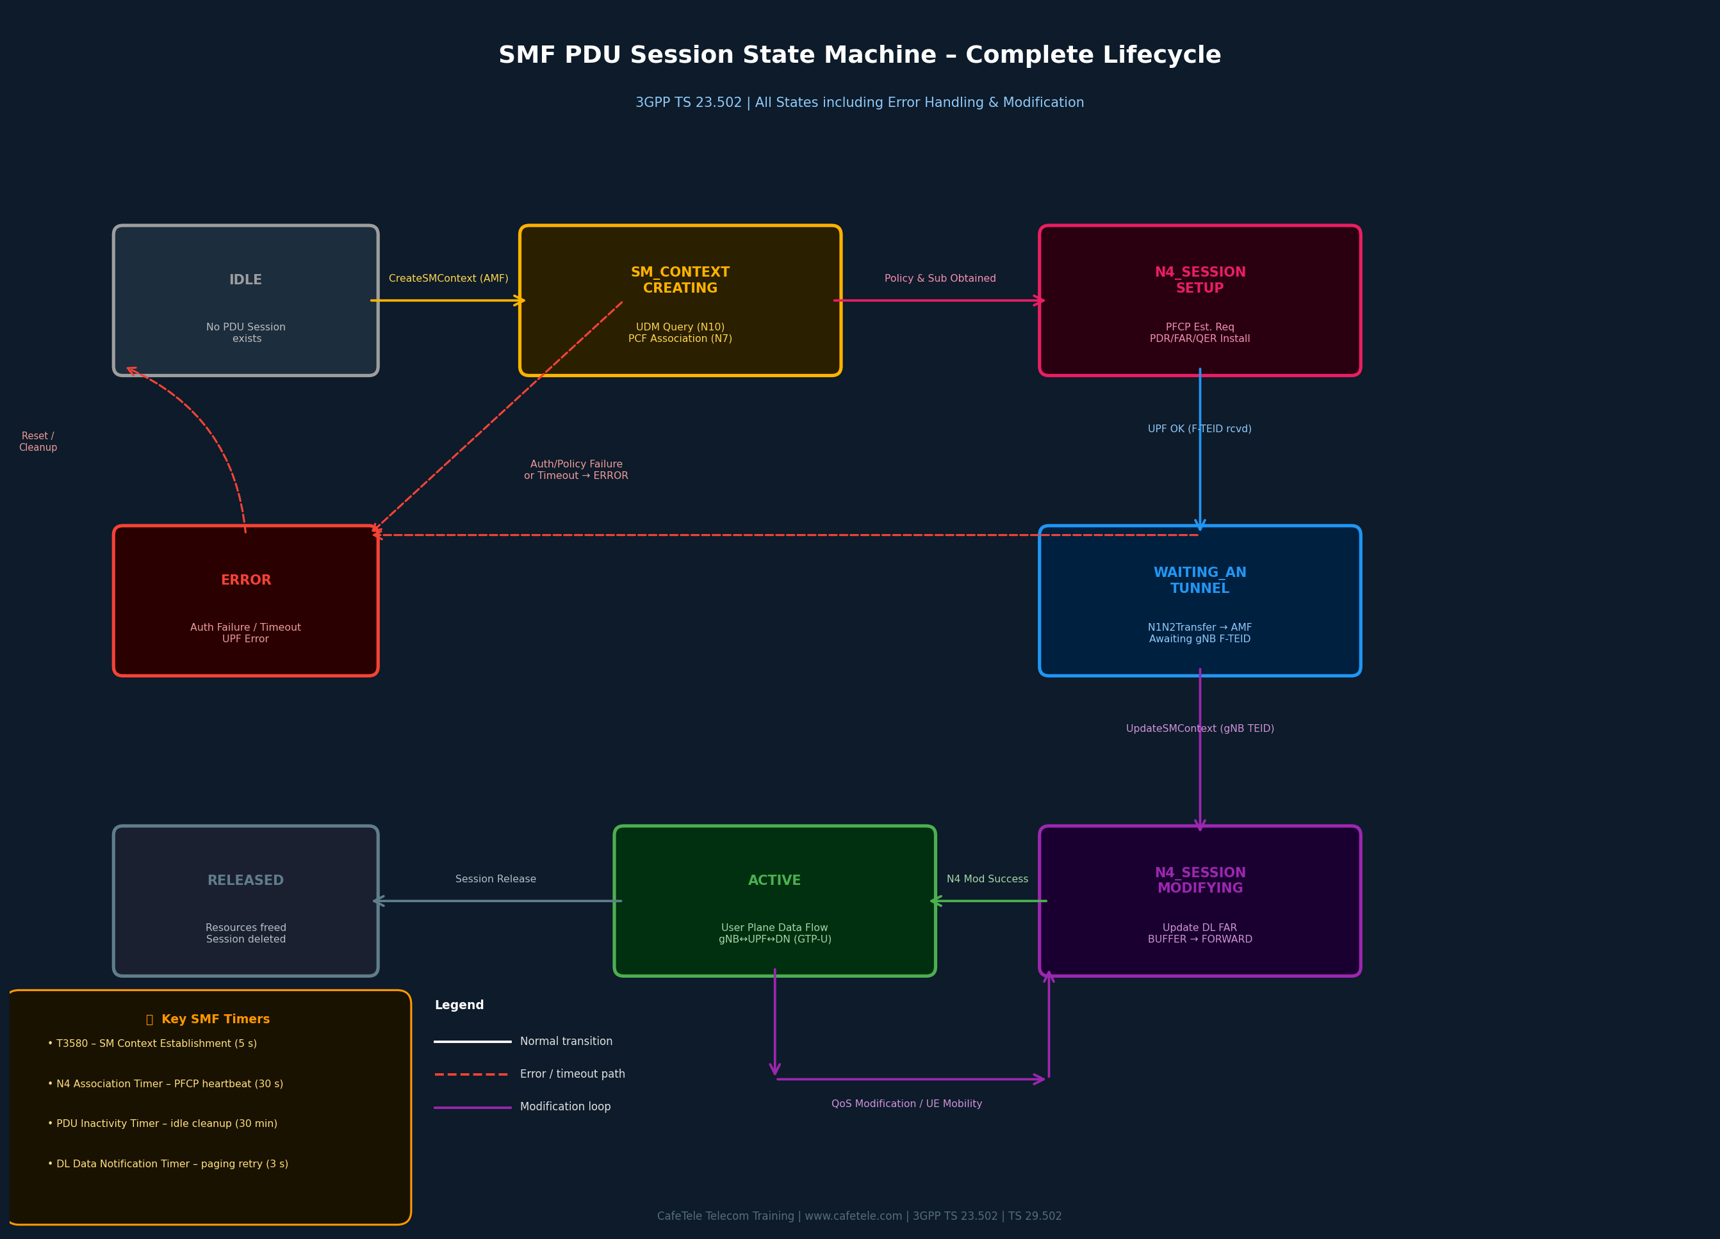
Figure 4.2: Enhanced SMF PDU Session State Machine — Complete Lifecycle including Error Handling & Modification (3GPP TS 23.502)

4.4 Deep Dive: Each State Explained with Real-World Context

4.4.1 IDLE State
The IDLE state is the ground state of the SMF — no PDU session exists, and the SMF holds no session context. The UE may be registered with the network (in CM-CONNECTED or CM-IDLE for signaling), but no user-plane connectivity exists.

Real-World Example: You pick up your phone from sleep. It is registered with the 5G network, but you haven't opened any app yet. No PDU session is active — the UE is in IDLE state from the SMF's perspective. The moment you tap "Instagram," the UE's NAS layer sends a PDU Session Establishment Request, triggering the transition to SM_CONTEXT_CREATING.

Technical Detail: What Triggers Exit from IDLE?
• The AMF sends Nsmf_PDUSession_CreateSMContext to the SMF, carrying:
- SUPI (Subscriber Permanent Identifier)
- DNN (Data Network Name, e.g., "internet", "ims")
- S-NSSAI (Network Slice: SST + SD)
- PDU Session ID (1-255, assigned by AMF)
- N1 SM Container (NAS PDU Session Establishment Request)
- Request Type (Initial Request, Existing PDU Session, etc.)
• SMF validates the request and creates an internal SM Context object
• SMF starts timer T3580 (typically 5 seconds) — session must complete by then

4.4.2 SM_CONTEXT_CREATING State
In this state, the SMF is performing the critical "pre-session" work: verifying the subscriber's authorization, retrieving their subscription profile, and negotiating policy rules. This state involves the most interactions with other NFs.

Interaction | Message / Operation | Purpose
SMF → UDM | Nudm_SDM_Get (UE subscription data) | Fetch allowed DNNs, S-NSSAIs, session AMBR, static IP (if any)
SMF → UDM | Nudm_SDM_Subscribe (change notifications) | SMF subscribes for subscription data changes (e.g., plan upgrade)
SMF → PCF | Npcf_SMPolicyControl_Create | Create SM Policy Association; receive PCC rules, QoS flows, charging rules
SMF internal | UE IP Address Allocation (DHCPv4/v6 or static pool) | Assign UE IP from DNN-specific address pool (e.g., 10.45.0.0/16)
SMF internal | UPF Selection | Select optimal UPF based on UE location (TAI), DNN, load, slice

Real-World Example: Emma is a premium Verizon subscriber roaming in Germany. Her phone connects to Deutsche Telekom's 5G network (V-PLMN). The V-SMF in Germany contacts Emma's H-UDM in the USA to verify she has a roaming subscription for DNN "internet" with 100 Mbps roaming AMBR. The H-PCF is consulted to retrieve her roaming PCC rules. This cross-PLMN lookup happens entirely within the SM_CONTEXT_CREATING state, typically in under 20 ms.

4.4.3 N4_SESSION_SETUP State
This state is where the SMF communicates with the User Plane Function (UPF) using the PFCP (Packet Forwarding Control Protocol) to create a PFCP session and install the initial packet processing rules.

PFCP Rule | Type | Configuration in N4_SESSION_SETUP
PDR-UL | Packet Detection Rule | Match UL packets from UE: Source interface = ACCESS (N3), UE IP in SDF filter. Precedence 100. Linked to FAR-UL.
PDR-DL | Packet Detection Rule | Match DL packets to UE: Destination interface = CORE (N6), match UE IP. Precedence 200. Linked to FAR-DL.
FAR-UL | Forwarding Action Rule | Action: FORWARD. Outer header removal (GTP-U). Destination: N6 interface to DN. Activated immediately.
FAR-DL | Forwarding Action Rule | Action: BUFFER (critical!). gNB DL F-TEID is NOT yet known. UPF will buffer DL packets. Will be updated to FORWARD later.
QER | QoS Enforcement Rule | Enforces Session AMBR (e.g., DL 500 Mbps / UL 100 Mbps). QoS flow bitrate limits. Linked to both PDRs.
URR | Usage Reporting Rule | Online/offline charging triggers. Volume thresholds, time limits. Reports usage events to SMF for CDR generation.

Key Point: The FAR-DL is set to BUFFER during N4_SESSION_SETUP because the gNB (radio base station) tunnel endpoint (F-TEID) is not yet known. The UPF must buffer any incoming downlink packets for the UE until the gNB's TEID is received in the next state. This is why you may notice a brief delay (50-100 ms) on the first downlink packet of a session — the buffer is being flushed.

Real-World Example: A taxi app (Uber/Ola) server sends a push notification to a driver's phone as it's completing session setup. The UPF receives this DL packet and buffers it since the FAR-DL is in BUFFER mode. Once the gNB tunnel is established (50 ms later), the buffered notification packet is immediately forwarded — the driver sees the notification as soon as the session goes ACTIVE.

4.4.4 WAITING_AN_TUNNEL State
After the PFCP session is established with the UPF, the SMF sends the PDU Session Accept to the UE via AMF. The session now "waits" for the radio access network (gNB) to report its tunnel endpoint.

- SMF sends Namf_Communication_N1N2MessageTransfer to AMF containing:
  - N1 SM Container: NAS PDU Session Establishment Accept (UE IP, QoS rules)
  - N2 SM Information: PDU Session Resource Setup Request Transfer (UPF F-TEID for N3)
- AMF forwards N2 SM Info to gNB via NG-AP PDU Session Resource Setup Request
- gNB allocates radio bearer (DRB — Data Radio Bearer) for the QoS flow
- gNB sends NG-AP PDU Session Resource Setup Response with its N3 DL F-TEID to AMF
- AMF triggers Nsmf_PDUSession_UpdateSMContext to SMF with gNB F-TEID

Why This State Can Take the Longest
The WAITING_AN_TUNNEL duration depends on radio conditions and UE processing:
• Fast (20-40 ms): UE is already in RRC_CONNECTED, gNB responds quickly
• Medium (50-100 ms): UE transitions from RRC_IDLE to RRC_CONNECTED during setup
• Slow (200-500 ms): Congested radio, handover in progress, or UE processing delay
• Timeout: T3580 (5 s default) — if UpdateSMContext not received in time, session fails

This is why 5G session establishment time (perceived by the app) correlates strongly
with radio conditions — the control plane is fast, but radio bearer setup is variable.

4.4.5 N4_SESSION_MODIFYING State
Upon receiving the gNB's DL F-TEID, the SMF immediately sends a PFCP Session Modification Request to the UPF to update the DL FAR from BUFFER to FORWARD mode with the gNB's tunnel endpoint.
PFCP Session Modification Request payload (key IE):
IE Name | Value / Content | Purpose
F-SEID | CP F-SEID: SMF's PFCP session ID | Identifies the PFCP session to modify
Update FAR | FAR-ID: DL-FAR, Apply Action: FORWARD, Outer Header Creation: GTP-U, gNB DL TEID, gNB IP | Critical: Switch DL from BUFFER to FORWARD
Create PDR | New PDR for additional QoS flows (if requested by PCF/gNB) | Add dedicated QoS flow (e.g., for voice)

The UPF responds with PFCP Session Modification Response (Cause: Request Accepted). The SMF then sends Nsmf_PDUSession_UpdateSMContext Response (200 OK) to AMF, officially completing the establishment procedure.
Real-World Timing: From the moment the PFCP Session Modification Request is sent to when the UPF responds and the UE receives the first data packet is typically 5-20 ms on a well-connected UPF with low N4 latency.

4.4.6 ACTIVE State
The ACTIVE state is the steady state of a PDU Session. All PFCP rules are operational, data flows bidirectionally, and the SMF primarily monitors events rather than actively configuring network functions. However, ACTIVE is not entirely passive.
Events handled while in ACTIVE state:
- UE Mobility (Xn-based handover): gNB TEID changes, SMF receives UpdateSMContext with new target gNB F-TEID, sends PFCP Session Modification to UPF to update DL FAR — briefly enters N4_SESSION_MODIFYING then returns to ACTIVE
- QoS Flow Modification: PCF sends Npcf_SMPolicyControl_UpdateNotify with new PCC rules, SMF installs new QoS flows via PFCP and updates gNB via N2 SM info
- Downlink Data Notification (DDN): UE in CM-IDLE, UPF buffers DL packet, SMF pages UE via AMF, UE reconnects, SMF updates UPF with new gNB tunnel
- Charging Events: URR reporting thresholds crossed, SMF forwards usage reports to CHF (Charging Function)
- N4 Heartbeat: SMF monitors UPF health via periodic PFCP Heartbeat Request/Response
Real-World Example — UE Mobility: Alice is on a train, streaming a 4K video. Every 30-60 seconds, her phone handovers between different gNBs along the track. For each Xn-based handover, the SMF briefly transitions from ACTIVE to N4_SESSION_MODIFYING (to update the DL FAR with the new gNB's TEID) and back to ACTIVE — all within 10-30 ms. Alice's video never buffers.

4.4.7 ERROR and RELEASED States
These are terminal states — once a session enters ERROR or RELEASED, the SMF performs cleanup and the state machine effectively resets for that session ID.
State | Typical Causes | Cleanup Actions
ERROR | UDM: subscriber not authorized for DNN | PCF: policy reject | UPF: PFCP failure | T3580 timer expiry | IP pool exhausted | Respond to AMF with failure cause | Release IP if allocated | Send PFCP Session Delete if UPF was reached | PCF SM Policy terminate
RELEASED | UE requested release (PDU Session Release Command) | Network initiated release (e.g., subscriber deregistration) | Inactivity timer expiry | PFCP Session Delete (remove all UPF rules) | IP address returned to pool | PCF SM Policy delete | UDM subscription data unsubscribe

The 5GSM Cause Codes (defined in 3GPP TS 24.501) sent to the UE explain why the session failed. Common causes include: #27 (Missing or unknown DNN), #28 (Unknown PDU session type), #50 (PDU session type not allowed), #67 (PDU session does not exist). These appear in the NAS PDU Session Establishment Reject message.

4.5 State Transition Triggers, Guards & Actions
The diagram below provides a comprehensive view of every state transition in the SMF state machine, including the triggering event (what causes the transition), the guard condition (what must be true for the transition to occur), and the actions performed during the transition.

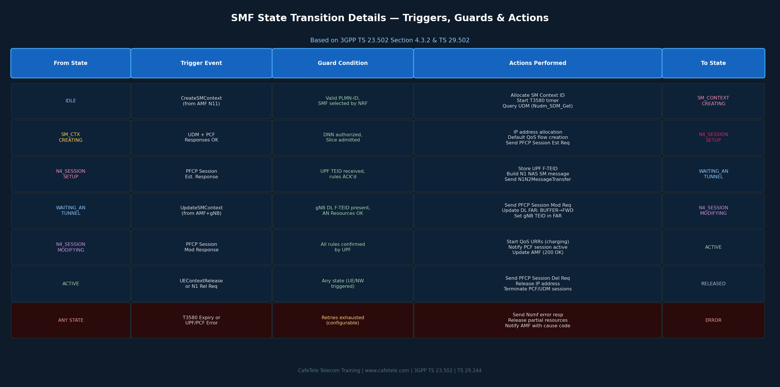
Figure 4.3: SMF State Transition Details — Triggers, Guards & Actions per Transition (3GPP TS 23.502 Section 4.3.2)

4.6 Real-World Scenario Analysis — End-to-End State Machine Walkthrough
The following diagram compares how the SMF state machine behaves across three different real-world use cases, highlighting the different timing profiles depending on the network slice and service type.
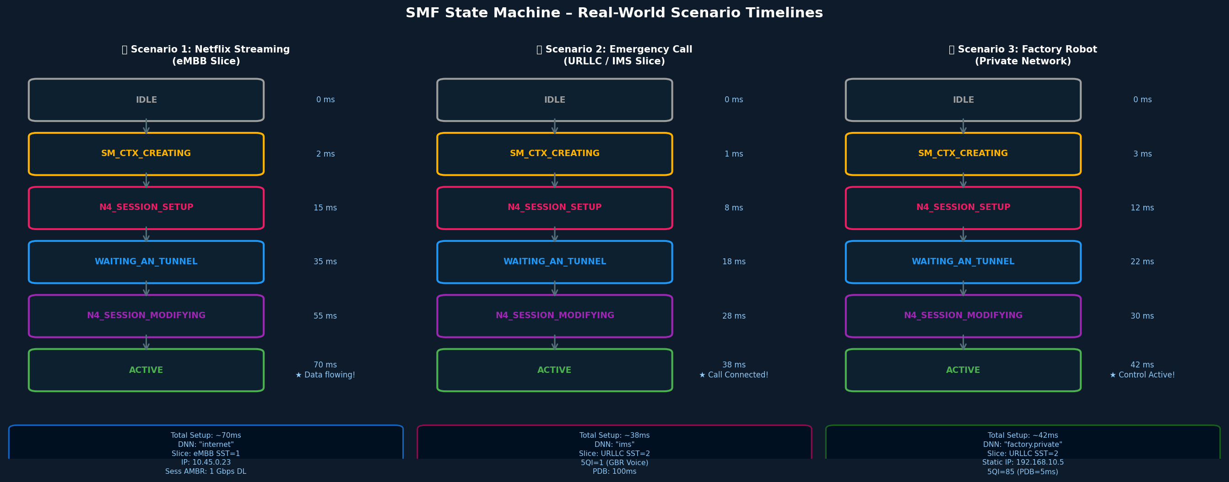
Figure 4.4: SMF State Machine Timing Comparison — eMBB vs URLLC vs Private Network Scenarios

4.6.1 Scenario 1: Video Streaming (eMBB Slice)
Sarah opens Netflix on her 5G smartphone in a major city.
- IDLE → SM_CONTEXT_CREATING (2 ms): AMF sends CreateSMContext. DNN = "internet", S-NSSAI: SST=1 (eMBB). SMF queries UDM and PCF. IP allocated: 10.45.0.23. Session AMBR: DL=1 Gbps / UL=200 Mbps.
- SM_CONTEXT_CREATING → N4_SESSION_SETUP (15 ms): UDM confirms subscription with 1 Gbps data plan. PCF returns PCC rules with 5QI=9 (best-effort internet). SMF selects UPF-1 (co-located with gNB cluster). PFCP Session Establishment sent.
- N4_SESSION_SETUP → WAITING_AN_TUNNEL (35 ms): UPF installs PDRs, FAR-UL=FORWARD, FAR-DL=BUFFER. N1N2 Transfer sent to AMF. gNB receives N2 SM Info, allocates DRB for QFI=1.
- WAITING_AN_TUNNEL → N4_SESSION_MODIFYING (55 ms): AMF sends UpdateSMContext with gNB DL F-TEID. SMF sends PFCP Modification to update FAR-DL to FORWARD → gNB TEID.
- N4_SESSION_MODIFYING → ACTIVE (70 ms): UPF confirms modification. SMF notifies AMF. Netflix CDN stream begins flowing. Sarah's 4K video starts buffering immediately.

Performance Benchmark: Real Network Data
Based on publicly available 5G core performance benchmarks and 3GPP requirements:
• Average eMBB PDU Session Setup Time (median): 50-100 ms end-to-end
• Breakdown: Control plane (AMF/SMF/PCF/UDM) ~30 ms + Radio bearer setup ~40 ms
• 5G SA target: <100 ms for initial data transfer (3GPP TS 22.261)
• URLLC target: <10 ms for critical services on pre-configured slices
• T-Mobile 5G SA measured ~87 ms average (reported at GSMA 2024)

4.6.2 Scenario 2: Emergency Call (IMS/URLLC Slice)
John dials 911 on his 5G phone in an urban area.
Emergency calls are prioritized at every layer. The URLLC slice (SST=2) is pre-configured in most 5G cores with:
- Pre-allocated IP addresses to avoid DHCPv6 latency (static pool)
- Pre-established PFCP N4 associations with all UPFs (no PFCP Association Setup needed)
- Priority 5QI=1 (GBR, PDB=100ms, guaranteed 128 kbps) for voice bearer
- Admission control bypass for emergency sessions (ARP=1 Preemption Capability)

Total session setup: ~38 ms. The URLLC slice achieves this by pre-caching most policy decisions. PCF returns emergency PCC rules from a local cache (<1 ms) rather than fetching from a database. Emergency calls are exempt from normal subscriber authorization checks (a phone can dial 911 without a SIM in some regions).

4.6.3 Scenario 3: Industrial IoT — Factory Robot Control (Private Network)
A robotic welding arm on a BMW factory floor in Munich uses 5G URLLC for real-time control signals.

- DNN: "factory.private.bmw.de" — connects to BMW's private MEC (Multi-access Edge Computing) server
- Static IP: 192.168.10.5 — pre-assigned, no DHCP needed (eliminates 5-10 ms)
- SMF is co-located with gNB at the factory (edge deployment) — reduces N4 RTT to <1 ms
- 5QI=85 (URLLC, PDB=5ms, PER=10^-5) — for control signals, any packet loss stops the robot
- Total setup: ~42 ms including RRC establishment time

The factory private network scenario demonstrates one of the most compelling 5G use cases: the SMF state machine runs on an edge server literally within the factory premises, enabling ultra-low latency (5 ms end-to-end from sensor to actuator) that was impossible with 4G LTE.

4.7 PFCP Rules Lifecycle Across SMF States (N4 Interface)
One of the most technically important aspects of the SMF state machine is understanding how the PFCP (Packet Forwarding Control Protocol) rules evolve at the UPF as the SMF transitions through states. The following diagram maps the PFCP rule state to each SMF state.

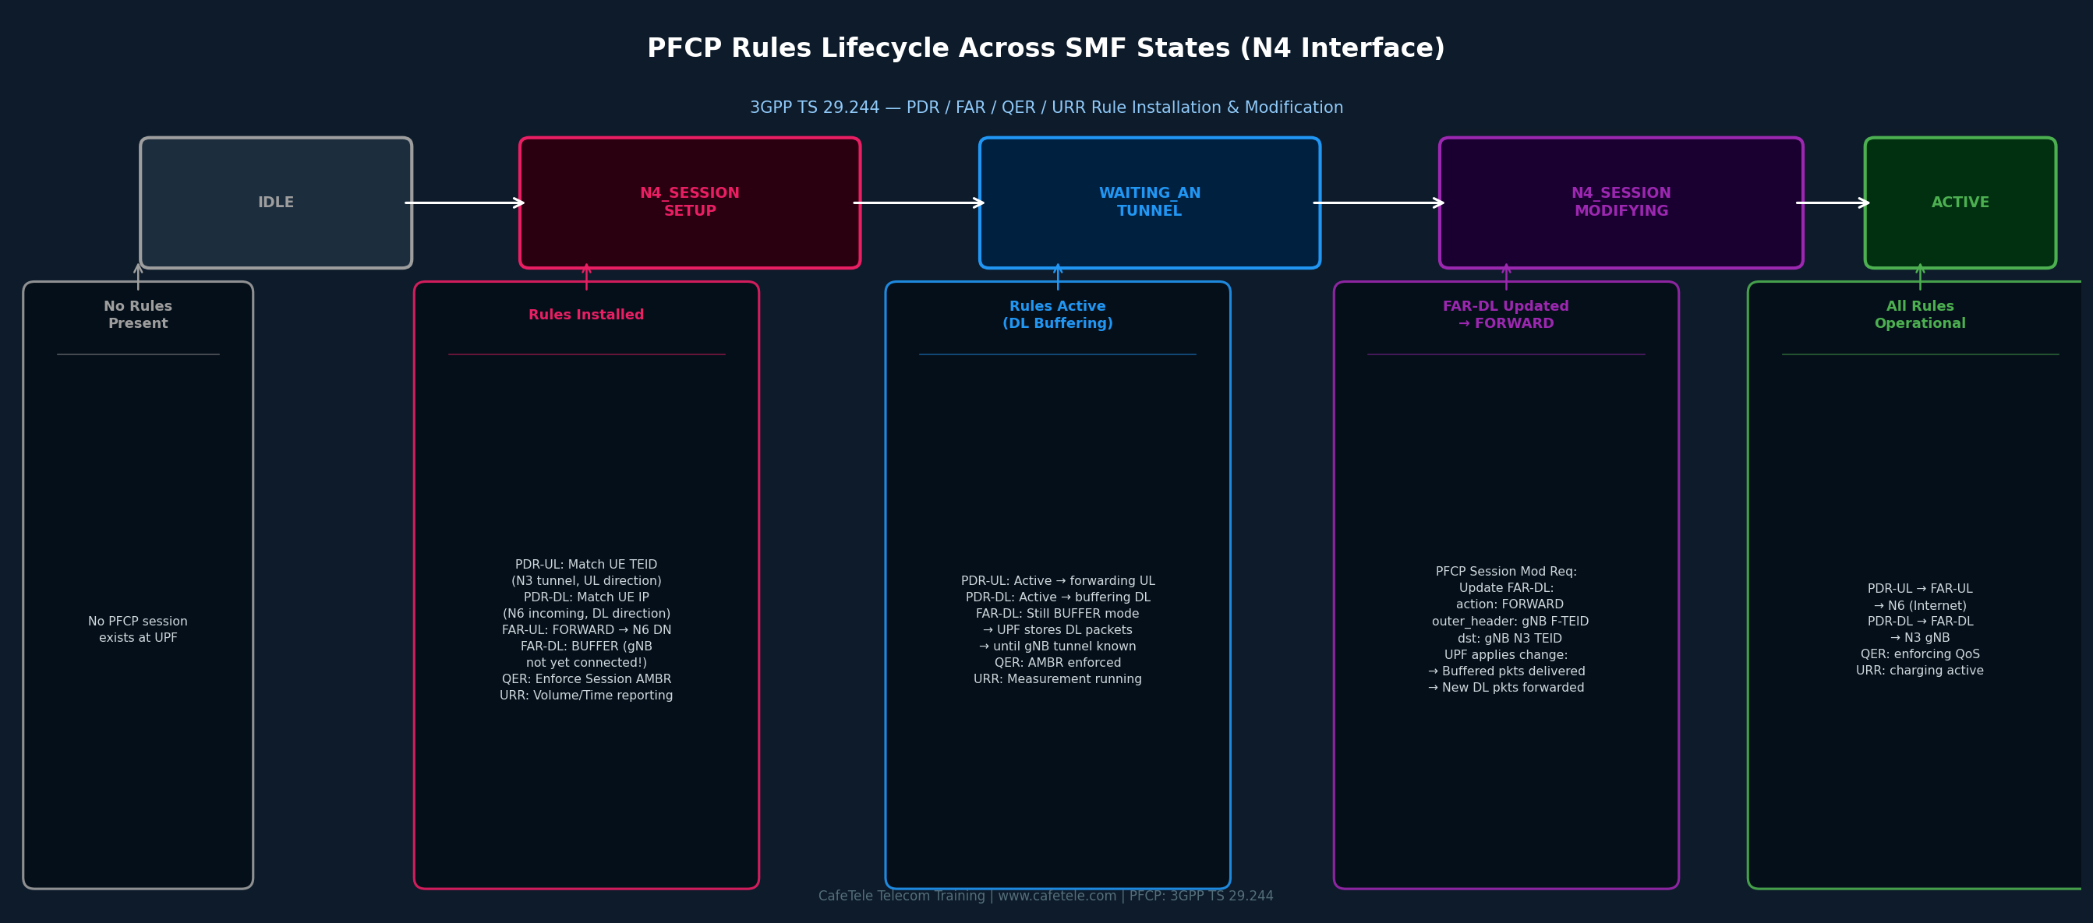
Figure 4.5: PFCP Rules Lifecycle — How PDR/FAR/QER/URR rules evolve across SMF states (3GPP TS 29.244)

The critical insight from this diagram is the FAR-DL transition: it starts as BUFFER and only becomes FORWARD when the gNB's tunnel endpoint is known. This two-phase approach ensures no packets are lost — they are safely buffered in the UPF while the radio bearer is being established. This is a fundamental design choice in the 3GPP standard.

4.8 SMF Timers and Their Role in State Transitions
Timers are essential to the SMF state machine — they define the maximum time the SMF will wait in any given state before taking corrective action (typically moving to ERROR and cleaning up).

Timer Name | Default Value | Active in State | Behavior on Expiry
T3580 (SM Context Timer) | 5 seconds | SM_CONTEXT_CREATING | Session creation fails. AMF notified with cause "Network Failure". UE receives PDU Session Rejection.
N4 PFCP Session Est. Timer | 3 seconds | N4_SESSION_SETUP | SMF retries PFCP establishment up to 3 times, then selects backup UPF or fails session.
AN Tunnel Wait Timer | Implicit (T3580) | WAITING_AN_TUNNEL | If UpdateSMContext not received before T3580, PFCP Session Delete sent to UPF, session fails.
N4 PFCP Association Timer | 30 seconds | ACTIVE (heartbeat) | SMF detects UPF failure. All sessions on that UPF enter ERROR. Triggers UPF failover if redundant UPF exists.
PDU Session Inactivity Timer | 30 minutes (operator) | ACTIVE | Operator-configured. For IoT or enterprise sessions with long idle periods. Triggers network-initiated release to free IP resources.
DL Data Notif. Timer | 3 seconds | ACTIVE (CM-IDLE) | Paging retry timer. If UE does not respond to paging within 3s, AMF retries. After N retries, DL packet dropped.

4.9 SMF State Machine in Session Modification Scenarios
The SMF state machine handles not just initial session establishment but also modifications throughout the ACTIVE lifetime. Three common modification scenarios are explored below.

4.9.1 Scenario: UE Handover (Xn-based)
When a UE moves between two gNBs that are directly connected (Xn interface), the handover is handled at the RAN level first, and then the SMF is notified to update the UPF.

- ACTIVE: Alice's phone is at gNB-A (TEID: 0x00000001)
- gNB-A detects strong signal from gNB-B, initiates Xn handover
- gNB-B confirms radio path; AMF sends UpdateSMContext to SMF with new gNB-B F-TEID
- ACTIVE → N4_SESSION_MODIFYING: SMF sends PFCP Session Modification to update FAR-DL: gNB-B TEID
- UPF switches DL forwarding from gNB-A to gNB-B (atomic operation)
- N4_SESSION_MODIFYING → ACTIVE: Total interruption: <30 ms, imperceptible to the user

4.9.2 Scenario: Dedicated QoS Flow Addition (VoNR mid-session)
Bob is browsing the internet (PDU Session ACTIVE with 5QI=9 default flow). He initiates a VoNR call — this requires adding a dedicated QoS flow with GBR (Guaranteed Bit Rate).

- PCF sends Npcf_SMPolicyControl_UpdateNotify with new PCC rule for voice (5QI=1, GBR 128kbps, PDB=100ms)
- ACTIVE → N4_SESSION_MODIFYING: SMF sends PFCP Session Modification: Create new PDR + FAR + QER for voice flow
- SMF sends N1N2MessageTransfer to AMF with new QoS flow descriptor for gNB
- gNB allocates dedicated radio bearer (DRB) for voice QFI
- N4_SESSION_MODIFYING → ACTIVE: Voice stream begins with guaranteed bitrate

4.9.3 Scenario: UE enters CM-IDLE (Downlink Data Notification)
After 10 seconds of inactivity, the UE's radio enters RRC_IDLE to save battery. The N3 tunnel is released. If a DL packet arrives while the UE is idle:

- DL packet (e.g., WhatsApp message) arrives at UPF from Internet (N6)
- UPF: FAR-DL was pre-set to BUFFER (updated by SMF when UE went idle via UpdateSMContext)
- UPF sends PFCP Session Report Request (with Downlink Data Report IE) to SMF
- SMF sends Namf_Communication_N1N2MessageTransfer (DDN) to AMF (no N2 data, paging trigger)
- AMF initiates NAS Paging to UE (broadcast in tracking area)
- UE wakes up, performs Service Request, re-establishes RRC connection
- AMF sends UpdateSMContext to SMF with new gNB F-TEID
- SMF updates UPF FAR-DL to FORWARD with new gNB TEID (N4_SESSION_MODIFYING → ACTIVE)
- Buffered WhatsApp message delivered — total latency: 200-500 ms

4.10 SMF State Machine: Operator Deployment Considerations
Understanding the state machine is not only important for network function developers but also for operators who design, configure, and troubleshoot 5G core networks.

Concern | State Machine Impact | Operator Action
High session setup latency | Long time in SM_CONTEXT_CREATING (UDM/PCF slow) or WAITING_AN_TUNNEL (radio slow) | Monitor N10/N7 interface latency. Use PCF local caching. Optimize UDM database queries.
Session setup failures | High rate of sessions entering ERROR state. Check 5GSM cause codes. | Monitor T3580 expiry KPI. Check UPF capacity and PFCP association health.
UPF overload | PFCP Session Est Req timeout, sessions stuck in N4_SESSION_SETUP | SMF UPF selection algorithm: avoid overloaded UPFs. Implement UPF auto-scaling on Kubernetes.
IP address exhaustion | Sessions fail in SM_CONTEXT_CREATING with cause #27 (no IP available) | Monitor IP pool utilization. Implement CGNAT for IPv4. Enable dual-stack IPv4v6 to use IPv6 pools.
Handover failures | Sessions drop when transitioning between ACTIVE and N4_SESSION_MODIFYING during handover | Reduce N4 RTT by placing SMF/UPF co-located at edge. Use N4 PFCP buffering for 0ms handover.

4.11 Summary and Key Takeaways
The SMF PDU Session State Machine is the central orchestration engine of 5G data connectivity. It ensures that every data session is established, maintained, and released in a controlled, standardized, and reliable manner.
✅ | The state machine has 8 states: IDLE, SM_CONTEXT_CREATING, N4_SESSION_SETUP, WAITING_AN_TUNNEL, N4_SESSION_MODIFYING, ACTIVE, RELEASED, ERROR
✅ | Each PDU Session maintains its own independent state machine instance
✅ | The critical design point is FAR-DL BUFFER → FORWARD transition: ensures no DL packets are lost during radio bearer setup
✅ | Timer T3580 (5 s) is the global watchdog — session must complete before it expires
✅ | ACTIVE state supports sub-state transitions for handover (via N4_SESSION_MODIFYING loop) without full session teardown
✅ | URLLC slices achieve sub-40ms setup by pre-caching subscriptions, static IPs, and pre-configured PFCP associations
✅ | The state machine design in 3GPP TS 23.502 is the blueprint for all compliant 5G core vendors (Ericsson, Nokia, Huawei, Samsung, Open5GS, free5GC)

5. C++ Implementation
#include <iostream>
#include <string>
#include <vector>
#include <map>
#include <memory>
#include <chrono>
#include <iomanip>
#include <sstream>
#include <random>
#include <algorithm>
#include <ctime>
#include <stdexcept>
#include <optional>

// ═══════════════════════════════════════════════════════════════════════════
// UTILITY CLASSES - Logging and System Tools
// ═══════════════════════════════════════════════════════════════════════════

/**
* @class Logger
* @brief Provides structured logging with timestamps for network function operations
*/
class Logger {
private:
std::string getTimestamp() const {
auto now = std::chrono::system_clock::now();
auto time = std::chrono::system_clock::to_time_t(now);
auto ms = std::chrono::duration_cast<std::chrono::milliseconds>(
now.time_since_epoch()) % 1000;

std::stringstream ss;
ss << std::put_time(std::localtime(&time), "%Y-%m-%d %H:%M:%S");
ss << "." << std::setfill('0') << std::setw(3) << ms.count();
return ss.str();
}

public:
void info(const std::string& module, const std::string& message) const {
std::cout << "[" << getTimestamp() << "] [INFO] [" << module << "] "
<< message << std::endl;
}

void success(const std::string& module, const std::string& message) const {
std::cout << "[" << getTimestamp() << "] [✓ SUCCESS] [" << module << "] "
<< message << std::endl;
}

void error(const std::string& module, const std::string& message) const {
std::cout << "[" << getTimestamp() << "] [✗ ERROR] [" << module << "] "
<< message << std::endl;
}

void warning(const std::string& module, const std::string& message) const {
std::cout << "[" << getTimestamp() << "] [⚠ WARNING] [" << module << "] "
<< message << std::endl;
}

void protocol(const std::string& interface, const std::string& direction,
const std::string& message) const {
std::cout << "[" << getTimestamp() << "] [" << interface << "] "
<< direction << " " << message << std::endl;
}
};

// ═══════════════════════════════════════════════════════════════════════════
// 5G CORE NETWORK DATA STRUCTURES
// ═══════════════════════════════════════════════════════════════════════════

/**
* @enum PDUSessionType
* @brief Defines the types of PDU sessions as per 3GPP TS 23.501
*/
enum class PDUSessionType {
IPv4, ///< IPv4 only
IPv6, ///< IPv6 only
IPv4v6, ///< Dual stack IPv4 and IPv6
Ethernet, ///< Ethernet type
Unstructured ///< Unstructured type (for specific use cases)
};

/**
* @enum SSCMode
* @brief Session and Service Continuity Mode as per 3GPP TS 23.501
*/
enum class SSCMode {
SSC_MODE_1, ///< Maintain UPF anchor point
SSC_MODE_2, ///< Release and re-establish with new UPF
SSC_MODE_3 ///< Make-before-break handover
};

/**
* @struct SNSSAI
* @brief Single Network Slice Selection Assistance Information
* Identifies a network slice as per 3GPP TS 23.003
*/
struct SNSSAI {
uint8_t sst; ///< Slice/Service Type (1-255)
uint32_t sd; ///< Slice Differentiator (24-bit, optional)

std::string toString() const {
std::stringstream ss;
ss << "SST=" << static_cast<int>(sst);
if (sd != 0) {
ss << ", SD=0x" << std::hex << std::setfill('0') << std::setw(6) << sd;
}
return ss.str();
}

bool operator==(const SNSSAI& other) const {
return sst == other.sst && sd == other.sd;
}
};

/**
* @struct QoSFlow
* @brief Quality of Service Flow identifier and parameters
* As per 3GPP TS 23.501 Section 5.7.1
*/
struct QoSFlow {
uint8_t qfi; ///< QoS Flow Identifier (1-63)
uint8_t five_qi; ///< 5G QoS Identifier (5QI)
uint32_t gfbr; ///< Guaranteed Flow Bit Rate (kbps)
uint32_t mfbr; ///< Maximum Flow Bit Rate (kbps)
uint8_t priority; ///< Priority level (1-127, lower is higher priority)
uint16_t packet_delay; ///< Packet Delay Budget (ms)
double packet_error; ///< Packet Error Rate (PER)
bool gfbr_present; ///< Indicates if GFBR is applicable (GBR flows)

/**
* @brief Determines if this is a Guaranteed Bit Rate (GBR) flow
*/
std::string getResourceType() const {
// GBR 5QIs: 1, 2, 3, 4, 65, 66, 67, 75, etc.
return (five_qi <= 4 || five_qi == 65 || five_qi == 66 ||
five_qi == 67 || five_qi == 75) ? "GBR" : "Non-GBR";
}

/**
* @brief Returns the service characteristics based on 5QI
* As per 3GPP TS 23.501 Table 5.7.4-1
*/
std::string getQoSCharacteristics() const {
std::map<uint8_t, std::string> qci_map = {
{1, "Conversational Voice (VoNR, VoLTE)"},
{2, "Conversational Video (Live Streaming)"},
{3, "Real-time Gaming, V2X Messages"},
{4, "Non-Conversational Video (Buffered Streaming)"},
{5, "IMS Signaling"},
{6, "Video (Buffered), TCP-based (HTTP, FTP)"},
{7, "Voice, Video (Live), Interactive Gaming"},
{8, "Video (Buffered), TCP-based Premium"},
{9, "Video (Buffered), TCP-based Standard"},
{65, "Mission Critical PTT Voice"},
{66, "Mission Critical Video"},
{69, "Mission Critical Delay Sensitive Signaling"},
{70, "Mission Critical Data"},
{79, "V2X Messages"},
{80, "Low Latency eMBB Applications"},
{82, "Discrete Automation (Small Packets)"},
{83, "Discrete Automation (Large Packets)"},
{84, "Intelligent Transport Systems"},
{85, "Electricity Distribution (High Voltage)"}
};

auto it = qci_map.find(five_qi);
if (it != qci_map.end()) {
return it->second;
}
return "Standard Data Transfer";
}

/**
* @brief Validates QoS Flow parameters
*/
bool isValid() const {
return qfi >= 1 && qfi <= 63 &&
five_qi >= 1 && five_qi <= 255 &&
priority >= 1 && priority <= 127;
}
};

/**
* @struct FTEID
* @brief Fully Qualified Tunnel Endpoint Identifier
* Used in GTP-U tunneling (3GPP TS 29.281)
*/
struct FTEID {
uint32_t teid; ///< Tunnel Endpoint Identifier
std::string ipv4; ///< IPv4 address of tunnel endpoint
std::string ipv6; ///< IPv6 address of tunnel endpoint (optional)

std::string toString() const {
std::stringstream ss;
ss << "TEID=0x" << std::hex << std::setfill('0') << std::setw(8) << teid
<< std::dec << ", IPv4=" << ipv4;
if (!ipv6.empty()) {
ss << ", IPv6=" << ipv6;
}
return ss.str();
}
};

/**
* @struct PCCRule
* @brief Policy and Charging Control Rule
* Provided by PCF as per 3GPP TS 29.512
*/
struct PCCRule {
std::string rule_id; ///< Unique rule identifier
uint8_t precedence; ///< Rule precedence (lower value = higher priority)
std::string flow_description; ///< Packet filter information
uint8_t qfi; ///< Associated QoS Flow Identifier
bool active; ///< Rule activation status

std::string toString() const {
std::stringstream ss;
ss << "Rule[" << rule_id << "] Precedence=" << static_cast<int>(precedence)
<< ", QFI=" << static_cast<int>(qfi)
<< ", Flow=" << flow_description
<< ", Status=" << (active ? "ACTIVE" : "INACTIVE");
return ss.str();
}
};

// ═══════════════════════════════════════════════════════════════════════════
// PDU SESSION CLASS
// ═══════════════════════════════════════════════════════════════════════════

/**
* @class PDUSession
* @brief Represents a PDU (Protocol Data Unit) Session
*
* Manages the complete lifecycle of a PDU session including IP allocation,
* QoS flows, PCC rules, and traffic statistics.
*/
class PDUSession {
private:
// Session identifiers
uint16_t pdu_session_id;
PDUSessionType session_type;
std::string dnn; ///< Data Network Name
SNSSAI snssai; ///< Network Slice identifier
SSCMode ssc_mode;

// UE addressing
std::string ue_ipv4;
std::string ue_ipv6;

// Tunnel endpoints
FTEID upf_fteid_n3; ///< N3 interface (gNB to UPF)
FTEID upf_fteid_n9; ///< N9 interface (UPF to UPF for roaming)

// QoS and Policy
std::vector<QoSFlow> qos_flows;
std::vector<PCCRule> pcc_rules;

// Session state
std::string state;
uint64_t uplink_bytes;
uint64_t downlink_bytes;
std::chrono::system_clock::time_point establishment_time;

// Random number generation
std::random_device rd;
std::mt19937 gen;

/**
* @brief Generates a random IPv4 address within a subnet
*/
std::string generateIPv4(const std::string& subnet) {
std::uniform_int_distribution<> dist(10, 250);
std::stringstream ss;
ss << subnet << "." << dist(gen);
return ss.str();
}

/**
* @brief Generates a random IPv6 address with a prefix
*/
std::string generateIPv6(const std::string& prefix) {
std::uniform_int_distribution<> dist(0, 65535);
std::stringstream ss;
ss << prefix << ":"
<< std::hex << std::setfill('0') << std::setw(4) << dist(gen) << ":"
<< std::setw(4) << dist(gen) << ":"
<< std::setw(4) << dist(gen) << ":"
<< std::setw(4) << dist(gen);
return ss.str();
}

/**
* @brief Generates a random Tunnel Endpoint Identifier (TEID)
*/
uint32_t generateTEID() {
std::uniform_int_distribution<uint32_t> dist(0x10000000, 0xFFFFFFFF);
return dist(gen);
}

public:
/**
* @brief Constructs a new PDU Session
*/
PDUSession(uint16_t id, PDUSessionType type, const std::string& dnn_name,
const SNSSAI& slice, SSCMode mode)
: pdu_session_id(id), session_type(type), dnn(dnn_name),
snssai(slice), ssc_mode(mode), state("INACTIVE"),
uplink_bytes(0), downlink_bytes(0), gen(rd()) {
establishment_time = std::chrono::system_clock::now();
}

/**
* @brief Allocates IP address(es) to the UE based on session type
*/
void allocateIPAddress() {
if (session_type == PDUSessionType::IPv4 || session_type == PDUSessionType::IPv4v6) {
ue_ipv4 = generateIPv4("10.45.0");
}
if (session_type == PDUSessionType::IPv6 || session_type == PDUSessionType::IPv4v6) {
ue_ipv6 = generateIPv6("2001:db8:5g:ue");
}
}

/**
* @brief Allocates F-TEID for UPF interfaces
*/
void allocateUPFFTEID() {
upf_fteid_n3.teid = generateTEID();
upf_fteid_n3.ipv4 = generateIPv4("192.168.100");

upf_fteid_n9.teid = generateTEID();
upf_fteid_n9.ipv4 = generateIPv4("192.168.101");
}

/**
* @brief Adds a QoS Flow to the session
*/
void addQoSFlow(const QoSFlow& flow) {
if (!flow.isValid()) {
throw std::invalid_argument("Invalid QoS Flow parameters");
}

// Check for duplicate QFI
for (const auto& existing : qos_flows) {
if (existing.qfi == flow.qfi) {
throw std::invalid_argument("QFI " + std::to_string(flow.qfi) + " already exists");
}
}

qos_flows.push_back(flow);
}

/**
* @brief Adds a PCC Rule to the session
*/
void addPCCRule(const PCCRule& rule) {
pcc_rules.push_back(rule);
}

/**
* @brief Updates session state
*/
void setState(const std::string& new_state) {
state = new_state;
}

/**
* @brief Updates traffic statistics
*/
void updateTraffic(uint64_t ul, uint64_t dl) {
uplink_bytes += ul;
downlink_bytes += dl;
}

// ═══════════════════════════════════════════════════════════════════════
// GETTERS
// ═══════════════════════════════════════════════════════════════════════

uint16_t getSessionId() const { return pdu_session_id; }
std::string getDNN() const { return dnn; }
SNSSAI getSNSSAI() const { return snssai; }
std::string getState() const { return state; }
std::string getUEIPv4() const { return ue_ipv4; }
std::string getUEIPv6() const { return ue_ipv6; }
FTEID getUPFFTEIDN3() const { return upf_fteid_n3; }
FTEID getUPFFTEIDN9() const { return upf_fteid_n9; }
const std::vector<QoSFlow>& getQoSFlows() const { return qos_flows; }
const std::vector<PCCRule>& getPCCRules() const { return pcc_rules; }
uint64_t getUplinkBytes() const { return uplink_bytes; }
uint64_t getDownlinkBytes() const { return downlink_bytes; }

std::string getSessionTypeString() const {
switch (session_type) {
case PDUSessionType::IPv4: return "IPv4";
case PDUSessionType::IPv6: return "IPv6";
case PDUSessionType::IPv4v6: return "IPv4v6 (Dual Stack)";
case PDUSessionType::Ethernet: return "Ethernet";
case PDUSessionType::Unstructured: return "Unstructured";
default: return "Unknown";
}
}

std::string getSSCModeString() const {
switch (ssc_mode) {
case SSCMode::SSC_MODE_1: return "SSC Mode 1 (UPF Anchor Maintained)";
case SSCMode::SSC_MODE_2: return "SSC Mode 2 (Release & Re-establish)";
case SSCMode::SSC_MODE_3: return "SSC Mode 3 (Make-Before-Break)";
default: return "Unknown";
}
}

/**
* @brief Calculates session duration
*/
std::string getSessionDuration() const {
auto now = std::chrono::system_clock::now();
auto duration = std::chrono::duration_cast<std::chrono::seconds>(
now - establishment_time);

auto hours = std::chrono::duration_cast<std::chrono::hours>(duration);
duration -= hours;
auto minutes = std::chrono::duration_cast<std::chrono::minutes>(duration);
duration -= minutes;
auto seconds = duration;

std::stringstream ss;
ss << std::setfill('0') << std::setw(2) << hours.count() << ":"
<< std::setw(2) << minutes.count() << ":"
<< std::setw(2) << seconds.count();
return ss.str();
}

/**
* @brief Displays comprehensive session information
*/
void displaySessionInfo() const {
std::cout << "\n╔══════════════════════════════════════════════════════════════════════╗\n";
std::cout << "║ PDU SESSION DETAILED INFORMATION ║\n";
std::cout << "╠══════════════════════════════════════════════════════════════════════╣\n";
std::cout << "║ BASIC INFORMATION ║\n";
std::cout << "╟──────────────────────────────────────────────────────────────────────╢\n";
std::cout << "║ PDU Session ID : " << std::setw(43) << std::left << pdu_session_id << "║\n";
std::cout << "║ State : " << std::setw(43) << state << "║\n";
std::cout << "║ Session Type : " << std::setw(43) << getSessionTypeString() << "║\n";
std::cout << "║ DNN : " << std::setw(43) << dnn << "║\n";
std::cout << "║ S-NSSAI : " << std::setw(43) << snssai.toString() << "║\n";
std::cout << "║ SSC Mode : " << std::setw(43) << getSSCModeString() << "║\n";
std::cout << "║ Session Duration : " << std::setw(43) << getSessionDuration() << "║\n";

std::cout << "╠══════════════════════════════════════════════════════════════════════╣\n";
std::cout << "║ UE IP ADDRESSING ║\n";
std::cout << "╟──────────────────────────────────────────────────────────────────────╢\n";
if (!ue_ipv4.empty()) {
std::cout << "║ UE IPv4 Address : " << std::setw(43) << ue_ipv4 << "║\n";
}
if (!ue_ipv6.empty()) {
std::cout << "║ UE IPv6 Address : " << std::setw(43) << ue_ipv6 << "║\n";
}

std::cout << "╠══════════════════════════════════════════════════════════════════════╣\n";
std::cout << "║ TUNNEL ENDPOINTS (GTP-U) ║\n";
std::cout << "╟──────────────────────────────────────────────────────────────────────╢\n";
std::cout << "║ UPF N3 F-TEID : " << std::setw(43) << upf_fteid_n3.toString() << "║\n";
std::cout << "║ UPF N9 F-TEID : " << std::setw(43) << upf_fteid_n9.toString() << "║\n";

std::cout << "╠══════════════════════════════════════════════════════════════════════╣\n";
std::cout << "║ QoS FLOWS (" << std::setw(2) << qos_flows.size() << ") ║\n";
std::cout << "╠══════════════════════════════════════════════════════════════════════╣\n";

for (size_t i = 0; i < qos_flows.size(); ++i) {
const auto& flow = qos_flows[i];
std::cout << "║ Flow #" << (i+1) << " ║\n";
std::cout << "║ QFI: " << std::setw(2) << static_cast<int>(flow.qfi)
<< " | 5QI: " << std::setw(3) << static_cast<int>(flow.five_qi)
<< " | Type: " << std::setw(8) << flow.getResourceType()
<< " | Priority: " << std::setw(3) << static_cast<int>(flow.priority) << std::setw(15) << " " << "║\n";

std::string chars = flow.getQoSCharacteristics();
if (chars.length() > 60) {
chars = chars.substr(0, 57) + "...";
}
std::cout << "║ Service: " << std::setw(56) << std::left << chars << "║\n";

if (flow.gfbr_present) {
std::cout << "║ GFBR: " << std::setw(7) << flow.gfbr << " kbps | MFBR: "
<< std::setw(7) << flow.mfbr << " kbps" << std::setw(22) << " " << "║\n";
} else {
std::cout << "║ Max Flow BR: " << std::setw(7) << flow.mfbr << " kbps" << std::setw(35) << " " << "║\n";
}

std::cout << "║ Packet Delay Budget: " << std::setw(4) << flow.packet_delay
<< " ms | PER: " << std::scientific << std::setprecision(1)
<< flow.packet_error << std::setw(20) << " " << "║\n" << std::fixed;

if (i < qos_flows.size() - 1) {
std::cout << "╟──────────────────────────────────────────────────────────────────────╢\n";
}
}

std::cout << "╠══════════════════════════════════════════════════════════════════════╣\n";
std::cout << "║ PCC RULES (" << std::setw(2) << pcc_rules.size() << ") ║\n";
std::cout << "╠══════════════════════════════════════════════════════════════════════╣\n";

if (pcc_rules.empty()) {
std::cout << "║ No PCC rules configured ║\n";
} else {
for (const auto& rule : pcc_rules) {
std::string rule_str = rule.toString();
if (rule_str.length() > 67) {
rule_str = rule_str.substr(0, 64) + "...";
}
std::cout << "║ " << std::setw(68) << std::left << rule_str << "║\n";
}
}

std::cout << "╠══════════════════════════════════════════════════════════════════════╣\n";
std::cout << "║ TRAFFIC STATISTICS ║\n";
std::cout << "╠══════════════════════════════════════════════════════════════════════╣\n";

// Format bytes with appropriate units
auto formatBytes = [](uint64_t bytes) -> std::string {
std::stringstream ss;
if (bytes >= 1073741824) { // GB
ss << std::fixed << std::setprecision(2) << (bytes / 1073741824.0) << " GB";
} else if (bytes >= 1048576) { // MB
ss << std::fixed << std::setprecision(2) << (bytes / 1048576.0) << " MB";
} else if (bytes >= 1024) { // KB
ss << std::fixed << std::setprecision(2) << (bytes / 1024.0) << " KB";
} else {
ss << bytes << " bytes";
}
return ss.str();
};

std::cout << "║ Uplink : " << std::setw(43) << formatBytes(uplink_bytes) << "║\n";
std::cout << "║ Downlink : " << std::setw(43) << formatBytes(downlink_bytes) << "║\n";
std::cout << "║ Total : " << std::setw(43) << formatBytes(uplink_bytes + downlink_bytes) << "║\n";
std::cout << "╚══════════════════════════════════════════════════════════════════════╝\n";
}
};

// ═══════════════════════════════════════════════════════════════════════════
// NETWORK FUNCTION SIMULATORS
// ═══════════════════════════════════════════════════════════════════════════

/**
* @class UDMSimulator
* @brief Unified Data Management function simulator
*
* Handles subscription data retrieval and authentication as per 3GPP TS 29.503
*/
class UDMSimulator {
private:
Logger& logger;

public:
UDMSimulator(Logger& log) : logger(log) {}

/**
* @brief Retrieves subscription data for a given SUPI
*/
bool getSubscriptionData(const std::string& supi, const SNSSAI& snssai, const std::string& dnn) {
logger.protocol("N8 (SMF->UDM)", "→", "GET /subscription-data/" + supi + "/sm-data");
logger.info("UDM", "Checking subscription authorization for SUPI=" + supi);
logger.info("UDM", "Verifying S-NSSAI: " + snssai.toString() + ", DNN: " + dnn);

// Simulate subscription database lookup
logger.info("UDM", "Querying subscription database (UDSF)...");
logger.info("UDM", "Validating DNN access permissions...");
logger.info("UDM", "Validating Network Slice access permissions...");

// Simulate successful authorization
logger.success("UDM", "Subscription data retrieved - Authorization GRANTED");
logger.info("UDM", "SMF allowed to proceed with PDU Session establishment");
logger.protocol("N8 (UDM->SMF)", "←", "200 OK - Subscription Data");
return true;
}

/**
* @brief Updates session management subscription data
*/
void updateSMSubscription(const std::string& supi, uint16_t pdu_session_id) {
logger.info("UDM", "Updating SM subscription for SUPI=" + supi);
logger.info("UDM", "Recording active PDU Session ID: " + std::to_string(pdu_session_id));
}
};

/**
* @class PCFSimulator
* @brief Policy Control Function simulator
*
* Provides PCC rules for policy enforcement as per 3GPP TS 29.512
*/
class PCFSimulator {
private:
Logger& logger;

public:
PCFSimulator(Logger& log) : logger(log) {}

/**
* @brief Generates PCC rules based on DNN and network slice
*/
std::vector<PCCRule> getPCCRules(const std::string& dnn, const SNSSAI& snssai) {
logger.protocol("N7 (SMF->PCF)", "→", "POST /sm-policies - Request PCC Rules");
logger.info("PCF", "Generating PCC rules for DNN=" + dnn + ", S-NSSAI=" + snssai.toString());

std::vector<PCCRule> rules;

// Generate rules based on DNN
if (dnn == "internet" || dnn == "ims") {
// Default rule for general traffic
PCCRule default_rule;
default_rule.rule_id = "PCC-RULE-DEFAULT";
default_rule.precedence = 100;
default_rule.flow_description = "permit out ip from any to assigned";
default_rule.qfi = 9; // Default QFI
default_rule.active = true;
rules.push_back(default_rule);

// IMS-specific rules
if (dnn == "ims") {
// SIP signaling rule
PCCRule sip_rule;
sip_rule.rule_id = "PCC-RULE-SIP";
sip_rule.precedence = 10;
sip_rule.flow_description = "permit in/out udp from any 5060 to assigned";
sip_rule.qfi = 5; // IMS Signaling
sip_rule.active = true;
rules.push_back(sip_rule);

// RTP media rule
PCCRule rtp_rule;
rtp_rule.rule_id = "PCC-RULE-RTP";
rtp_rule.precedence = 20;
rtp_rule.flow_description = "permit in/out udp from any 16384-32767 to assigned";
rtp_rule.qfi = 1; // Conversational Voice
rtp_rule.active = true;
rules.push_back(rtp_rule);

// RTCP control rule
PCCRule rtcp_rule;
rtcp_rule.rule_id = "PCC-RULE-RTCP";
rtcp_rule.precedence = 30;
rtcp_rule.flow_description = "permit in/out udp from any 16385-32768 to assigned";
rtcp_rule.qfi = 1;
rtcp_rule.active = true;
rules.push_back(rtcp_rule);
}
}

logger.success("PCF", "Generated " + std::to_string(rules.size()) + " PCC rules");
logger.protocol("N7 (PCF->SMF)", "←", "201 Created - PCC Rules Delivered");

for (const auto& rule : rules) {
logger.info("PCF", " ↳ " + rule.toString());
}

return rules;
}

/**
* @brief Notifies about policy updates
*/
void updatePCCRules(uint16_t pdu_session_id) {
logger.protocol("N7 (PCF->SMF)", "←", "NOTIFY - Policy Update for PDU Session " +
std::to_string(pdu_session_id));
logger.info("PCF", "Policy update notification received");
logger.info("PCF", "SMF should re-evaluate QoS and charging policies");
}
};

/**
* @class UPFSimulator
* @brief User Plane Function simulator
*
* Manages PFCP sessions and packet forwarding as per 3GPP TS 29.244
*/
class UPFSimulator {
private:
Logger& logger;
std::map<uint16_t, uint32_t> pfcp_sessions; ///< PDU Session ID -> PFCP Session ID mapping
std::map<uint16_t, std::vector<uint8_t>> session_qfis; ///< Track QFIs per session

public:
UPFSimulator(Logger& log) : logger(log) {}

/**
* @brief Establishes a PFCP session with the UPF
*/
bool establishPFCPSession(uint16_t pdu_session_id, const FTEID& fteid) {
logger.protocol("N4 (SMF->UPF)", "→", "PFCP Session Establishment Request");
logger.info("PFCP", "Creating PFCP session for PDU Session ID: " + std::to_string(pdu_session_id));
logger.info("PFCP", "UPF F-TEID (N3): " + fteid.toString());

// Generate PFCP Session ID (SEID)
uint32_t pfcp_session_id = 0x80000000 | pdu_session_id;
pfcp_sessions[pdu_session_id] = pfcp_session_id;

logger.info("UPF", "Allocating GTP-U tunnel resources for N3 interface");
logger.info("UPF", "Programming Packet Detection Rules (PDRs) for downlink/uplink");
logger.info("UPF", "Programming Forwarding Action Rules (FARs)");
logger.info("UPF", " • FAR 1: Uplink forwarding to Data Network");
logger.info("UPF", " • FAR 2: Downlink forwarding to gNB via N3");
logger.info("UPF", "Programming QoS Enforcement Rules (QERs)");
logger.info("UPF", "Programming Usage Reporting Rules (URRs) for charging");

logger.success("UPF", "PFCP Session established - SEID: 0x" +
std::to_string(pfcp_session_id));
logger.protocol("N4 (UPF->SMF)", "←", "PFCP Session Establishment Response - SUCCESS");
return true;
}

/**
* @brief Modifies an existing PFCP session (e.g., adding QoS flows)
*/
bool modifyPFCPSession(uint16_t pdu_session_id, const QoSFlow& flow) {
auto it = pfcp_sessions.find(pdu_session_id);
if (it == pfcp_sessions.end()) {
logger.error("UPF", "PFCP session not found for PDU Session ID: " +
std::to_string(pdu_session_id));
return false;
}

logger.protocol("N4 (SMF->UPF)", "→", "PFCP Session Modification Request");
logger.info("PFCP", "Modifying PFCP session for PDU Session ID: " + std::to_string(pdu_session_id));
logger.info("PFCP", "Adding QoS Flow - QFI: " + std::to_string(flow.qfi) +
", 5QI: " + std::to_string(flow.five_qi));

logger.info("UPF", "Creating new PDR for QFI " + std::to_string(flow.qfi));
logger.info("UPF", " • PDR ID: " + std::to_string(pdu_session_id * 100 + flow.qfi));
logger.info("UPF", " • QFI marking: " + std::to_string(flow.qfi));
logger.info("UPF", "Updating QoS Enforcement Rules for new flow");
logger.info("UPF", "Configuring traffic shaping:");
logger.info("UPF", " • Maximum Flow Bit Rate: " + std::to_string(flow.mfbr) + " kbps");

if (flow.gfbr_present) {
logger.info("UPF", " • Guaranteed Flow Bit Rate: " + std::to_string(flow.gfbr) + " kbps");
logger.info("UPF", "Reserving dedicated bandwidth for GBR flow");
}

logger.info("UPF", "Configuring QoS parameters:");
logger.info("UPF", " • Priority Level: " + std::to_string(flow.priority));
logger.info("UPF", " • Packet Delay Budget: " + std::to_string(flow.packet_delay) + " ms");

// Track QFI
session_qfis[pdu_session_id].push_back(flow.qfi);

logger.success("UPF", "PFCP Session modified successfully");
logger.success("UPF", "New QoS flow is now active and enforced");
logger.protocol("N4 (UPF->SMF)", "←", "PFCP Session Modification Response - SUCCESS");
return true;
}

/**
* @brief Releases a PFCP session
*/
void releasePFCPSession(uint16_t pdu_session_id) {
auto it = pfcp_sessions.find(pdu_session_id);
if (it == pfcp_sessions.end()) {
logger.warning("UPF", "PFCP session not found for PDU Session ID: " +
std::to_string(pdu_session_id));
return;
}

logger.protocol("N4 (SMF->UPF)", "→", "PFCP Session Deletion Request");
logger.info("PFCP", "Releasing PFCP session for PDU Session ID: " + std::to_string(pdu_session_id));
logger.info("PFCP", "SEID: 0x" + std::to_string(it->second));

logger.info("UPF", "Releasing GTP-U tunnel resources");
logger.info("UPF", "Removing all Packet Detection Rules (PDRs)");
logger.info("UPF", "Removing all Forwarding Action Rules (FARs)");
logger.info("UPF", "Removing all QoS Enforcement Rules (QERs)");
logger.info("UPF", "Removing all Usage Reporting Rules (URRs)");
logger.info("UPF", "Flushing buffered packets for this session");

pfcp_sessions.erase(it);
session_qfis.erase(pdu_session_id);

logger.success("UPF", "PFCP Session deleted successfully");
logger.success("UPF", "All resources released");
logger.protocol("N4 (UPF->SMF)", "←", "PFCP Session Deletion Response - SUCCESS");
}

/**
* @brief Gets statistics for a PFCP session
*/
void getSessionStats(uint16_t pdu_session_id) {
auto it = pfcp_sessions.find(pdu_session_id);
if (it == pfcp_sessions.end()) {
logger.error("UPF", "PFCP session not found");
return;
}

logger.info("UPF", "Session statistics for PDU Session " + std::to_string(pdu_session_id));
logger.info("UPF", " • Active QFIs: " + std::to_string(session_qfis[pdu_session_id].size()));
logger.info("UPF", " • PFCP SEID: 0x" + std::to_string(it->second));
}
};

// ═══════════════════════════════════════════════════════════════════════════
// SMF SIMULATOR - MAIN SESSION MANAGER
// ═══════════════════════════════════════════════════════════════════════════

/**
* @class SMFSimulator
* @brief Session Management Function simulator
*
* Main class orchestrating PDU session lifecycle management
*/
class SMFSimulator {
private:
Logger logger;
UDMSimulator udm;
PCFSimulator pcf;
UPFSimulator upf;
std::map<uint16_t, std::unique_ptr<PDUSession>> sessions;
uint16_t next_session_id;

/**
* @brief Creates a default Non-GBR QoS flow (QoS Flow ID 9, 5QI 9)
*/
QoSFlow createDefaultQoSFlow() const {
QoSFlow flow;
flow.qfi = 9;
flow.five_qi = 9; // Default bearer
flow.gfbr = 0;
flow.mfbr = 100000; // 100 Mbps max
flow.priority = 80;
flow.packet_delay = 300; // 300 ms
flow.packet_error = 1e-6;
flow.gfbr_present = false;
return flow;
}

/**
* @brief Creates a Voice QoS flow (GBR, 5QI 1)
*/
QoSFlow createVoiceQoSFlow() const {
QoSFlow flow;
flow.qfi = 1;
flow.five_qi = 1; // Conversational Voice
flow.gfbr = 128; // 128 kbps guaranteed
flow.mfbr = 256; // 256 kbps max
flow.priority = 20; // High priority
flow.packet_delay = 100; // 100 ms delay budget
flow.packet_error = 1e-2;
flow.gfbr_present = true;
return flow;
}

/**
* @brief Creates a Video QoS flow (GBR, 5QI 2)
*/
QoSFlow createVideoQoSFlow() const {
QoSFlow flow;
flow.qfi = 2;
flow.five_qi = 2; // Conversational Video
flow.gfbr = 4000; // 4 Mbps guaranteed
flow.mfbr = 10000; // 10 Mbps max
flow.priority = 40;
flow.packet_delay = 150; // 150 ms delay budget
flow.packet_error = 1e-3;
flow.gfbr_present = true;
return flow;
}

/**
* @brief Creates a Gaming QoS flow (GBR, 5QI 3)
*/
QoSFlow createGamingQoSFlow() const {
QoSFlow flow;
flow.qfi = 3;
flow.five_qi = 3; // Real-time Gaming
flow.gfbr = 5000; // 5 Mbps guaranteed
flow.mfbr = 15000; // 15 Mbps max
flow.priority = 30;
flow.packet_delay = 50; // 50 ms delay budget (low latency)
flow.packet_error = 1e-3;
flow.gfbr_present = true;
return flow;
}

public:
SMFSimulator() : udm(logger), pcf(logger), upf(logger), next_session_id(1) {
logger.info("SMF", "═══════════════════════════════════════════════════════════");
logger.info("SMF", " 5G Core SMF Simulator initialized");
logger.info("SMF", " Version: 2.1 Enhanced Edition");
logger.info("SMF", " Standards: 3GPP TS 23.502, TS 29.502, TS 29.244");
logger.info("SMF", "═══════════════════════════════════════════════════════════");
logger.info("SMF", "Ready to handle PDU Session establishment requests");
}

/**
* @brief Establishes a new PDU Session
*
* Implements the complete PDU Session Establishment procedure as per
* 3GPP TS 23.502 Section 4.3.2
*/
bool establishPDUSession(PDUSessionType type, const std::string& dnn,
const SNSSAI& snssai, SSCMode ssc_mode) {
std::cout << "\n" << std::string(80, '=') << "\n";
logger.info("SMF", "╔════════════════════════════════════════════════════════════╗");
logger.info("SMF", "║ INITIATING PDU SESSION ESTABLISHMENT PROCEDURE ║");
logger.info("SMF", "╚════════════════════════════════════════════════════════════╝");

uint16_t pdu_session_id = next_session_id++;
std::string supi = "imsi-001010000000001";

logger.info("SMF", "Request Parameters:");
logger.info("SMF", " • PDU Session ID: " + std::to_string(pdu_session_id));
logger.info("SMF", " • SUPI: " + supi);
logger.info("SMF", " • DNN: " + dnn);
logger.info("SMF", " • S-NSSAI: " + snssai.toString());

try {
// ═══════════════════════════════════════════════════════════════
// STEP 1: UDM Subscription Authorization
// ═══════════════════════════════════════════════════════════════
logger.info("SMF", "\n[STEP 1/7] UDM Subscription Authorization");
logger.info("SMF", "───────────────────────────────────────────");
if (!udm.getSubscriptionData(supi, snssai, dnn)) {
logger.error("SMF", "Subscription authorization failed");
logger.error("SMF", "PDU Session establishment ABORTED");
return false;
}

// ═══════════════════════════════════════════════════════════════
// STEP 2: Create PDU Session Context
// ═══════════════════════════════════════════════════════════════
logger.info("SMF", "\n[STEP 2/7] Creating PDU Session Context");
logger.info("SMF", "───────────────────────────────────────────");
auto session = std::make_unique<PDUSession>(pdu_session_id, type, dnn, snssai, ssc_mode);
logger.success("SMF", "PDU Session context created in memory");
logger.info("SMF", "Session will use " + session->getSSCModeString());

// ═══════════════════════════════════════════════════════════════
// STEP 3: UPF Selection
// ═══════════════════════════════════════════════════════════════
logger.info("SMF", "\n[STEP 3/7] UPF Selection (N4 Interface)");
logger.info("SMF", "───────────────────────────────────────────");
logger.info("SMF", "Evaluating UPF candidates based on:");
logger.info("SMF", " • Network slice requirements (S-NSSAI)");
logger.info("SMF", " • DNN routing policies");
logger.info("SMF", " • Geographic proximity to UE");
logger.info("SMF", " • Current load and available capacity");
logger.info("SMF", " • Required service quality");
logger.success("SMF", "Selected UPF: UPF-REGION-01");
logger.info("SMF", " • UPF Address: 192.168.100.1");
logger.info("SMF", " • Location: Core DC Region 1");
logger.info("SMF", " • Load: 45% (within capacity)");

// ═══════════════════════════════════════════════════════════════
// STEP 4: IP Address Allocation
// ═══════════════════════════════════════════════════════════════
logger.info("SMF", "\n[STEP 4/7] IP Address Allocation");
logger.info("SMF", "───────────────────────────────────────────");
logger.info("SMF", "Allocating IP address from pool for DNN: " + dnn);
session->allocateIPAddress();
session->allocateUPFFTEID();

if (!session->getUEIPv4().empty()) {
logger.success("SMF", "UE IPv4 allocated: " + session->getUEIPv4());
}
if (!session->getUEIPv6().empty()) {
logger.success("SMF", "UE IPv6 allocated: " + session->getUEIPv6());
}

logger.info("SMF", "F-TEID allocation for GTP-U tunnels:");
logger.info("SMF", " • N3 Interface (gNB↔UPF): " + session->getUPFFTEIDN3().toString());
logger.info("SMF", " • N9 Interface (UPF↔UPF): " + session->getUPFFTEIDN9().toString());

// ═══════════════════════════════════════════════════════════════
// STEP 5: PCF Interaction (Policy Control)
// ═══════════════════════════════════════════════════════════════
logger.info("SMF", "\n[STEP 5/7] Policy Control Function (PCF) Interaction");
logger.info("SMF", "───────────────────────────────────────────");
logger.info("SMF", "Requesting PCC rules from PCF via N7 interface");
auto pcc_rules = pcf.getPCCRules(dnn, snssai);

for (const auto& rule : pcc_rules) {
session->addPCCRule(rule);
}
logger.success("SMF", "PCC rules installed: " + std::to_string(pcc_rules.size()) + " rule(s)");

// ═══════════════════════════════════════════════════════════════
// STEP 6: Default QoS Flow Establishment
// ═══════════════════════════════════════════════════════════════
logger.info("SMF", "\n[STEP 6/7] QoS Flow Establishment");
logger.info("SMF", "───────────────────────────────────────────");
logger.info("SMF", "Creating default QoS flow for session");
QoSFlow default_flow = createDefaultQoSFlow();
session->addQoSFlow(default_flow);
logger.success("SMF", "Default QoS Flow created:");
logger.info("SMF", " • QFI: " + std::to_string(default_flow.qfi));
logger.info("SMF", " • 5QI: " + std::to_string(default_flow.five_qi));
logger.info("SMF", " • Type: " + default_flow.getResourceType());
logger.info("SMF", " • Service: " + default_flow.getQoSCharacteristics());

// ═══════════════════════════════════════════════════════════════
// STEP 7: PFCP Session with UPF
// ═══════════════════════════════════════════════════════════════
logger.info("SMF", "\n[STEP 7/7] PFCP Session Establishment (N4 Interface)");
logger.info("SMF", "───────────────────────────────────────────");
logger.info("SMF", "Establishing PFCP session with selected UPF");
if (!upf.establishPFCPSession(pdu_session_id, session->getUPFFTEIDN3())) {
logger.error("SMF", "PFCP session establishment failed");
logger.error("SMF", "PDU Session establishment ABORTED");
return false;
}

// ═══════════════════════════════════════════════════════════════
// Session Activation
// ═══════════════════════════════════════════════════════════════
session->setState("ACTIVE");
udm.updateSMSubscription(supi, pdu_session_id);

// Success notification
logger.info("SMF", "\n");
logger.success("SMF", "╔════════════════════════════════════════════════════════════╗");
logger.success("SMF", "║ PDU SESSION ESTABLISHMENT COMPLETED SUCCESSFULLY! ║");
logger.success("SMF", "╚════════════════════════════════════════════════════════════╝");
logger.info("SMF", "");
logger.info("SMF", "Session Status:");
logger.info("SMF", " • PDU Session ID: " + std::to_string(pdu_session_id));
logger.info("SMF", " • State: ACTIVE");
logger.info("SMF", " • GTP-U Tunnel: ESTABLISHED");
logger.info("SMF", " • User Plane: READY FOR DATA TRANSFER");
logger.info("SMF", " • QoS Flows: " + std::to_string(session->getQoSFlows().size()));
logger.info("SMF", " • PCC Rules: " + std::to_string(session->getPCCRules().size()));
std::cout << std::string(80, '=') << "\n";

// Store session
sessions[pdu_session_id] = std::move(session);

return true;

} catch (const std::exception& e) {
logger.error("SMF", "Exception during PDU Session establishment: " + std::string(e.what()));
logger.error("SMF", "PDU Session establishment FAILED");
return false;
}
}

/**
* @brief Adds a new QoS flow to an existing PDU session
*/
bool addQoSFlow(uint16_t pdu_session_id, const QoSFlow& flow) {
auto it = sessions.find(pdu_session_id);
if (it == sessions.end()) {
logger.error("SMF", "PDU Session not found: " + std::to_string(pdu_session_id));
return false;
}

std::cout << "\n" << std::string(80, '=') << "\n";
logger.info("SMF", "╔════════════════════════════════════════════════════════════╗");
logger.info("SMF", "║ QoS FLOW ADDITION PROCEDURE ║");
logger.info("SMF", "╚════════════════════════════════════════════════════════════╝");

logger.info("SMF", "Target PDU Session ID: " + std::to_string(pdu_session_id));
logger.info("SMF", "New QoS Flow Parameters:");
logger.info("SMF", " • QFI: " + std::to_string(flow.qfi));
logger.info("SMF", " • 5QI: " + std::to_string(flow.five_qi));
logger.info("SMF", " • Type: " + flow.getResourceType());
logger.info("SMF", " • Service: " + flow.getQoSCharacteristics());
logger.info("SMF", " • Priority: " + std::to_string(flow.priority));

try {
it->second->addQoSFlow(flow);
logger.success("SMF", "QoS flow added to session context");

// Update UPF via PFCP
logger.info("SMF", "Updating UPF with new QoS flow via N4 interface");
if (!upf.modifyPFCPSession(pdu_session_id, flow)) {
logger.error("SMF", "Failed to update UPF");
return false;
}

logger.success("SMF", "╔════════════════════════════════════════════════════════════╗");
logger.success("SMF", "║ QoS FLOW ADDED SUCCESSFULLY! ║");
logger.success("SMF", "╚════════════════════════════════════════════════════════════╝");
logger.info("SMF", "New QoS flow is active and ready for traffic");
std::cout << std::string(80, '=') << "\n";

return true;

} catch (const std::exception& e) {
logger.error("SMF", "Failed to add QoS flow: " + std::string(e.what()));
return false;
}
}

/**
* @brief Displays detailed information for a specific session
*/
void displaySession(uint16_t pdu_session_id) {
auto it = sessions.find(pdu_session_id);
if (it != sessions.end()) {
it->second->displaySessionInfo();
} else {
logger.error("SMF", "PDU Session not found: " + std::to_string(pdu_session_id));
}
}
/**
* @brief Displays a summary of all active sessions
*/
void displayAllSessions() {
std::cout << "\n╔════════════════════════════════════════════════════════════════════════╗\n";
std::cout << "║ ACTIVE PDU SESSIONS SUMMARY ║\n";
std::cout << "╠════════════════════════════════════════════════════════════════════════╣\n";

if (sessions.empty()) {
std::cout << "║ No active sessions ║\n";
} else {
std::cout << "║ ID │ DNN │ State │ Slice │ Flows │ Type ║\n";
std::cout << "╟──────┼─────────────────┼────────────┼──────────────┼───────┼─────────╢\n";

for (const auto& [id, session] : sessions) {
std::string dnn_padded = session->getDNN();
dnn_padded.resize(15, ' ');

std::string state_padded = session->getState();
state_padded.resize(10, ' ');

std::string snssai_str = "SST=" + std::to_string(session->getSNSSAI().sst);
snssai_str.resize(12, ' ');

std::string type = session->getSessionTypeString();
if (type.length() > 7) type = type.substr(0, 7);
type.resize(7, ' ');

std::cout << "║ " << std::setw(4) << std::left << id
<< " │ " << dnn_padded
<< " │ " << state_padded
<< " │ " << snssai_str
<< " │ " << std::setw(5) << session->getQoSFlows().size()
<< " │ " << type << " ║\n";
}
}
std::cout << "╠════════════════════════════════════════════════════════════════════════╣\n";
std::cout << "║ Total Active Sessions: " << std::setw(48) << std::left << sessions.size() << "║\n";
std::cout << "╚════════════════════════════════════════════════════════════════════════╝\n";
}

/**
* @brief Quick test: Establish an Internet PDU session
*/
bool testInternetSession() {
SNSSAI snssai{1, 0x000001}; // eMBB slice (SST=1)
return establishPDUSession(PDUSessionType::IPv4, "internet", snssai, SSCMode::SSC_MODE_1);
}
/**
* @brief Quick test: Establish an IMS PDU session with voice capability
*/
bool testIMSSession() {
SNSSAI snssai{5, 0x000005}; // IMS slice (SST=5)
bool result = establishPDUSession(PDUSessionType::IPv4v6, "ims", snssai, SSCMode::SSC_MODE_2);

if (result && !sessions.empty()) {
uint16_t session_id = sessions.rbegin()->first;
// Automatically add voice QoS flow for IMS
logger.info("SMF", "\nAutomatically adding Voice QoS flow for IMS session...");
addQoSFlow(session_id, createVoiceQoSFlow());
}

return result;
}
/**
* @brief Adds a voice QoS flow to the most recent session
*/
void addVoiceFlow() {
if (sessions.empty()) {
logger.error("SMF", "No active PDU sessions. Please establish a session first.");
return;
}
uint16_t session_id = sessions.rbegin()->first;
addQoSFlow(session_id, createVoiceQoSFlow());
}
/**
* @brief Adds a video QoS flow to the most recent session
*/
void addVideoFlow() {
if (sessions.empty()) {
logger.error("SMF", "No active PDU sessions. Please establish a session first.");
return;
}
uint16_t session_id = sessions.rbegin()->first;
addQoSFlow(session_id, createVideoQoSFlow());
}
/**
* @brief Adds a gaming QoS flow to the most recent session
*/
void addGamingFlow() {
if (sessions.empty()) {
logger.error("SMF", "No active PDU sessions. Please establish a session first.");
return;
}
uint16_t session_id = sessions.rbegin()->first;
addQoSFlow(session_id, createGamingQoSFlow());
}
/**
* @brief Shows details of the most recently created session
*/
void showCurrentSession() {
if (sessions.empty()) {
logger.error("SMF", "No active PDU sessions");
return;
}
uint16_t session_id = sessions.rbegin()->first;
displaySession(session_id);
}
/**
* @brief Releases a PDU session
*/
void releaseSession(uint16_t pdu_session_id) {
auto it = sessions.find(pdu_session_id);
if (it == sessions.end()) {
logger.error("SMF", "PDU Session not found: " + std::to_string(pdu_session_id));
return;
}

std::cout << "\n" << std::string(80, '=') << "\n";
logger.info("SMF", "╔════════════════════════════════════════════════════════════╗");
logger.info("SMF", "║ PDU SESSION RELEASE PROCEDURE ║");
logger.info("SMF", "╚════════════════════════════════════════════════════════════╝");
logger.info("SMF", "Initiating PDU Session Release for Session " + std::to_string(pdu_session_id));

logger.info("SMF", "Step 1: Notifying UPF to release resources");
upf.releasePFCPSession(pdu_session_id);

logger.info("SMF", "Step 2: Removing session context from SMF");
sessions.erase(it);

logger.info("SMF", "Step 3: Notifying PCF about session termination");
// In real implementation, would notify PCF

logger.success("SMF", "╔════════════════════════════════════════════════════════════╗");
logger.success("SMF", "║ PDU SESSION RELEASED SUCCESSFULLY ║");
logger.success("SMF", "╚════════════════════════════════════════════════════════════╝");
logger.info("SMF", "PDU Session " + std::to_string(pdu_session_id) + " is now terminated");
std::cout << std::string(80, '=') << "\n";
}

/**
* @brief Gets total number of active sessions
*/
size_t getActiveSessionCount() const {
return sessions.size();
}
};

// ═══════════════════════════════════════════════════════════════════════════
// MAIN PROGRAM - USER INTERFACE
// ═══════════════════════════════════════════════════════════════════════════

/**
* @brief Displays the main menu
*/
void displayMenu() {
std::cout << "\n";
std::cout << "╔══════════════════════════════════════════════════════════════════════╗\n";
std::cout << "║ ║\n";
std::cout << "║ 5G CORE NETWORK - SMF PDU SESSION SIMULATOR ║\n";
std::cout << "║ Enhanced Edition v2.1 ║\n";
std::cout << "║ ║\n";
std::cout << "║ Reference: 3GPP TS 23.502 ║\n";
std::cout << "║ ║\n";
std::cout << "╠══════════════════════════════════════════════════════════════════════╣\n";
std::cout << "║ ║\n";
std::cout << "║ PDU SESSION ESTABLISHMENT ║\n";
std::cout << "║ ───────────────────────── ║\n";
std::cout << "║ 1. Establish Internet PDU Session (IPv4, DNN=internet) ║\n";
std::cout << "║ 2. Establish IMS PDU Session (IPv4v6, DNN=ims) ║\n";
std::cout << "║ ║\n";
std::cout << "║ QoS FLOW MANAGEMENT ║\n";
std::cout << "║ ─────────────────── ║\n";
std::cout << "║ 3. Add Voice QoS Flow (5QI=1, GBR) to Current Session ║\n";
std::cout << "║ 4. Add Video QoS Flow (5QI=2, GBR) to Current Session ║\n";
std::cout << "║ 5. Add Gaming QoS Flow (5QI=3, GBR) to Current Session ║\n";
std::cout << "║ ║\n";
std::cout << "║ SESSION INFORMATION ║\n";
std::cout << "║ ─────────────────── ║\n";
std::cout << "║ 6. Display Current PDU Session Details ║\n";
std::cout << "║ 7. Display All Active Sessions ║\n";
std::cout << "║ ║\n";
std::cout << "║ SESSION RELEASE ║\n";
std::cout << "║ ─────────────── ║\n";
std::cout << "║ 8. Release Current PDU Session ║\n";
std::cout << "║ ║\n";
std::cout << "║ 0. Exit Simulator ║\n";
std::cout << "║ ║\n";
std::cout << "╚══════════════════════════════════════════════════════════════════════╝\n";
std::cout << "\nSelect option: ";
}

/**
* @brief Main entry point
*/
int main() {
// Display banner
std::cout << "\n";
std::cout << "████████████████████████████████████████████████████████████████████████\n";
std::cout << "█ █\n";
std::cout << "█ 5G CORE NETWORK TRAINING LAB █\n";
std::cout << "█ SMF PDU SESSION ESTABLISHMENT SIMULATOR █\n";
std::cout << "█ Enhanced Edition v2.1 █\n";
std::cout << "█ █\n";
std::cout << "█ Layer: 5G Core (SMF - Session Management Function) █\n";
std::cout << "█ Standards: 3GPP TS 23.502, TS 29.502, TS 29.244 █\n";
std::cout << "█ Difficulty: Intermediate to Advanced █\n";
std::cout << "█ █\n";
std::cout << "█ Features: █\n";
std::cout << "█ • Full PDU Session Lifecycle Management █\n";
std::cout << "█ • PFCP Protocol Simulation (N4 Interface) █\n";
std::cout << "█ • QoS Flow Management with 5QI Mapping █\n";
std::cout << "█ • Network Slicing (S-NSSAI) Support █\n";
std::cout << "█ • Policy Control (PCF) Integration █\n";
std::cout << "█ • Enhanced Error Handling & Validation █\n";
std::cout << "█ █\n";
std::cout << "████████████████████████████████████████████████████████████████████████\n";

// Initialize SMF Simulator
SMFSimulator smf;

int choice;
bool running = true;

// Main event loop
while (running) {
displayMenu();

if (!(std::cin >> choice)) {
std::cin.clear();
std::cin.ignore(10000, '\n');
std::cout << "\n[ERROR] Invalid input. Please enter a number.\n";
continue;
}

switch (choice) {
case 1:
smf.testInternetSession();
break;

case 2:
smf.testIMSSession();
break;

case 3:
smf.addVoiceFlow();
break;

case 4:
smf.addVideoFlow();
break;

case 5:
smf.addGamingFlow();
break;

case 6:
smf.showCurrentSession();
break;

case 7:
smf.displayAllSessions();
break;

case 8: {
if (smf.getActiveSessionCount() == 0) {
std::cout << "\n[ERROR] No active sessions to release.\n";
break;
}
std::cout << "Enter PDU Session ID to release: ";
uint16_t session_id;
if (std::cin >> session_id) {
smf.releaseSession(session_id);
} else {
std::cin.clear();
std::cin.ignore(10000, '\n');
std::cout << "\n[ERROR] Invalid session ID.\n";
}
break;
}

case 0:
std::cout << "\n╔══════════════════════════════════════════════════════════════╗\n";
std::cout << "║ ║\n";
std::cout << "║ Thank you for using the 5G Core SMF Simulator! ║\n";
std::cout << "║ Training Lab Session Complete. ║\n";
std::cout << "║ ║\n";
std::cout << "║ For more information, visit: ║\n";
std::cout << "║ 3GPP Specifications: https://www.3gpp.org/specifications ║\n";
std::cout << "║ ║\n";
std::cout << "╚══════════════════════════════════════════════════════════════╝\n\n";
running = false;
break;

default:
std::cout << "\n[ERROR] Invalid option. Please select 0-8.\n";
}
}

return 0;
}

6. Output:
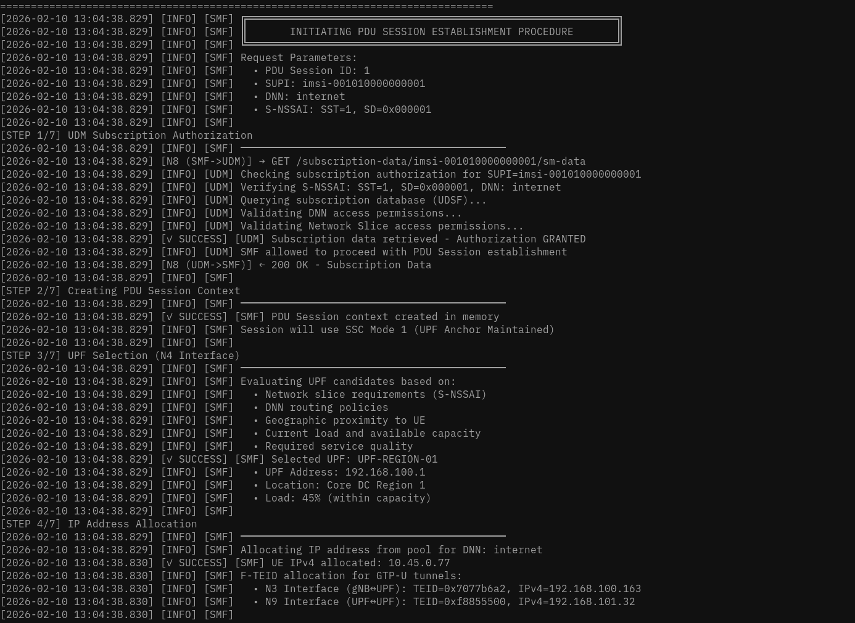
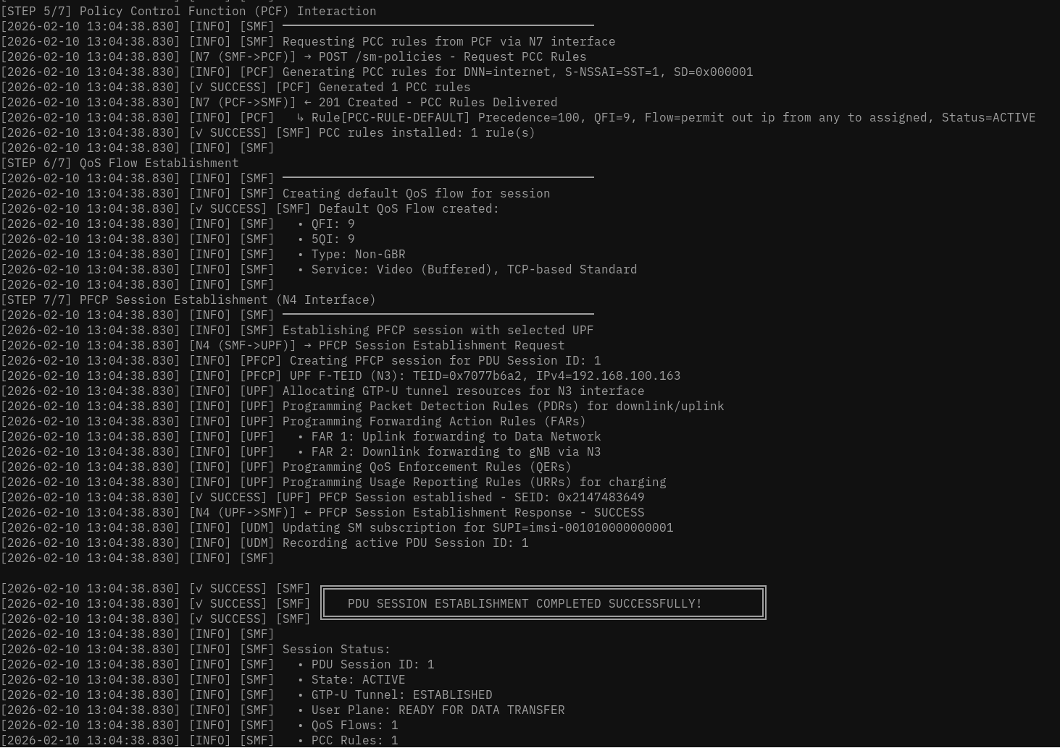

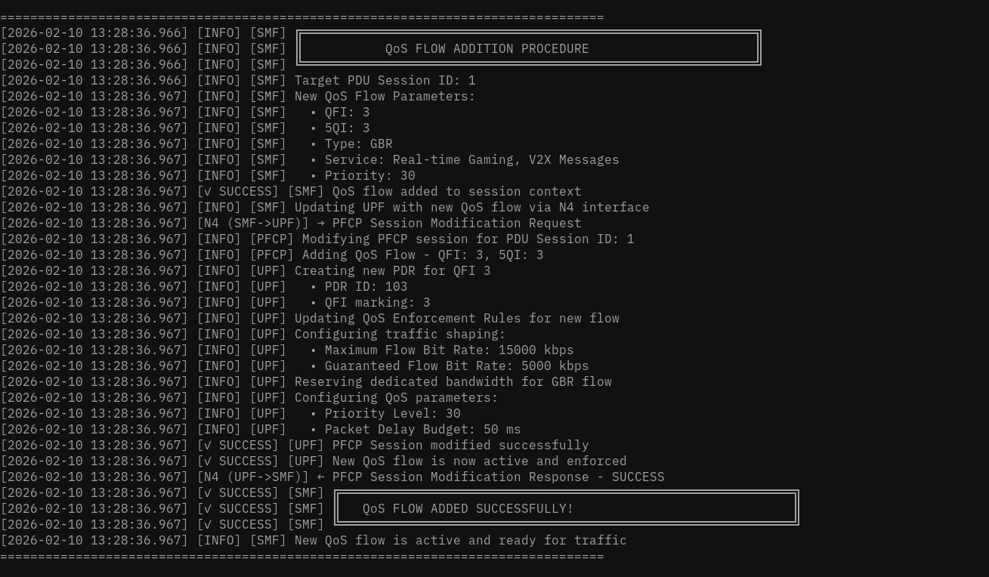

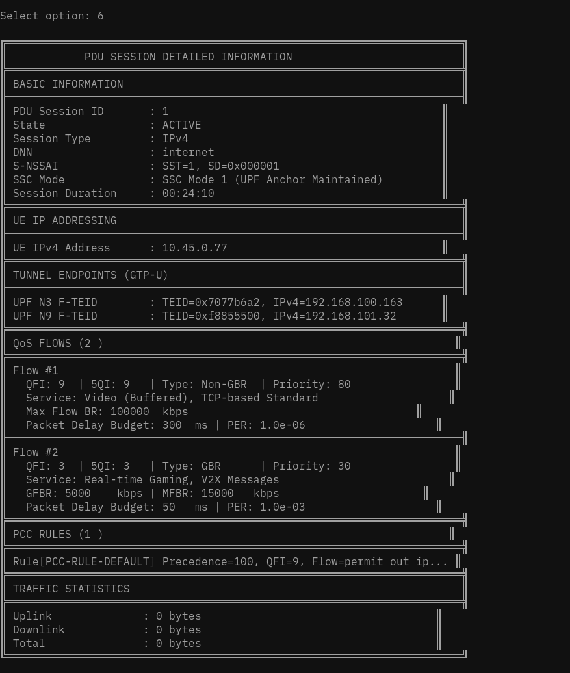
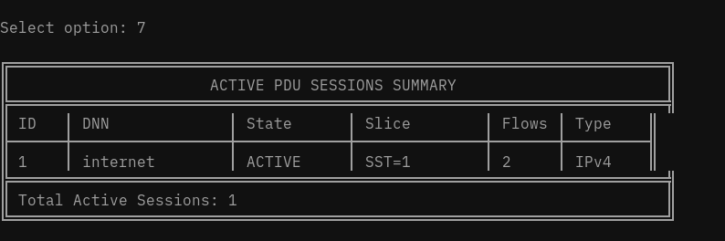
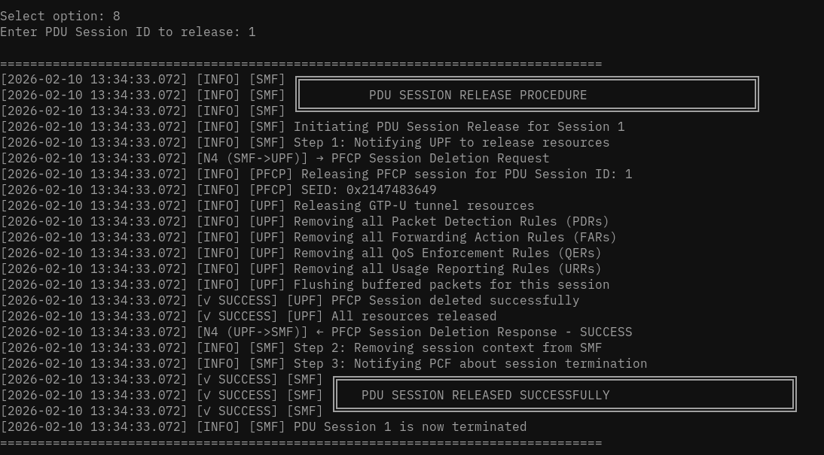

7. Key Concepts & 3GPP References
This section provides comprehensive explanations of the core technical concepts that underpin 5G Session Management: the PFCP protocol used between SMF and UPF, the GTP-U tunneling protocol on the N3 interface, and the 5G QoS model. Understanding these concepts is essential for implementing, troubleshooting, and optimizing any 5G core network.

3GPP Specifications Covered in This Topic
• TS 29.244 — Packet Forwarding Control Protocol (PFCP) — N4 Interface Specification
• TS 29.281 — GPRS Tunneling Protocol User Plane (GTP-U) — N3 Interface
• TS 23.501 — System Architecture for the 5G System — QoS Framework (Section 5.7)
• TS 23.502 — Procedures for the 5G System — SMF/UPF Interactions
• TS 38.415 — NG-RAN — PDU Session User Plane Protocol

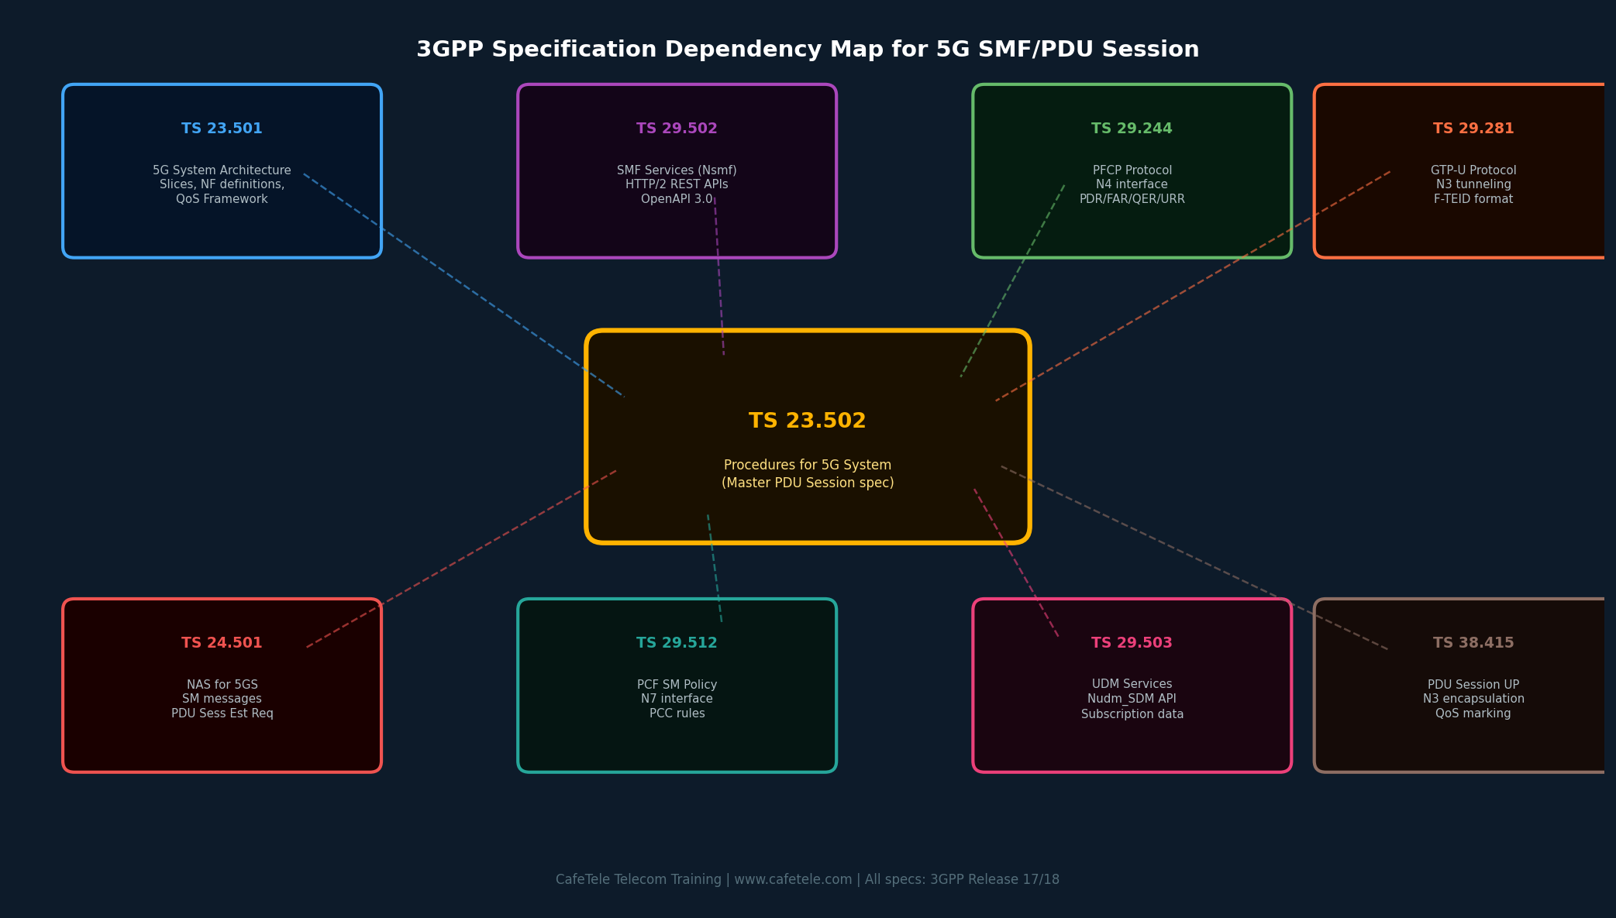
Figure 7.1: 3GPP Specification Dependency Map — Key specs for 5G SMF/PDU Session

7.1 PFCP Protocol (TS 29.244)
The Packet Forwarding Control Protocol (PFCP) is the dedicated protocol used on the N4 interface between the Session Management Function (SMF) and the User Plane Function (UPF). It is the mechanism through which the control plane instructs the user plane on how to handle packets — which to forward, which to buffer, how to enforce QoS, and how to report usage.

Think of PFCP as the "programming language" the SMF uses to write packet-processing programs into the UPF. Just as a developer writes code that tells a computer how to handle different inputs, the SMF writes PFCP rules that tell the UPF how to handle every packet belonging to a PDU Session.

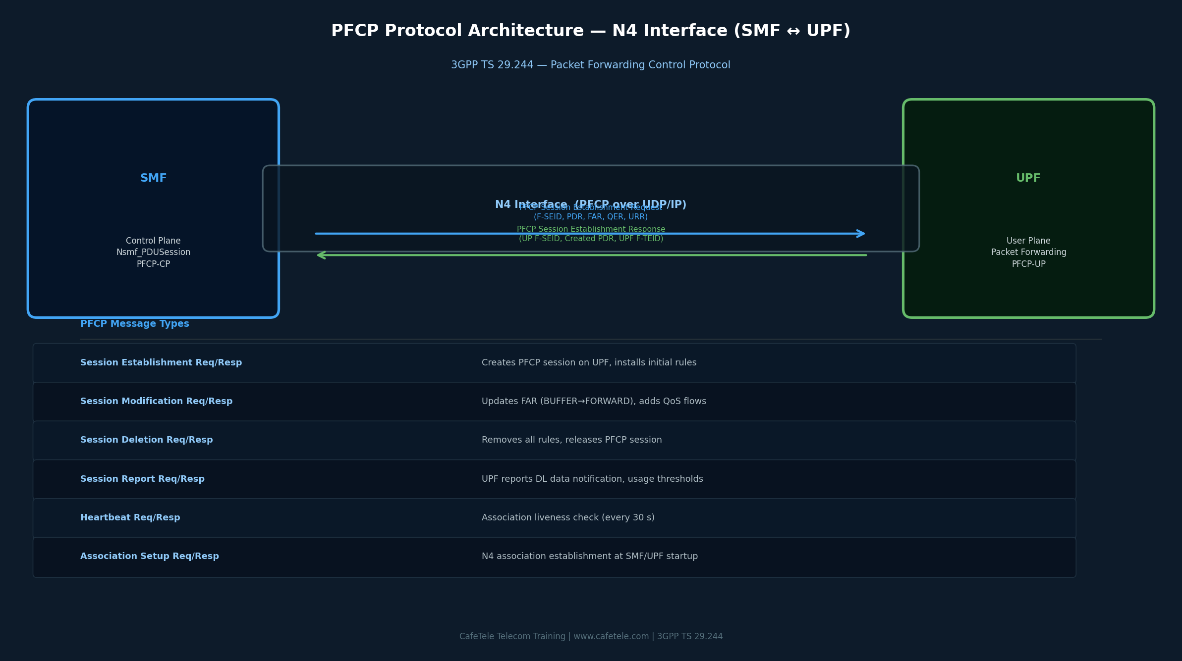
Figure 7.2: PFCP Protocol Architecture — N4 Interface Between SMF and UPF (3GPP TS 29.244)

7.1.1 PFCP Session Establishment — Step by Step
When the SMF enters the N4_SESSION_SETUP state, it sends a PFCP Session Establishment Request containing all the rules the UPF needs to handle the new PDU Session:
- SMF selects UPF (based on DNN, S-NSSAI, UE location, and load balancing)
- SMF sends PFCP Association Setup Request to establish N4 association (if not already established at startup)
- SMF builds the PFCP Session Establishment Request:
  - CP F-SEID: SMF's PFCP session endpoint identifier
  - PDR-UL: Uplink packet detection rule (match UE tunnel on N3)
  - PDR-DL: Downlink packet detection rule (match UE IP from N6)
  - FAR-UL: Forward uplink packets to N6 (Internet)
  - FAR-DL: BUFFER mode (gNB TEID not yet known)
  - QER: Enforce Session AMBR and per-flow bitrates
  - URR: Define usage measurement and reporting thresholds
- UPF processes the rules, allocates its own F-SEID, and creates an N3 F-TEID (TEID + IP) for uplink from gNB
- UPF responds with PFCP Session Establishment Response (Cause: Request Accepted, UP F-SEID, Created PDR with UPF F-TEID)
- SMF stores the UPF's N3 F-TEID to include in N2 SM Info sent to gNB

7.1.2 PFCP Rule Types — The Four Pillars
Every PFCP session is built from four types of rules: PDR, FAR, QER, and URR. Each serves a distinct purpose in the packet processing pipeline.
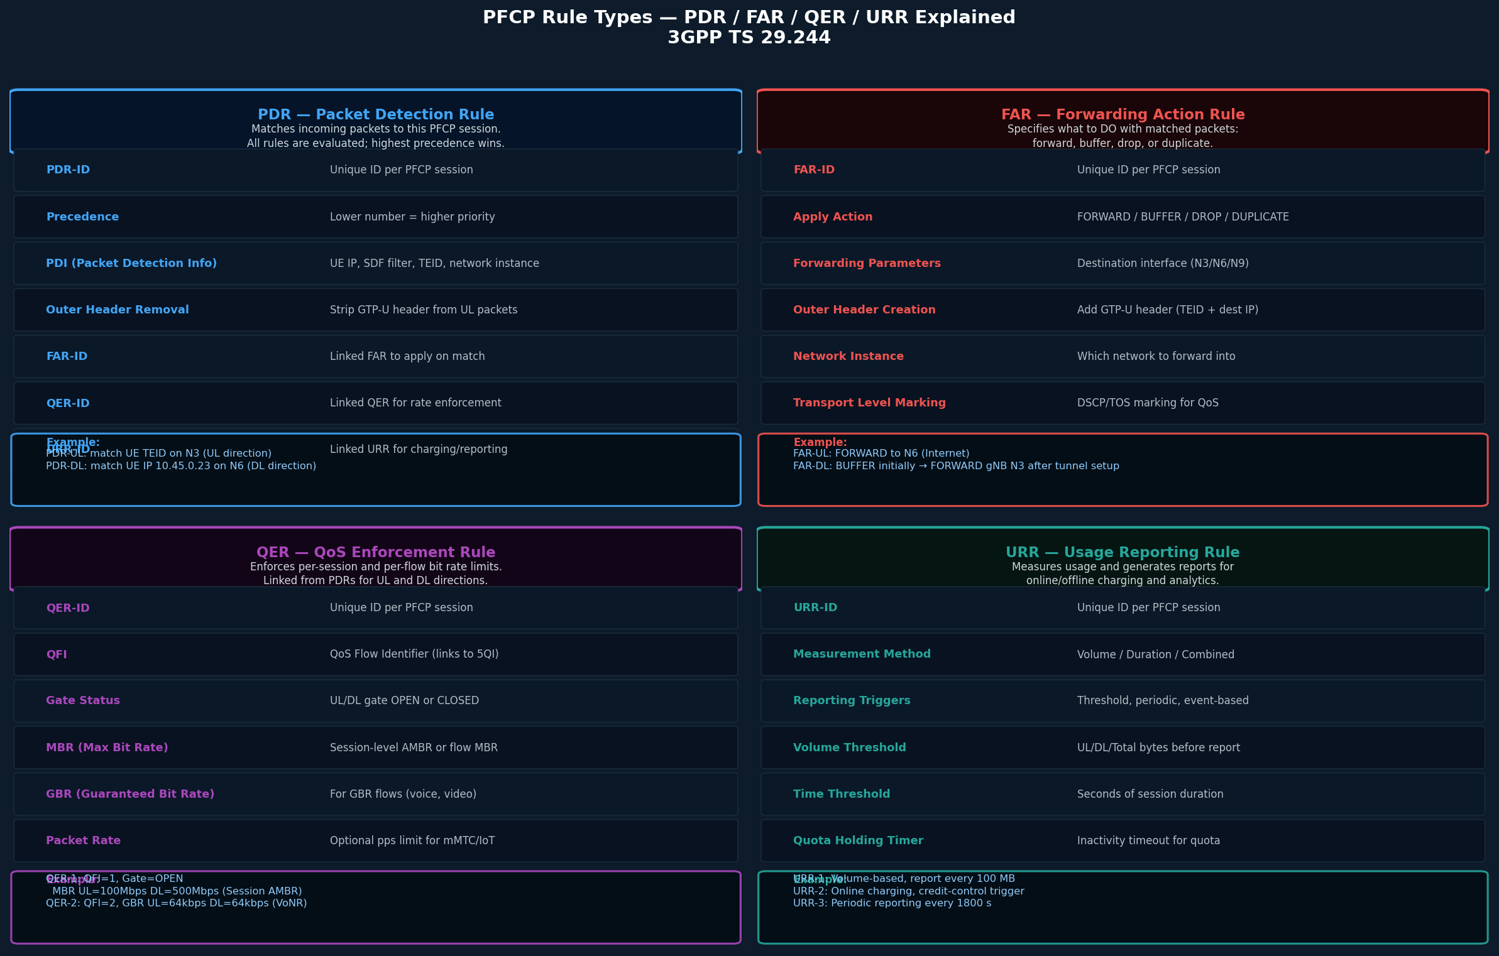
Figure 7.3: PFCP Rule Types — PDR, FAR, QER, URR Explained with Examples (3GPP TS 29.244)

7.1.3 PFCP in Action — The DL FAR Transition
One of the most important PFCP operations is the Downlink FAR transition from BUFFER to FORWARD. This happens during the N4_SESSION_MODIFYING state and is what enables the first downlink packet to reach the UE:

Phase | FAR-DL Configuration | Behavior
N4_SESSION_SETUP | Apply Action: BUFFER | UPF stores all incoming DL packets in a buffer. No packets forwarded yet — gNB TEID unknown.
N4_SESSION_MODIFYING | Apply Action: FORWARD Outer Header Creation: GTP-U Dest TEID: gNB DL F-TEID Dest IP: gNB N3 IP | SMF sends PFCP Session Modification Request. UPF atomically switches DL FAR to FORWARD. Buffered packets delivered instantly.
ACTIVE | Apply Action: FORWARD (stable, gNB TEID locked) | All subsequent DL packets forwarded directly to gNB via GTP-U tunnel. No buffering.

7.1.4 Real-World PFCP Example — Ola/Uber Driver App
When an Ola driver's app connects to the Ola server to go "online" for ride requests, a complete PFCP session is established on the network:
- PDR-UL: Match packets arriving on N3 with TEID=0x0000ABCD (driver phone's UL tunnel)
- PDR-DL: Match packets destined to IP 10.45.0.77 (driver's UE IP) arriving from N6
- FAR-UL: FORWARD to N6 interface (Internet) — driver's HTTP requests reach Ola servers
- FAR-DL: Initially BUFFER, then FORWARD to gNB TEID=0x00002500 (driver's gNB) — ride requests pushed to driver
- QER: Session AMBR DL=100 Mbps / UL=50 Mbps (standard eMBB slice)
- URR: Volume trigger at 500 MB for CDR (Call Detail Record) generation for billing
Every HTTP response from Ola's server (ride request notification, map update, surge pricing) travels as a DL packet matched by PDR-DL, governed by QER rate limits, measured by URR, and forwarded by FAR-DL through the GTP-U tunnel to the driver's phone.

7.2 GTP-U Tunneling — N3 Interface (TS 29.281)
The N3 interface between the gNB (5G base station) and UPF uses GTP-U (GPRS Tunneling Protocol — User Plane) to create per-PDU-session tunnels. GTP-U encapsulates user data packets (IP, Ethernet, etc.) inside GTP headers, allowing the network to identify which PDU Session (and therefore which UE and QoS flow) each packet belongs to.

GTP-U has been used since 2G GPRS networks and continues in 5G because it provides a lightweight, proven tunneling mechanism that scales to billions of sessions. In 5G, each PDU Session has at least one GTP-U tunnel on N3, and each QoS flow can be mapped to a separate tunnel for differentiated treatment.
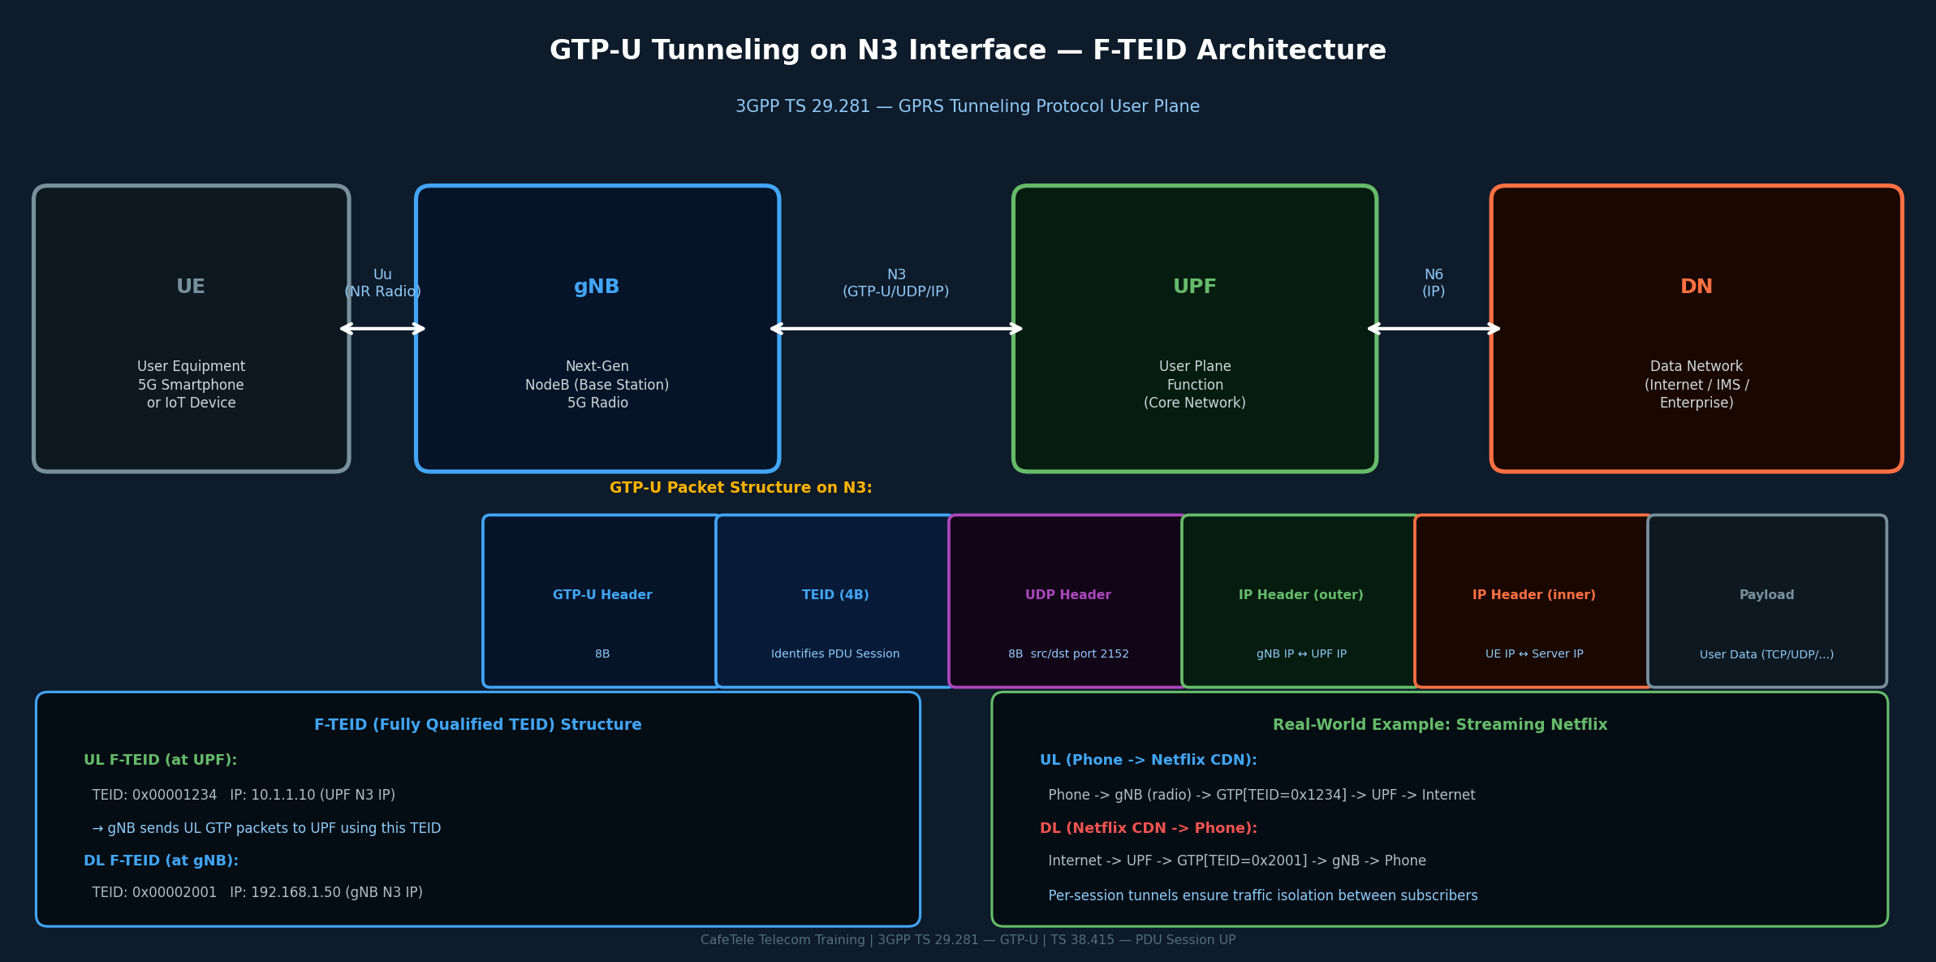

Figure 7.4: GTP-U Tunneling on the N3 Interface — F-TEID Architecture & Packet Structure (3GPP TS 29.281)

7.2.1 F-TEID — The Tunnel Identifier
Every GTP-U tunnel endpoint is identified by a Fully Qualified Tunnel Endpoint Identifier (F-TEID), which consists of two parts:

F-TEID Component | Details | Example Value
TEID (4 bytes) | 32-bit Tunnel Endpoint ID. Unique per session on that endpoint. Assigned by the receiving side (UPF assigns UL TEID; gNB assigns DL TEID). | 0x00001234 (UPF UL TEID) 0x00002001 (gNB DL TEID)
IP Address (4 or 16 bytes) | IPv4 or IPv6 address of the N3 interface on the endpoint. Identifies which UPF or gNB the tunnel terminates at. | 10.1.1.10 (UPF N3 IP) 192.168.1.50 (gNB N3 IP)

The UL F-TEID (at the UPF) is sent from the UPF to the SMF in the PFCP Session Establishment Response, and then from the SMF to the gNB in the N2 SM Info (NG-AP). The DL F-TEID (at the gNB) flows from gNB to AMF to SMF via UpdateSMContext, and the SMF installs it in the FAR-DL via PFCP Session Modification.

7.2.2 GTP-U Header Structure
The GTP-U header is 8 bytes minimum and contains the critical TEID field that the receiving endpoint uses to identify which PDU Session the encapsulated packet belongs to:

Field | Size | Description
Flags | 1 byte | Version (3b)=1, PT=1 (GTP), E/S/PN extension flags
Message Type | 1 byte | 0xFF = G-PDU (user data). Other values: Echo Request/Response, Error Indication
Length | 2 bytes | Length of GTP payload + optional fields (not including mandatory 8-byte header)
TEID | 4 bytes | THE key field — 32-bit Tunnel Endpoint ID. Receiver maps this to a PDU Session context.
Seq / NPDU / Ext | 4 bytes | Sequence number (optional), N-PDU number, Extension Header type — used for QoS marking in 5G

7.2.3 Real-World GTP-U Scenarios
Three everyday 5G use cases showing how GTP-U tunnels work in practice:
Scenario | Uplink Path (Phone to Internet) | Downlink Path (Internet to Phone)
Google Maps Navigation | Phone → gNB (radio) → GTP-U[TEID=0xABCD] → UPF → Google Maps server at 8.8.8.8 | Google → UPF (match UE IP 10.45.0.5) → GTP-U[TEID=0x2001] → gNB → Phone
WhatsApp Video Call | 2 GTP-U tunnels: one for signaling (5QI=5), one for media (5QI=1 GBR). Each QoS flow maps to separate PDR/FAR at UPF. | Incoming video frames arrive from WhatsApp server, matched by UE IP, encapsulated in GTP-U with QFI marking in Extension Header.
Factory Robot (Private 5G) | Robot sends sensor telemetry: GTP-U[TEID=factory_TEID] → UPF (edge) → MEC server. Latency: <1 ms one-way. | MEC control commands → UPF → GTP-U → gNB → robot actuator. URLLC 5QI=85, PDB=5ms strict.

7.3 QoS Model in 5G NR (TS 23.501)
The 5G QoS model is fundamentally different from 4G LTE's EPS bearer-based approach. In 5G, QoS is managed at the level of QoS Flows within a PDU Session, each identified by a QoS Flow Identifier (QFI). This allows much more granular traffic differentiation without the complexity of bearer management.
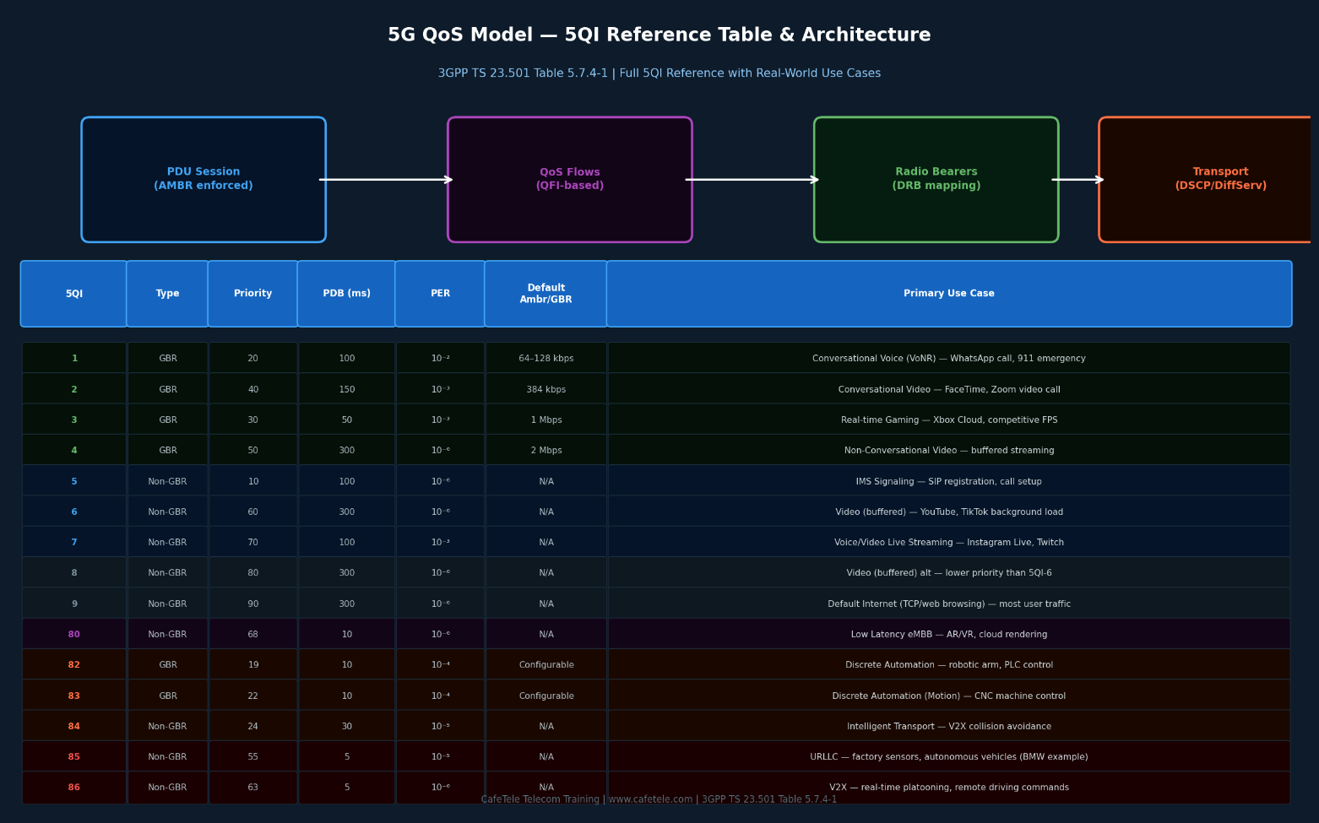
The 5G QoS framework uses standardized 5QI (5G QoS Indicator) values defined in 3GPP TS 23.501 Table 5.7.4-1. Each 5QI maps to a set of QoS characteristics that determine how the network treats packets with that QFI: priority level, packet delay budget, packet error rate, and whether a guaranteed bit rate is required.
Figure 7.5: 5G QoS Architecture & Complete 5QI Reference Table (3GPP TS 23.501 Table 5.7.4-1)

7.3.1 QoS Flow vs. Bearer — What Changed from 4G
In 4G LTE, QoS was tied to EPS bearers (default + dedicated), which required signaling from eNB through MME to P-GW. In 5G, QoS Flows are more flexible:

Aspect | 4G LTE (EPS Bearers) | 5G NR (QoS Flows)
Identifier | EBI (EPS Bearer ID, 5 bits) | QFI (QoS Flow ID, 6 bits, per PDU Session)
QoS Indicator | QCI (QoS Class Identifier, 1 byte) | 5QI (5G QoS Indicator) — standardized + operator-defined
Radio Mapping | 1 bearer = 1 DRB (radio bearer) | Multiple QoS Flows can share 1 DRB (reflective QoS)
Setup Complexity | Dedicated bearer setup requires 8+ messages | QoS Flow added via single PCF policy update + PFCP mod
URLLC Support | Limited — minimum PDB 50ms | Native — 5QI=85 with PDB=5ms, PER=10^-5

7.3.2 GBR vs. Non-GBR Flows — When to Use Each
The choice between GBR (Guaranteed Bit Rate) and Non-GBR flows has major implications for network resource allocation and user experience:

- GBR Flows (5QI 1-4, 65-66, 82-84): Reserve dedicated radio resources. The network guarantees a minimum bit rate even under congestion. Used for voice calls, video calls, and real-time control. Example: A VoNR call uses 5QI=1 GBR flow with guaranteed 64 kbps — the call cannot be degraded by a user next to you streaming 4K video.
- Non-GBR Flows (5QI 5-9, 69-70, 79-86): Share available capacity. No bit rate guarantee, but a maximum bit rate (enforced by QER). Used for internet browsing, streaming, IoT telemetry. Example: Netflix uses 5QI=9 Non-GBR — it gets whatever bandwidth is available, limited by your plan's Session AMBR.
- Session AMBR (Aggregate Maximum Bit Rate): Applies to all Non-GBR flows within a PDU Session. Set by the operator based on the subscriber's plan. Enforced at the UPF via QER.

7.3.3 Key 5QI Values — Real-World Application Mapping
Here is a practitioner's guide to the most commonly used 5QI values and which applications or services use them:

5QI | PDB | Type | Operator Usage | Real-World Applications
1 | 100 ms | GBR | VoNR, IMS Voice | WhatsApp calls, 911 emergency, carrier VoNR (T-Mobile, Jio)
2 | 150 ms | GBR | Video Telephony | FaceTime Video, Zoom HD video, Google Meet
5 | 100 ms | Non-GBR | IMS Signaling | SIP REGISTER/INVITE for VoNR session setup, RCS messaging
7 | 100 ms | Non-GBR | Live Streaming | YouTube Live, Instagram Live, Twitch stream ingest
9 | 300 ms | Non-GBR | Default Internet | All general internet traffic: web browsing, email, app downloads
80 | 10 ms | Non-GBR | Low Latency eMBB | Cloud gaming (GeForce NOW), AR/VR headsets, remote desktop
85 | 5 ms | Non-GBR | URLLC (Industrial) | BMW factory robots, semiconductor PLC control, smart grid SCADA
86 | 5 ms | Non-GBR | V2X Platooning | Autonomous truck convoys, V2X collision avoidance, remote driving

7.3.4 QoS Flow in a Real PDU Session — Video + Voice Example
When Priya video-calls her family from a 5G phone, a single PDU Session on the IMS DNN carries multiple QoS Flows simultaneously:

- QFI=1, 5QI=5, Non-GBR: IMS SIP signaling (call setup, re-INVITE for codec negotiation). PDB=100ms.
- QFI=2, 5QI=1, GBR=64kbps: AMR-WB voice codec stream. Guaranteed bit rate. PDB=100ms, PER=10^-2.
- QFI=3, 5QI=2, GBR=384kbps: H.264 video stream. Guaranteed bit rate for smooth video. PDB=150ms.
- All three QoS Flows coexist within a single PDU Session to DNN="ims". The SMF installs 3 PDR/FAR pairs in the UPF. The gNB maps them to appropriate DRBs based on QFI.

7.4 How PFCP, GTP-U, and QoS Work Together
These three concepts form a cohesive packet processing pipeline. Understanding their interplay is key to mastering 5G user plane behavior:

- PCF delivers PCC rules to SMF via Npcf_SMPolicyControl — specifying which QoS flows to create (5QI, GBR, priority)
- SMF translates PCC rules into PFCP rules (PDR/FAR/QER) and sends them to UPF via N4
- UPF installs PFCP rules and creates a GTP-U tunnel endpoint (UL F-TEID) for the PDU Session
- SMF sends the UPF's UL F-TEID to gNB in the N2 SM Info; gNB responds with its DL F-TEID
- SMF updates UPF's FAR-DL with gNB's DL F-TEID via PFCP Session Modification
- UPF uses GTP-U to encapsulate DL packets with gNB's TEID and forwards to gNB on N3
- gNB decapsulates GTP-U, reads QFI from extension header, maps to correct DRB, delivers to UE over radio
- QER in UPF enforces AMBR/GBR limits; URR accumulates byte counters for charging
Key Insight: Separation of Concerns
• PFCP defines the RULES (what to do with each packet)
• GTP-U provides the TRANSPORT (how to move packets between gNB and UPF)
• 5QI/QoS defines the SERVICE LEVEL (how much priority and resources to give)
The elegance of 5G design is that changing QoS policy (PCF) only requires a PFCP
Session Modification — no GTP-U tunnel change needed. The tunnel stays up; only
the FAR/QER rules change. This enables sub-second QoS policy enforcement.

8. Compilation & Execution Guide
This section provides a complete guide to compiling and running the SMF PDU Session simulation code included in this training document. The implementation is a self-contained C++17 file with no external dependencies — it can be compiled and executed on any modern Linux, macOS, or Windows system with a C++17-capable compiler.

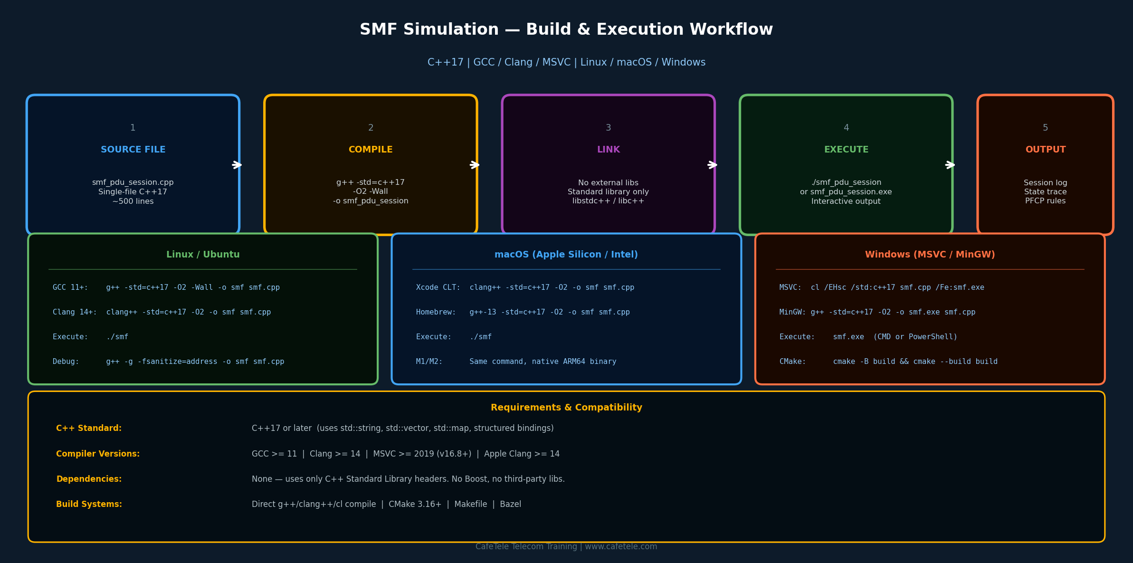
Figure 8.1: SMF Simulation — Build Workflow Across All Platforms (C++17, GCC/Clang/MSVC)

8.1 System Requirements
Component | Requirement
C++ Standard | C++17 or later — uses structured bindings, std::optional, fold expressions
GCC | GCC 11.0 or later (g++). Pre-installed on most Linux distros. Install: sudo apt install g++
Clang | Clang 14.0 or later (clang++). Default on macOS. Install: sudo apt install clang
MSVC | MSVC 2019 (v16.8+) or 2022. Included with Visual Studio Community (free). C++17 mode required.
RAM / Disk | Minimal — 256 MB RAM, 50 MB disk for compiler. Executable is ~500 KB.
External Libraries | None. Only C++ Standard Library (iostream, string, vector, map, functional, memory).

8.2 Linux Compilation (Recommended)
Linux (Ubuntu, Debian, Fedora, CentOS, Arch) is the recommended platform for 5G network simulation work, as it mirrors the deployment environment of production 5G core network functions.

8.2.1 Install GCC on Ubuntu/Debian
# Update package lists
sudo apt update

# Install GCC and essential build tools
sudo apt install -y build-essential g++ gcc

# Verify installation
g++ --version # Should show GCC 11+ or later

8.2.2 Compile and Run
# Standard optimized build
g++ -std=c++17 -O2 -Wall -Wextra -o smf_pdu_session smf_pdu_session.cpp

# Run the simulation
./smf_pdu_session

# Debug build (with AddressSanitizer for memory error detection)
g++ -std=c++17 -g -O0 -fsanitize=address,undefined -o smf_debug smf_pdu_session.cpp
./smf_debug

# With verbose output piped to a log file
./smf_pdu_session 2>&1 | tee simulation_output.log

8.2.3 Compiler Flags Explained
Flag | Purpose
-std=c++17 | Enable C++17 standard. Required for structured bindings, std::optional, if constexpr.
-O2 | Optimization level 2: good performance/compile-time balance. Use -O3 for maximum speed.
-Wall | Enable all standard warnings. Important for catching potential bugs.
-Wextra | Enable additional warnings beyond -Wall. Recommended for production-quality code.
-g | Include debug symbols. Required for GDB/LLDB debugging and sanitizers.
-fsanitize=address | AddressSanitizer: detect heap buffer overflows, use-after-free, memory leaks at runtime.

8.3 macOS Compilation
macOS uses Apple Clang by default (via Xcode Command Line Tools). Both Intel (x86_64) and Apple Silicon (ARM64/M1/M2/M3) architectures are supported natively.

8.3.1 Install Xcode Command Line Tools
# Install Xcode Command Line Tools (includes Apple Clang)
xcode-select --install

# Verify
clang++ --version # Should show Apple clang 14+ or LLVM clang 14+

# Optional: Install latest GCC via Homebrew
brew install gcc
g++-13 --version

8.3.2 Compile and Run on macOS
# Using Apple Clang (default)
clang++ -std=c++17 -O2 -Wall -o smf_pdu_session smf_pdu_session.cpp
./smf_pdu_session

# Using Homebrew GCC (e.g., GCC 13)
g++-13 -std=c++17 -O2 -Wall -o smf_pdu_session smf_pdu_session.cpp
./smf_pdu_session

# Apple Silicon M1/M2/M3 — same command, builds native ARM64 binary
# The resulting binary will be arm64 architecture (not x86_64)
file smf_pdu_session # Shows: Mach-O 64-bit executable arm64

Note: On macOS, -fsanitize=address requires using Apple's llvm-symbolizer for readable output. AddressSanitizer is fully supported on both Intel and Apple Silicon architectures.

8.4 Windows Compilation
Windows supports compilation via three toolchains: MSVC (Microsoft Visual C++), MinGW-w64 (GCC port), and Clang for Windows. MSVC is the most integrated option for Windows-native development.

8.4.1 Using MSVC (Visual Studio)
Visual Studio Community Edition is free and includes MSVC. Download from visualstudio.microsoft.com. Select the "Desktop development with C++" workload during installation.

REM Open "Developer Command Prompt for VS 2022" (from Start Menu)

REM Compile with MSVC
cl /EHsc /std:c++17 /O2 /W4 smf_pdu_session.cpp /Fe:smf_pdu_session.exe

REM Run
smf_pdu_session.exe

REM Debug build with Address Sanitizer (MSVC 2019 16.9+)
cl /EHsc /std:c++17 /Zi /fsanitize=address smf_pdu_session.cpp /Fe:smf_debug.exe
smf_debug.exe

8.4.2 Using MinGW-w64 (GCC on Windows)
REM Install MinGW-w64 via MSYS2 (https://www.msys2.org/)
REM In MSYS2 terminal:
pacman -S mingw-w64-x86_64-gcc

REM Compile (in MinGW terminal or after adding MinGW to PATH)
g++ -std=c++17 -O2 -Wall -o smf_pdu_session.exe smf_pdu_session.cpp

REM Run
smf_pdu_session.exe

8.4.3 MSVC Compiler Flags
MSVC Flag | Equivalent / Purpose
/EHsc | Enable C++ exception handling (synchronous, structured). Required for standard C++.
/std:c++17 | Enable C++17 standard (same as -std=c++17 on GCC/Clang).
/O2 | Maximize speed optimization (equivalent to GCC -O2). Use /O2 for release builds.
/W4 | Warning level 4 (equivalent to GCC -Wall -Wextra). Catches common issues.
/Zi | Generate debug information (PDB file). Required for Visual Studio debugger.
/Fe:name | Specify output executable filename (equivalent to GCC -o name).

8.5 Build with CMake (Cross-Platform)
For teams working across multiple platforms, CMake provides a unified build system. The following CMakeLists.txt works on Linux, macOS, and Windows:

# CMakeLists.txt
cmake_minimum_required(VERSION 3.16)
project(SMF_PDU_Session LANGUAGES CXX)

set(CMAKE_CXX_STANDARD 17)
set(CMAKE_CXX_STANDARD_REQUIRED ON)

add_executable(smf_pdu_session smf_pdu_session.cpp)

# Enable warnings on all compilers
if(MSVC)
target_compile_options(smf_pdu_session PRIVATE /W4 /EHsc)
else()
target_compile_options(smf_pdu_session PRIVATE -Wall -Wextra)
endif()

# Build commands (run from project directory)

# Configure (creates build/ directory)
cmake -B build -DCMAKE_BUILD_TYPE=Release

# Build
cmake --build build --config Release

# Run
./build/smf_pdu_session # Linux/macOS
.\build\Release\smf_pdu_session.exe # Windows

8.6 Expected Output & Interpretation
When the simulation runs successfully, you will see a step-by-step trace of the complete PDU Session Establishment procedure. Here is an annotated guide to interpreting the output:

=== SMF PDU Session Establishment Simulation ===

[AMF->SMF] CreateSMContext: SUPI=imsi-001010000000001, DNN=internet, SST=1
↑ AMF initiates session for UE with IMSI, requesting "internet" DNN on eMBB slice

[SMF] State: IDLE -> SM_CONTEXT_CREATING
↑ SMF transitions to first active state, starts T3580 timer

[UDM] Subscription check: DNN=internet AUTHORIZED, AMBR=DL:500Mbps/UL:100Mbps
↑ UDM confirms subscriber is allowed this DNN with AMBR values

[PCF] Policy: 5QI=9, Default-QoS, Charging: online
↑ PCF returns PCC rule: best-effort internet (5QI=9), online charging

[SMF] IP Allocated: 10.45.0.10/32 UPF selected: upf-1.local
↑ SMF assigns UE IP from pool, selects UPF based on DNN/location

[SMF] State: SM_CONTEXT_CREATING -> N4_SESSION_SETUP
[UPF] PFCP Session Est: PDR-UL(TEID=0x1234), PDR-DL(IP=10.45.0.10)
[UPF] FAR-UL: FORWARD->N6 FAR-DL: BUFFER QER: 500/100Mbps
↑ UPF installs rules. Note FAR-DL=BUFFER: gNB TEID not yet known

[SMF] State: N4_SESSION_SETUP -> WAITING_AN_TUNNEL
[AMF] N1N2Transfer: NAS-Accept + N2-SMInfo(UPF-TEID=10.1.1.10:0x1234)
↑ SMF sends session accept to UE via AMF, includes UPF F-TEID for gNB

[AMF->SMF] UpdateSMContext: gNB-TEID=192.168.1.50:0x2001
↑ gNB allocated DRB, reports its DL F-TEID back through AMF

[SMF] State: WAITING_AN_TUNNEL -> N4_SESSION_MODIFYING
[UPF] FAR-DL updated: BUFFER -> FORWARD(gNB=192.168.1.50:0x2001)
↑ Critical moment: DL FAR switches to FORWARD, buffered packets now delivered

[SMF] State: N4_SESSION_MODIFYING -> ACTIVE
=== PDU Session ACTIVE: UE=10.45.0.10 <-> gNB(0x2001) <-> UPF <-> Internet ===
↑ Session fully established. Data can now flow in both directions.

8.6.1 Troubleshooting Common Compilation Errors
Error Message | Cause & Fix
error: 'optional' is not a member of 'std' | C++17 not enabled. Fix: add -std=c++17 (GCC/Clang) or /std:c++17 (MSVC)
cc1plus: error: unrecognized command line option '-std=c++17' | GCC version too old. Fix: upgrade to GCC 11+ (sudo apt install gcc-11)
ld: library not found for -lstdc++ | Missing C++ standard library on macOS. Fix: xcode-select --install
'to_string' is not a member of 'std' | Old MinGW on Windows. Fix: upgrade to MinGW-w64, add #include <string>
fatal error C1189: #error: "No Target Architecture" | Windows.h included without architecture define. Fix: define WIN32 or use Developer Command Prompt

8.7 Extending the Simulation
The simulation code is designed to be extended as a learning exercise. Here are suggested enhancements to deepen understanding:

- Add IPv6 Support: Modify the IP allocation function to support IPv6 addresses (e.g., 2001:db8:5g::/48 prefix) and PDU Session Type IPv4v6 dual-stack.
- Implement Session Modification: Add a function that simulates QoS flow modification — for example, triggering a dedicated voice bearer when a VoNR call starts during an active data session.
- Simulate UE Mobility: Add a handover procedure where the gNB F-TEID changes and the SMF must update the UPF via a second PFCP Session Modification.
- Add PCF Policy Update: Simulate a Npcf_SMPolicyControl_UpdateNotify call where the PCF changes the charging rule mid-session (e.g., applying a data cap when the subscriber exceeds their monthly quota).
- Multi-Session Support: Extend the SMF to manage multiple concurrent PDU Sessions for the same SUPI (e.g., an "internet" session and an "ims" session simultaneously).
- Add PFCP Heartbeat: Implement the N4 Association heartbeat timer and simulate UPF failure detection with session recovery to a backup UPF.

Learning Resources
• 3GPP TS 23.502 — Free download at www.3gpp.org (search "23502")
• Open5GS (open source 5G core): https://open5gs.org — real SMF C implementation
• free5GC (Go-based 5G core): https://free5gc.org — SMF with PFCP library
• UERANSIM (5G UE + RAN simulator): https://github.com/aligungr/UERANSIM
• Wireshark: Capture and inspect real PFCP and GTP-U packets from open5GS
• CafeTele Training: www.cafetele.com — Advanced 5G Core Network courses

